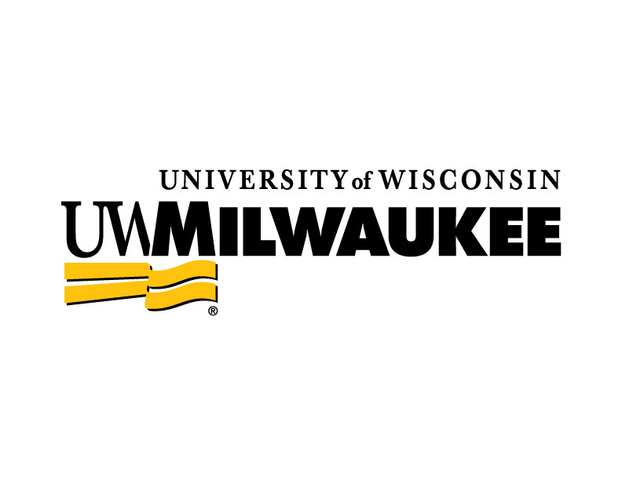
University Staff Excellence Awards
2023-2024 Nomination Form

- Nominee ____________________________ Name ________________title
and ________________________________________________department
- Nominated by ____________________________________________ Name
_______________________title and
____________________________________________________department
- Please select a category (select 1 only)
    - NEWCOMER AWARD - Those serving at UWM 5 years or less at UWM
    - LONG TERM SERVICE - Those serving 10 or more years at UWM
    - LIFETIME ACHIEVEMENT AWARD – Those serving 20 or more years at UWM
    - OUTSTANDING SERVICE in a single year
    - OTHER OUTSTANDING SERVICE – For example, Service to the Community on behalf of UWM, etc.
*The committee reserves the right to modify the award category of any nomination submission.
- Why are you nominating this individual? Focus on their time at UWM, what they do, and why they are exceptional. (word limit: up to 1500 words)
- Letters of support (optional). Up to 5 letters will be accepted. (word limit up to 1500 words)

If you would like to submit a nomination, please send to the UWM University Staff Awards committee by 4:30 p.m. on March 29, 2024. All materials should be sent to us-awards@uwm.edu. All materials are kept confidential by the Secretary of the University’s office.

