

COLLEGE FOR KIDS & TEENS HANDBOOK
Keep Young Minds Active All Summer Long!

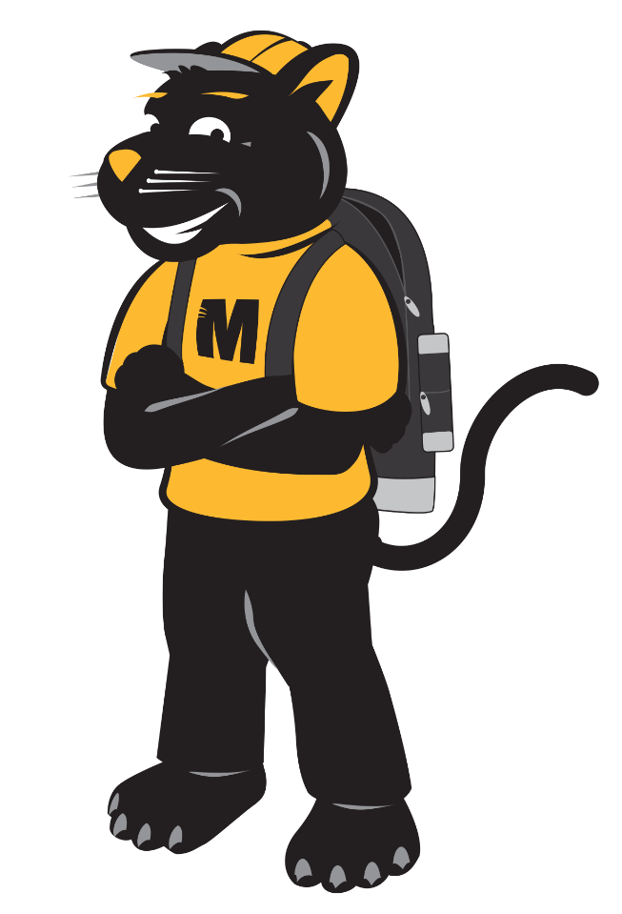

WHATS INSIDE
Health And Safety Policy & Procedures  Registration Information/Check-In  General Information/Pick-Up/Drop Off  Wristbands  Safety Information  Behavior Concerns Procedures  Photo and Video Restriction | Use of Electronic Devices  Medical And Special Needs  Severe, Unsafe Behavior  Parking Information  Car Pick-Up Procedures  CFK&T Handbook To-Do List

UWM COLLEGE FOR KIDS & TEENS—POLICIES AND PROCEDURES

Table of Content

Health And Safety Policy & Procedures 2
Registration Information 2
Check-In 2
General Information 3
Pick-Up/Drop Off Location 3
Drop Off 3
Pick-Up 3
Other Important Information 4
Wristbands 4
Safety Information 5
Behavior Concerns Procedures 5
Photo and Video Restriction 6
Use of Electronic Devices While at College for Kids & Teens 6
Policy Amendment: Personal Device and Social Media Use 6
Medical And Special Needs 7
Severe, Unsafe Behavior 7
Parking Information 7
Car Pick-Up Procedures 8
CFK&T Handbook To-Do List 9

HEALTH AND SAFETY POLICY & PROCEDURES:
Our program is subject to the University of Wisconsin and UWM Policies with regard to on-campus, in-person youth programming. This may affect aspects of our program delivery, including social distancing, age-group cohorting, and reduced class sizes. Any information related to these health and safety policies and procedures, which relate to program decision-making, as well as the possibility of reverting to an online delivery method, can be found on our website. Updates will be made as the policy is mandated by the University of Wisconsin and UWM.
Our policy states that we do not offer refunds or transfers after registration. We are mandated by UWM policies that in the event our program changes its delivery method to online for any reason due to health and safety concerns, then an exception to the refund policy may take effect. For more information, please see our website policy changes and information. uwm.edu/sce/kids
REGISTRATION INFORMATION:
You should have received a registration confirmation email.
Please read your confirmation(s) carefully. Call 414-227-3360 or email us immediately with any corrections to the child information, class title, date, time, or grade level.
Included in your confirmation email, you should have received links to our parental consent form and the College for Kids & Teen handbook. Please complete the parental consent form for each child and email to cfkids@uwm.edu.
Please be advised that your child will not be allowed to participate in class(es) unless we have the parental consent form on file. To avoid waiting in long lines on the first day of classes, we ask that you complete all forms prior to the first Monday of the program. It is suggested that the forms be completed at least two weeks prior to the first day to ensure that our staff has appropriate time to process the forms.
Check-In
On the first day of the first class, please check in at our registration table
located in front of Merrill Hall, 2512 E. Hartford Ave., with your child at least 30 minutes prior to your child’s first class to make sure you have completed all the proper paperwork. If your child signs up for multiple classes in multiple sections, you only need to do this once during the summer. Please use your registration confirmation or the website to refer to your class dates and times. We highly recommend printing your confirmation sheet and bringing it to check-in on your first day of class(es). Class names, dates, and times are included in this.
Your child will receive their CFK&T drawstring backpack and water bottle when all of the paperwork is complete. To avoid long lines, you may turn in all required forms and receive your backpack and water bottle Monday–Friday, the weeks of June 2-13. Our summer office is located in Merrill Hall, room 214.
2
GENERAL INFORMATION:
Pick-Up/Drop Off Location
You may pick up or drop off at the Circle Drive at Merrill Hall, 2512 E. Hartford Ave.
Drop Off
Drop your children off only if you see a CFK&T staff member (in a CFK&T T-shirt and/or CFK&T orange vest and with a name badge). If you do not see our staff, you should take your child to the CFK&T office in Merrill Hall, 2512 E. Hartford Ave., room 214. Keep in mind that we have limited staff; latecomers will need to wait in the office until someone becomes available. Only children who make it to Merrill Hall before the class start time will be escorted by their teacher. Children will take a 15-minute break before 11:30 a.m. and 2 p.m. class for snacks and lunches. We ask that you arrive at least 15 minutes prior to these classes in order for children to take these breaks with their classes.
Only children who have a signed parental consent form, indicating that they can leave unattended (orange wristband), will be able to leave without an adult. If you give your child this permission, please put the initial in the appropriate location on the parental consent form. This will give permission for your child to leave the program at any time without CFK&T supervision. (This would include but is not limited to: going to the bathroom and being picked up in a location other than the Circle Drive at Merrill Hall.) By agreeing to this, your child will be given the right to be on campus unsupervised. If you do not give this permission, they will stay with the instructor or staff at all times. No exceptions.
Pick-Up
The instructors will bring their students to Merrill Hall or the Circle Drive, where CFK&T staff will be waiting at the end of class time. You must pick up your child within 15 minutes of the end of class (i.e. if class ends at 11 a.m., you will need to pick him/her up no later than 11:15 a.m.). Children will be allowed to wait for their ride either inside at Merrill Hall or outside at the Circle Drive-up. CFK&T does not have the staffing resources to care for children who are not picked up within the 15-minute window. To cover costs, if you are late, you will be charged $10 for every 15 minutes you are late (e.g. 4:16-4:31 p.m. would be $10, 4:32-4:47 p.m. would be $20, and so on). If your child is not picked up within one hour, CFK&T will contact the UWM police. Your Child will not be allowed to return to classes until the fee has been paid.
CFK&T staff will no longer be available to escort students from classes during class time with few exceptions. If you are in need of picking your student up early from class, please plan to do so during the dismissal times. Sorry for any inconvenience.

3
INFORMATION
On the first day of a new class, it is very helpful to have your confirmation receipt along with you.
Do not leave your car unattended in the Merrill Hall Circle Drive, you will be ticketed by Campus Police and there is nothing we can do about it! Parking is available on campus at surface lots and parking structures.
Children who are enrolled in back-to-back classes will be supervised by our staff. Please make sure they have a snack or lunch with them each day. There are no facilities to purchase any food or beverages. For security purposes, the instructors and staff will also be wearing a lanyard with a name badge.
Breaktimes are supervised and take place between the classes during the 11-11:30 a.m. and 1:30-2 p.m. times. Please arrive at least 20 minutes before your child’s scheduled classes, as each class will be leaving Merrill Hall for their next class to eat lunch and take a break prior to the next class start time.
For dance and theatre classes, children must bring another pair of shoes to change into to participate. Please make sure your child brings appropriate shoes each day to class, no flip flops or sandals.
Please look out for the parent College for Kids & Teens program evaluation at the end of each session. Your feedback matters and we take the time to read all evaluations.
WRISTBANDS
CFK&T will provide color-coded bands to easily identify our kids on campus. Bands will be similar to those used at amusement parks. Wristbands are color-coded and tell the staff what privileges your child has, such as leaving campus unattended or participating in before and/or aftercare. Wristbands are given out on the first day of a session or discovery camp, and are to be worn each day of participation in the program. At the beginning of a new session, turn in your old wristband for a new one. Please ensure your child wears the wristband daily or your child will not be allowed to participate in class. If your child has lost or left their wristband at home, they will need to pay $3 to get a replacement band ($20 for replacement of orange wristbands and $10 for White without the original). No exceptions. This money will need to be paid before they can go to class. If someone does not have money for the replacement of the orange or white band, they will be given a yellow band and (lose all orange or white bands privileges) until they have paid the replacement fee. If you have any questions, feel free to give us a call.
4
SAFETY INFORMATION
To ensure a pleasant and safe experience for you and your child(ren), please read the following:
- Familiarize yourself with the UW-Milwaukee campus prior to the start of classes.
- Outside of the supervised chaperone service, between classes, you are responsible for your children at any point of the day that they are not enrolled in class or before/aftercare. If you would like your child to meet you at a different location on campus, there is a spot to sign on the parental consent form allowing the child to leave unattended (orange band). Please make sure you sign in at the appropriate location, or they will need to stay with our staff.
- Wristbands are mandatory and are required to be worn at all times during the program. Wristbands not only indicate that participants are in our program, but they also include our phone number. We can be reached at 414-227-3360, or the Campus Police (4627) can be reached at any campus phone. Campus phones are located throughout every building.
- Located throughout campus are the “Blue Light” emergency phones. These phones have direct lines to the Campus Police.
BEHAVIOR CONCERNS PROCEDURES
When a child’s behavior is of concern and negatively affecting others, it is the College for Kids & Teens (CFK&T) and the family’s responsibility to work together. It may be necessary to look for additional support to not only work with the child but to give support to staff and protect the safety of others in our program who may be negatively affected by the behavior. Generally, with cooperative efforts between home and CFK&T, behavioral difficulties become manageable, or the cause of the behaviors and possible solutions become clearer.
If a child has exhibited inappropriate behavior, the instructor will inform the Faculty Advisor at the early stages of the concern and communicate with them on a regular basis regarding the status of the problem. If the child’s behavior has affected the class to the point of disruption, the instructor will contact the Faculty Advisor. At this time, the Faculty Advisor will meet with the child and assess if immediate action is required. At that time, the Faculty Advisor will contact the parent/guardian. In most cases, the situation is usually resolved at this point. If the behavior continues or worsens, the instructor, Faculty Advisor, and the Director will then contact the parent/guardian about the next steps. These steps will include communication with the parent/guardian about the behavior and a discussion as to whether action will need to be taken. Steps may include: transferring classes, suspension from the program, or if necessary, dismissal from the program (this is seen as a last resort but may involve dismissal without refund for any or all of the enrollment.)
Our goal is to successfully enrich all children enrolled and limit the use of suspension, dismissal, and other exclusionary measures. CFK&T complies with federal and state civil rights laws. Parents/guardians are expected to seek or follow through with the supports and services suggested for their child.
5
If, after reasonable efforts by the parents/guardians, instructors, and administrators, no solution to the problem can be found, and a child’s behavior continues to be disruptive to the classroom in ways that require a disproportionate amount of one-to-one attention, parents/guardians will be counseled to find an alternative program arrangement that may be better able to meet their child’s needs. Our staff will share a list of resources regarding services and alternative programs in the community when possible. There are times when enrollment at UWM College for Kids & Teens is not in the best interests of the child.

PHOTO AND VIDEO RESTRICTION
UWM College for Kids & Teens (CFK&T) does not allow students to photograph or video-record any other student while in our program. Taking pictures or videos is strictly prohibited with a few exceptions, which may include the use of class projects and activities. This exception is only under the direct communication of our CFK&T office and will follow our photo permission policies.

USE OF ELECTRONIC DEVICES WHILE AT CFK&T
Electronic devices, which may include phones, tablets, gaming devices, and watches, are permitted while in our program during before-care and after-care programs (7:30-9:00 a.m. and 4:00-5:30 p.m.) and during break periods. (11:00-11:30 a.m. and 1:30-2:00 p.m.) CFK&T is not responsible for any lost, stolen or broken devices.
Students may not use these devices during class times and while walking to and from buildings.
While on devices, students are expected to only participate in appropriate activities in which the student does not watch, listen or play applications that include inappropriate language, sexual content, violence, or offensive behaviors. Students are not allowed to take photos or record any other students at any time in our program. If students are found to participate in any of these listed activities while on devices, the student’s device will be confiscated, and the parent will be notified immediately. Devices will then be returned to the parent.

PERSONAL DEVICE AND SOCIAL MEDIA USE
Students are not permitted to watch videos or engage with any social media platforms—including TikTok, Snapchat, Instagram, YouTube, Facebook, etc.—while participating in our program.
Failure to follow the above policies may result in the immediate confiscation of the device, and parents/guardians will be notified. The device will only be returned directly to the parent or guardian.
Repeated violations of this policy may lead to removal from the program without a refund.
6
MEDICAL AND SPECIAL NEEDS
Families are expected to share any child’s medical and special needs with our program to give staff and instructors the information that will help them work with your child. We are inclusive of all children with special needs and diagnoses within the scope of our programming but want families and children to have realistic goals regarding how they might participate in our enrichment programming. If a child is in need of special resources, i.e., an aide or interpreter, then we ask that this be shared with our program prior to the child’s scheduled attendance. Some resources can be made available, but not all. Our preference is that these needs be shared with our program immediately after enrollment so we can work with the family to develop a plan for your child’s success and discuss the availability, if applicable, of resources within the scope of the Accessibility Resources Center at UWM.
SEVERE, UNSAFE BEHAVIOR
When a child exhibits behavior that is a danger to themselves or to others or disrupts the learning environment to such a degree that most/all the children in the classroom are affected, the instructor will contact the Faculty Advisor and the Director. Situations in which a child has been involved in a fight, made unwanted physical contact with another child, or been involved in an incident deemed unsafe by our program can be causes for immediate dismissal from the CFK&T program. If requested, a meeting between the family, Director, Assistant Director, and Faculty Advisor can be scheduled to discuss any possible alternative outcomes. Behaviors such as hitting, kicking, biting, running away, spitting, yelling obscenities/ inappropriate words, throwing objects, destroying property, etc., are considered unsafe and will be grounds for the above-mentioned actions.
PARKING INFORMATION
Read signs and meters carefully. CFK&T is not responsible for any parking citations. Do not leave your car unattended at the Merrill Hall Circle Drive; you will be ticketed by Campus Police. Parking is available on campus at surface lots and parking structures.
The Parking and Transit Office is located on the ground floor of the Student Union, Room WG 25. Hours are Monday through Friday 8 a.m.–4:30 p.m.
You may pay at the “Pay Station.”
kiosks found in the campus lots. Rates vary depending on location. Chapman/Enderis & Garland/Library are $2/hour after 4p.m. on weekdays. Sandburg (available 24 hours/day) and EMS, Zelazo & Science lots are $1.50/hour. All other surface lots are $1/hour. In Union & Lubar, rates are $2/hour. If you have any questions about parking, feel free to give us a call at 414-227-3360 or the Parking & Transit office at 414-229-4000. Please note rates may change at any time.
See back cover for directional map.

7
CAR PICK-UP PROCEDURES
Car pick-up procedures are in place for the safety of all involved. CFK&T families must follow these procedures if they choose to get in the pick-up line. We highly recommend picking up during the following times: 11-11:20 a.m., 1:30-1:50 p.m. and 4-4:20 p.m. The circle drive will be clearer during these times.
- Please be patient as the children’s safety is our number one priority. We will try to move cars as quickly as possible. It usually takes around 15 minutes to clear the entire area. CFK&T staff will work to ensure the process is safe and efficient for everyone. Our focus will be on the safety of the children, so while our directions may be brief, they are given to maintain a smooth and safe process.
- Parents/Guardians have the opportunity to pick up their child(ren) at the Circle Drive at 2512 E. Hartford Ave.
- Vehicles enter the Circle Drive at the East Entrance nearest Downer Ave.
- The first set of vehicles that arrive can park in the outside lane until your child arrives. Please do not leave your vehicle as the car must keep moving forward as cars leave.
- We ask that vehicles move as far forward in this lane as possible and
continue to move forward every time a car leaves.
- Please note that you cannot park in the inner lane.
- If your child(ren) are not present, you MUST move through the semi-circle and come back around. Parking attendants will be helping us keep this lane clear.
- We cannot block the sidewalk or bus stop areas. If your child(ren) is
wearing an Orange Wristband and has been given permission to be left unattended, they may meet you at another location away from this
pick-up area.
- We are requesting that you approach the Circle Drive entrance from the northeast on Downer Avenue. Please take caution not to block the intersection or buses.

Please arrive 20 minutes prior to class starting for drop off.
Classes leave their rooms across campus 15 minutes prior to start time.

8
CFK&T Handbook To-Do List
Reminder: Registration opens February 10th at 10 a.m. and remains open until
10 days prior to the start of classes. Contact CFK&T office (cfkids@uwm.edu
or (414) 227-3360 if your child needs to be placed on a waitlist for a class.)
January 2 – Scholarship application submission is open.
After student(s) is(are) registered
☐ Keep a copy of registration confirmation (p. 2)
☐ Complete and return parental consent form (p. 2)
☐ Complete and return Special Needs and Medical Forms
(if applicable to your student(s)) (p. 6)
June 1-12 – Early Check In
☐ Verify consent forms are completed
☐ Receive child’s wristband
☐ Receive child’s bag and water bottle

First Monday of the First Class of the Summer
☐ Arrive no less than 30 minutes prior
☐ Stop at check-in table (p. 2)
☐ Have a copy of 1) registration confirmation; 2) parental consent form (special needs/medical if applicable)
☐ Remind your student(s) that they will be escorted into Merrill Hall by CFK&T Staff. No Parents/Guardians will be entering with their student(s).

Everyday Reminder
☐ Arrive 15-20 minutes prior to class (p. 3)
☐ Pack a cold lunch
☐ Be mindful of the weather and dress students appropriately and bring proper equipment i.e. umbrellas
☐ Have wristband on (p. 4)
☐ Late arrivals come to Merrill Hall and wait up to 15 minutes to be escorted to class by CFK&T staff (p. 3)
☐ Pick Up – Remain in your vehicle if using the circle drive and follow instructions of CFK&T staff (p. 3)
8
COLLEGE FOR KIDS & TEENS HANDBOOK
Merrill Hall Entrance

VEHICLE
VEHICLE
VEHICLE
Hartford Avenue
- Parents/Guardians have the opportunity to pick up their child(ren) at the Circle Drive at 2512 E. Hartford Ave.
- Vehicles enter the Circle Drive at the East Entrance nearest Downer Ave.
- The first set of vehicles that arrive can park in the outside lane until your child arrives. Please do not leave your vehicle as the car must keep moving forward as cars leave.
- We ask that vehicles move as far forward in this lane as possible and continue to move forward every time a car leaves

For more information uwm.edu/sce/kids
cfkids@uwm.edu, 414-227-3360

Please arrive 20 minutes before class starts for drop-off.
Classes leave to their rooms across campus 15 minutes before start time
Exit lane
Exit lane
Check-in Table
Downer Avenue
Enter the Circle Drive ONLY from
Downer Ave at the lights
VEHICLE
VEHICLE
VEHICLE
VEHICLE
VEHICLE
VEHICLE
VEHICLE
VEHICLE
Vehicles in the inside lane should move as
far forward as possible and continue to move forward every time a car leaves.
Exit lane
Exit lane

