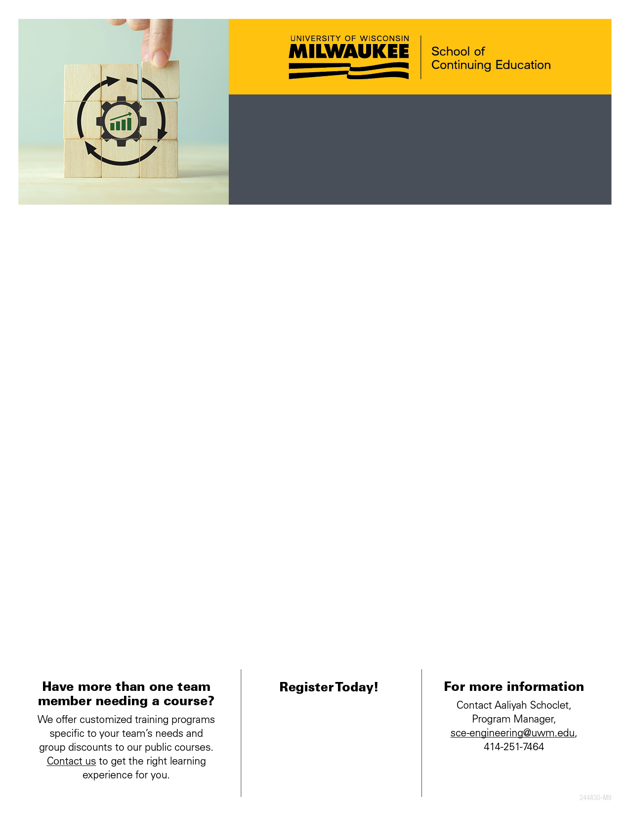
PLASTICS & ELASTOMERS ENGINEERING

Courses | Dates | Format | Early Bird Fee | Fee
Designing Plastic Parts for the Injection Molding Process | TBD | In-Person | TBD | TBD
Plastic Injection Mold Design: Basic and Advanced Topics | Apr 28 – 30 2026 | In-Person | $1,481 by  Apr 14 2026 | $1,645 after  Apr 14 2026
Spanish Language Skills for Manufacturers | Apr 29 – May 27  2026 | In-person | $671 by  Apr 15 2026 | $745 after  Apr 15 2026
Principles of Rubber Technology | May 5 – 7  2026 | Live Online | $1,310 by  Apr 21 2026 | $1,455 after  Apr 21 2026
Molding of Rubber and Design of Rubber Molds | May 6 – 8  2026 | In-Person with Livestream | $1,481 by  Mar 23 2026 | $1,645 after  Mar 23 2026
Becoming an Engineering Leader | May 19 – 20 2026 | In-person with Livestream | $1,067 by  May 5 2026 | $1,185 after  May 5 2026
Plastic Material Selection: From Concept to Production | May 27 – Jun 17 2026 | Live Online | $1,130 by  May 13 2026 | $1,255 after  May 13 2026
Plastic Part Failure: Analysis, Design & Prevention | Oct 20- 22 2026 | In-Person with Livestream | $1,481 by  Oct 6 2026 | $1,645 after  Oct 6 2026
Introduction to Thermo Fluids | Register Anytime | On-Demand Online | n/a | $1,290

Test box

