Exposure Control Plan for: XXXX
Agent Risk Group: Risk Group 2
Containment Level: BSL 2

Hazards
[Include general description of hazards posed by infectious agent, which may include characteristics of the agent, diseases or symptoms it may cause, and the major risk factors for infection within the laboratory. Much of this information may be pulled from a Material Safety Data Sheet(MSDS) or from the pathogen safety data sheets.

Modes of Transmission
[Include likely modes of transmission in the laboratory, such as direct skin, eye, or mucosal membrane exposure, parenteral inoculation by needle or other contaminated sharp, ingestion of liquid suspension or contaminated hand to mouth exposure, or inhalation of aerosols. This information may also be found in the MSDS or PSDS.]

Engineering Controls
[Describe engineering controls used to reduce exposure in the lab, some examples are listed below- you need to include safety precautions taken during injection and also during transport of loaded syringes.]
- A Certified Biosafety Cabinet must be used for all manipulations of the agent (i.e., pipetting, harvesting, infecting cells, filling tubes/containers, opening sealed centrifuge tubes/rotors, shaking, mixing, etc.) and for handling infected cells.
- Safety Engineered Sharps, such as those with retracting needles, shall be used for injections. In addition, the use of other sharps (i.e., glass Pasteur pipettes) must be eliminated wherever possible.
- For animal injections, the animal must be restrained or anesthetized.
- Biohazard Sharps Containers shall be available to dispose of sharps waste, including broken glass, needles, blades, etc.
- When centrifuging, use aerosol containment devices such as safety cups that fit in the centrifuge bucket, covers for the centrifuge bucket, heat sealed tubes, or sealed centrifuge rotors. Rotors should be removed and opened inside a BSC. Centrifuge tubes should be filled and opened in BSC.
- An in-line HEPA filter must be used for vacuum aspiration of spent media.

Administrative/ Work Practice Controls
[Describe various work practices used to control exposures, some examples are listed below]
- Access to the lab shall be restricted while work is in progress, doors shall remain closed during experimentation
- A sign incorporating the universal biohazard symbol shall be posted at the entrance of the laboratory or tissue culture room where agent is used (see last page)
- All lab personnel must be informed of the hazards of agent
- All lab personnel must be trained in proper handling, use, and disposal prior to working agent
- All lab personnel are advised to avoid rubbing eyes as a precautionary measure against eye infections
- All lab personnel will remove lab coat, discard gloves, and wash hands before exiting the lab

Personal Protective Equipment (PPE)
[Describe personal protective equipment required to be worn when working with infectious agent, some examples are listed below]
Lab coat shall be worn while working in the lab
Safety glasses or goggles shall be worn when handling agent
Disposable gloves shall be worn while working in the lab
Respirators are required for aerosol-producing procedures performed outside of a biosafety cabinet. Contact the US&A office at X6339 for fit-testing prior to use of respirators.

Disinfection
Describe the methods of disinfecting the agent.

Disposal
[Describe how the agent will be disposed]

Accidental Spill
[Describe spill procedures; standard methods are listed below]
In case of spill inside of biosafety cabinet:
- Lower sash and let biosafety cabinet continue to run (at least 5 minutes) in order to contain aerosols
- Immediately notify others around you
- Contaminated personal protective equipment(PPE), such as gloves, labcoat, and safety glasses, should be removed and disposed of as biohazardous waste or set aside for disinfection
For exposures/contamination, see “Personnel Contamination/Exposure Response” guidelines below
- Don appropriate PPE if not already wearing
- Use forceps to remove any broken glass or other sharp items; sharps should be placed into biohazard sharps containers
- Cover the spill with paper towels or other absorbent materials
- Apply 10% bleach directly around and onto the paper towels covering the spill
- Allow 15 minute contact time before cleaning, starting at the perimeter and working inwards towards the center
- Dispose of materials into biohazard bins
- Disinfect all surfaces of the biosafety cabinet with freshly prepared 10% bleach with a 15 minute contact time, followed by a wipedown with 70% ethanol to reduce corrosion
- Allow biosafety cabinet to run for at least 10 minutes before resuming work or turning off
- For large spills, you may contact the the Biosafety Office at 414-588-4261 for additional assistance.
In case of spill in lab (outside of biosafety cabinet):
- Immediately notify others around you
- Contaminated personal protective equipment(PPE), such as gloves, labcoat, and safety glasses, should be removed and disposed of as biohazardous waste or set aside for disinfection
- For exposures/contamination, see “Personnel Contamination/Exposure Response” guidelines below
- Leave the room and restrict access for 30 minutes to allow aerosols to settle
- Enter room wearing appropriate PPE
- Use forceps to remove any broken glass or other sharp items; sharps should be placed into biohazard sharps containers
- Cover the spill with paper towels or other absorbent materials
- Apply 10% bleach directly around and onto the paper towels covering the spill
- Allow 15 minute contact time before cleaning, starting at the perimeter and working inwards towards the center
- Dispose of materials into biohazard bins
- For large spills, you may contact the the Biosafety Office at 414-588-4261 for additional assistance.

Exposure Response
[Describe the steps to take in the event of an exposure; standard procedures are listed below]
In the event of an exposure, take the following precautions:
- Remove any contaminated clothing
- Wash all affected areas; for eye exposures, rinse for 15 minutes in eyewash or flush area with water, for needle-stick or other sharps exposure, wash wound area with soap and water for 15 minutes
- Report the exposure to your supervisor immediately

Special Practices for Animal Injections
[Describe special practices for handling animals exposed to infectious agent; standard procedures are described below]
- Facility: When animals are infected with agent, the Animal Biosafety Level of the project will generally be assigned to ABSL-2. This requires Biosafety Level-2 practice and facilities for procedures involving agent.
- Signage: Attached door sign must be posted on the door leading into the housing or procedure room. Cages must be labeled with the biohazard cage card label with agent identification and injection date upon injection of agent. Signage/labels must remain in place for a minimum of 1 week after the date of injection/exposure.
- Animal Excretion: Infected animals my excrete agent. Precaution must be taken not to create aerosols when emptying animal waste material and when washing down cages, or cleaning the room with pressure hoses. Surfaces that may be contaminated will be decontaminated ASAP with bleach solution. This practice must be followed for one full week after infection.
- Cage Change: Use a certified Class II biosafety cabinet when moving animal from dirty to clean cages. If multiple cages are being changed in the same biosafety cabinet, cages with animals infected with the agent should be changed last. Spray the inside surfaces of each cage with bleach solution and leave the cages in the biosafety cabinet for 15 minutes before returning them to the cage washing facility. Decontaminate the biosafety cabinet immediate after removing the contaminated cages with bleach solution.
- Bedding: A biosafety cabinet or negative airflow cage changing station should be used when disposing bedding into biohazard red bag. The red biohazard bag must be sealed and placed into the biohazard container.
- Animal Carcass: Infected carcasses should be placed in red biohazard bag and stored in designated for biohazardous carcass disposal.

[General Door sign to be placed on animal room where infected animals are housed; fill in applicable information and coordinate with ARC Manager and Campus Veterinarian]

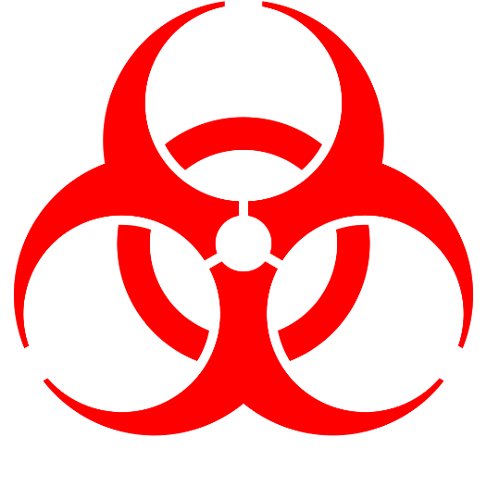

BSL-2
BIOSAFETY LEVEL | 2
RESTRICTED ACCESS
For work with: Insert one sentence summary here of project
Biohazardous Agents:
Procedure Required for Entry/ Exit: |  | Insert procedure required for entry/ exit
Special Practices (immunizations, etc.)
Notice | Call or See |  | Building | Room | UWM Phone | Home Phone
Entry or Advice

Emergency
Emergency

Building: Lapham Hall | Room | Date Posted:

