Congratulations, you're now able to create and administer assessments through the Campus Labs Baseline platform! To get started, log in using your ePanther ID at https://uwm.campuslabs.com. That will take you to a screen that looks like the image below. Click on “Baseline” to get into the assessment platform.
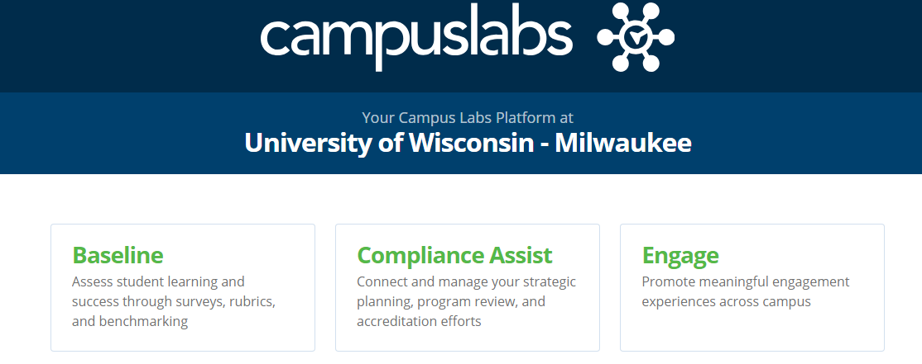
Now that you know you can get in, take 45 minutes to watch this Introduction to Baseline video. The most important content is shared from the beginning through minute 36, with about ten minutes of less often used features at the end of the video. This video will cover how to:
- Develop and conduct an assessment project
- Engage in professional development information and opportunities
- Locate community resources and national benchmarking studies
- Collect data online and with mobile devices
- Locate your assessment results
- Use the consultation available to you
If you want to dive into any specific topics, check out these articles and videos:
- How to request a project (article)
- How to preview your survey (article)
- How to export survey data (article)
- How to create a mass mailing (video)
- How to use reporting tools (video)
- Options for mobile survey data collection (article)
- Frequently Asked Questions about Baseline (article)
- An overview of the Student Response System, for formative assessment (article)
- Curious about a topic not listed here? The Campus Labs Baseline Support page has many more resources to help you navigate the website. You can also reach out to the Student Affairs Assessment Team to talk with someone 1:1 about your unique assessment questions and ideas!

