Power BI Advanced
This document provides a more thorough introduction to the Power BI service for authors who will publish content and manage workspaces and administrators who will be managing permissions and shared data assets. It describes the Power BI architecture and development workflow, explores some common campus reporting scenarios, and provides service development priorities.
Please note that the UWM Power BI service design is still being developed by the UWM Data Governance and Custodial Committee (DGCC) and this content is subject to change as the service matures. Specific questions about this content can be directed to DGCC-Group@uwm.edu.
For a simpler overview of the Power BI service and available license types, please see the related Power BI Basics document.

Power BI Architecture
Before jumping into licensing and development, it’s important to understand the Power BI architecture. The image below depicts the architecture and the general process flow for creating and sharing content:
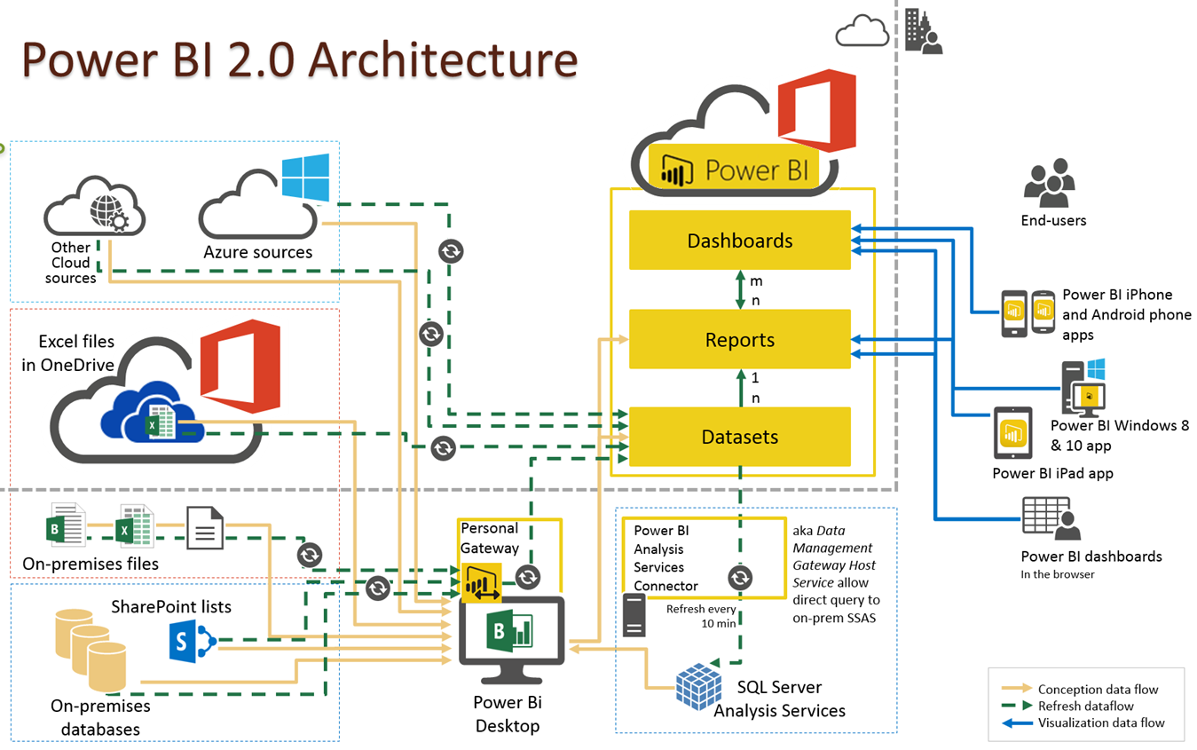
A couple of takeaways from this image about Power BI development:
- A common workflow in Power BI begins by connecting to data sources (either on-premises or in the cloud) and building a report or dataset in Power BI Desktop. You then publish that content from Power BI Desktop to the Power BI Service and share it in reports or dashboards, where end users can view and interact with it.
- For on-premises files or databases, an enterprise gateway can securely store credentials and automatically refresh datasets on a scheduled basis to ensure that data is always up-to-date.

Common Power BI Use Cases and Licensing Options
Please be aware that in the early stages of Power BI service, all data security measures will not be fully developed for automatically securing sensitive data. Pro licensees are responsible for managing user permissions on their content and adhering to all relevant state and federal data security guidelines.
If you have questions or concerns about the security of your data, please email DGCC-Group@uwm.edu.

I need to develop an interactive dashboard and share it with a small but known set of users (e.g., divisional leadership, department chairs) OR a larger, unknown set of users (e.g., all campus faculty and staff)
Development Flow: Create the report in the Power BI Desktop and then publish to the Power BI Service.
Licensing Options:
- Power BI Pro licenses for the report creator(s) and each of the viewers.
- Power BI Pro licenses for the report creator(s), Free licenses for each of the viewers, and Premium capacity added to the workspace in which the report is published.
Discussion: This example assumes that you are developing content which includes interactivity and user customizations, and not just a static report (see the next example for more basic report content).
- Option A is more feasible for the small known group, though from a support standpoint, it isn't ideal as it requires many Pro license requests for people who are only consuming content and probably don't need the additional Pro license capabilities.
- Option A would be a support nightmare for the large unknown group, as you'd have the above problem with many unnecessary Pro license requests, along with the need for a solid intake or onboarding process as new unknown users attempted to access your content.
- Option B is clearly the best option for both use cases, provided you have access to a Premium workspace where you can share your content.

I need to create a static report that’s refreshed regularly and shared out through SharePoint/Teams.
Development Flow: Create an Excel file within a SharePoint document library. This file needs to use Power Query to load data into a data model in order to be refreshable from the Power BI service.
Licenses Needed: Power BI Pro licenses for the report creator(s) so that it can be published to a Power BI workspace.
Discussion: This is a simplified workflow that doesn't require Pro licenses for viewers or a Premium Workspace but can still take advantage of automatic Power BI data refreshes. Depending on the simplicity of the content and the technical proficiency of your users, this may be an attractive option for many existing UWM reports. For example, if you just need to share a simple table or don't want to potentially confuse users with other Power BI options or provide training, this might be a solution.
Be aware that any users with access to this SharePoint document library will have access to the data in this report unless additional security precautions are taken. If you implement this solution, it is a good practice to manage document library permissions or create a new subfolder for this content with only the specific user(s) who require access to that data.

I want to create a report that's refreshed occasionally, and I plan to refresh it myself manually.
Development Flow: Create an Excel file and make sure your computer has the necessary components to connect to the appropriate data sources (e.g., the Oracle client is needed to connect to the data warehouse, HRS EPM, WISDM). Share this file using an appropriate secure storage location.
Licenses Needed: None
Discussion: This example is intended to show that not all authoring use cases will require the capabilities of the Power BI service or additional licenses. Excel and Power Query can provide similar data source connection and report creation functionality without some of the built-in sharing and updating capabilities of Power BI.
Again, be aware that any users with access to your secure storage location will be able to access this content, even if they are not authorized to view the data. As a content author, you are responsible for adhering to all relevant data security policies and ensuring that this content is appropriately secured.

Premium Workspaces and Service Design Priorities
We recognize that Premium Workspaces are required to unlock many of the powerful broad sharing capabilities of the Power BI service. It's also required to take full advantage of Dataflows with reusable elements called "computed entities" and create paginated reports.
The DGCC is making a conscious choice to prioritize some of the other structural service components and data security aspects of the service for Free and Pro license holders before we develop a formal process for applying Premium Capacity to individual workspaces.
At this point, we are focusing on:
- The hardware and personnel support for a true enterprise data gateway for refreshing Power BI data sets and reports. Currently, the Graduate School Office of Research is operating the only gateway on campus, which is not sustainable for an enterprise service.
- Developing the appropriate security groups, processes, and training for authors and admins to secure their Power BI content. Currently, we are working on a way to secure FERPA-protected dashboards, and on further securing access to sensitive content through the data gateway.
But we expect that a Premium Workspace funding and request model will be the next thing the group develops when these initial service design priorities are accomplished. If you have an immediate need for a Premium Workspace, please email DGCC-Group@uwm.edu to explore your options.

A Note on Power BI, OBIEE, and Other Tools
Several authors have asked us when to use Power BI, when to use OBIEE, and when to use any number of other available tools for creating and exploring data. Note that the following are just suggestions and shouldn't be taken as explicit rules for when to use the various tools at your disposal.
Power BI: The best full-featured tool for authors who want to build interactive BI content for the future, with a learning curve to match the power. You should use Power BI if you need rich visualizations, automatically-updated custom content, and regularly create your own data models with data from many external sources and files.
- Best available interactivity and visualizations available to all UWM faculty and staff without access requests (if you have a Premium Workspace).
- The most flexibility in creating custom data models from different data sources including Excel/CSV files and refreshing that data automatically on set schedules.
- Enormous depth and functionality also requires the most technical competency to identify and join data sources, build reports/dashboards, and apply security.
- No formal support provided for Power BI authors
OBIEE: The best tool for quickly creating simple reports and dashboards for a small set of defined users who already have OBIEE access. Use OBIEE if you are a less technical report author who mainly creates operational dashboards or tables with data from the UWM data warehouse.
- Pre-defined OBIEE data model simplifies report and dashboard creation, but also limits data flexibility by precluding custom join relationships between data and the use of Excel/CSV files
- Simpler set of visualizations that also requires all users to apply for Student Records Consumer access through the Data Access Request form.
- OBIEE environment requires FERPA training as a pre-requisite, so there are fewer security responsibilities for individual authors in securing content.
- Formal OBIEE author support provided by the UITS Enterprise Data Management team
SQL Developer: The best tool for exploring database fields and tables on your local computer without sharing needs, or for writing custom SQL queries to use in Power BI. Use SQL Developer if you already know SQL intimately and don't need to export data, but are interested in analyzing or exploring relationships between data before using another tool to create shareable BI content.
- No interface for joining tables or creating queries requires knowledge of SQL syntax to build and run queries
- Export functionality is limited to basic CSV/Excel tables without visualization or sharing capabilities

