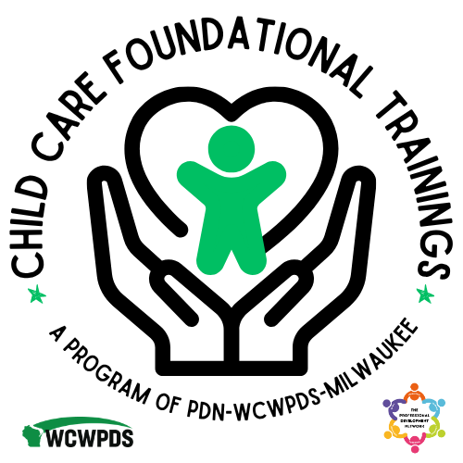

PDS ONLINE USER GUIDE FOR EARLY CARE
AND EDUCATION PROFESSIONAL USERS

Step One: Create a PDS Online Self-Registration Account Here:
https://pdsonline.csod.com/selfreg/register.aspx?c=self_reg_default
Once submitted, you will receive an email to the address you entered.
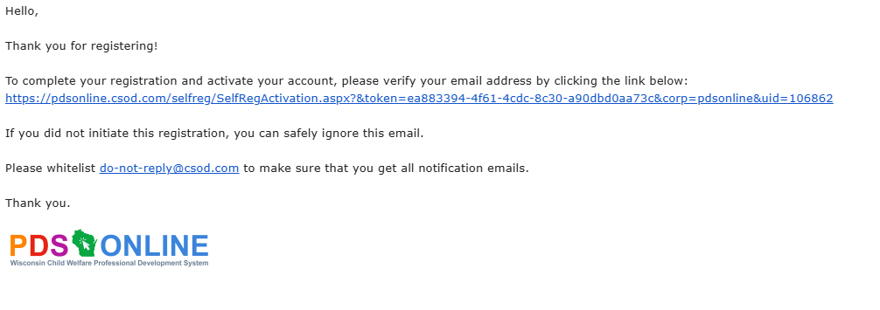
Click on the link, which will take you to this login screen. Enter the email and password you used to create your account:
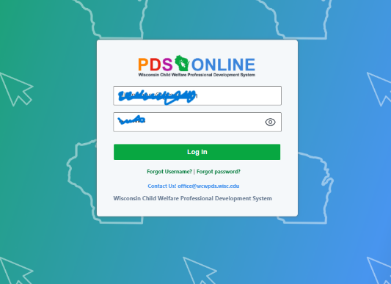
Once logged in, you will be directed to take a learner profile. This will allow you to see what you need to see in the system. You will select “Early Care & Education Professional”
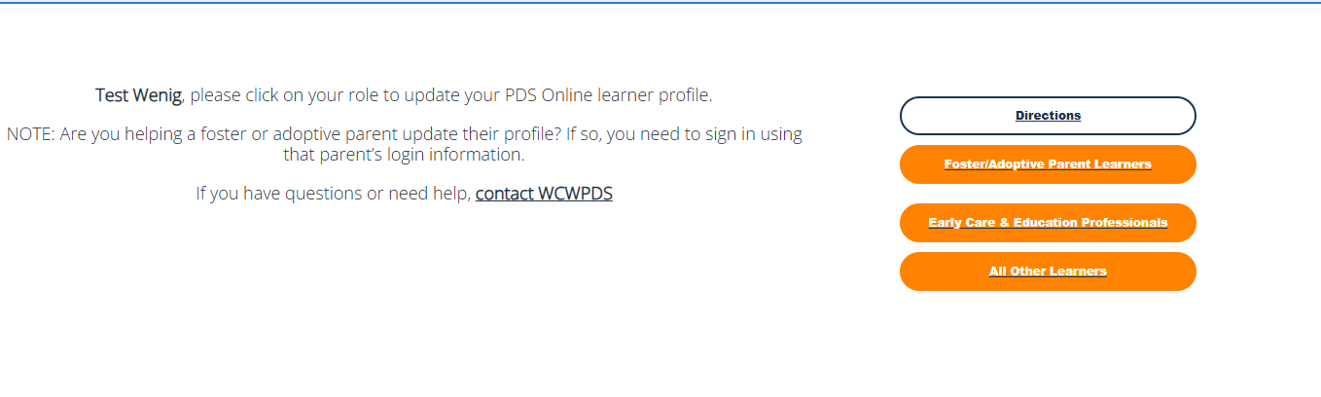

Fill out the learner profile, using the tips and suggestions below:
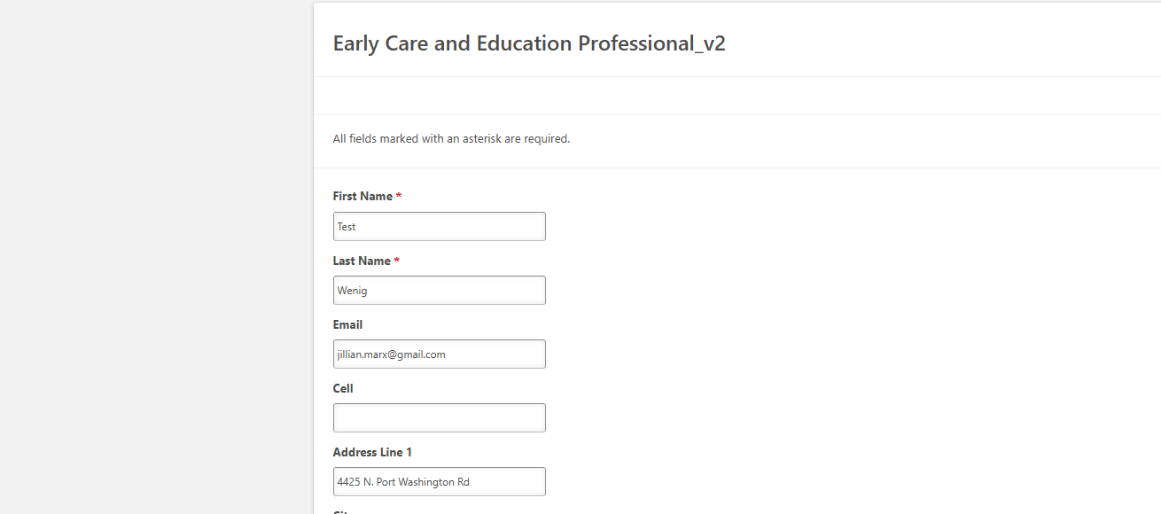
Please enter an email that you check regularly, and if you have a Registry account please use the same email.

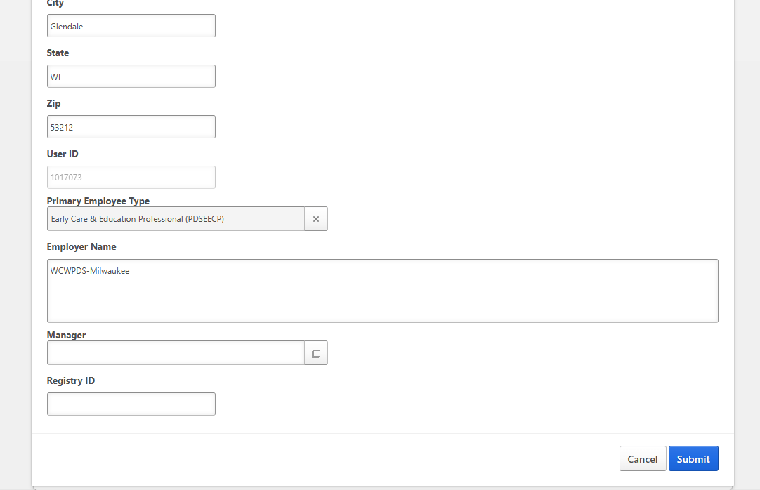
If known, please include your Registry ID. This can be updated at any time and will help in reporting back your completion information accurately.
Please list the organization you work for here.
You will ALWAYS select “Early Care & Education Professional for your Primary Employee Type to see the CCFT Trainings
Once completed, click submit.
Please allow the system 3-4 hours to update your profile before attempting to search or register for trainings.
Once updated, you can find a training several ways:
- If your TSO provided you a direct link to training, you can follow that link and hit “Request”.
- You can search from the interactive calendar on the PDN-CCFT website, which will link you directly to the training:
- You can search the event calendar in PDS Online.
TIP: You can narrow your search by looking up your TSO in the Session ID filter on the left side of the page:
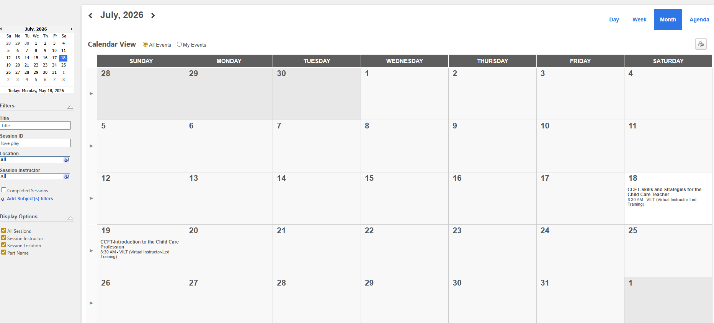

This example is the TSO “Love Play Learn Learn LLC”
By registering for the session, you will be put into the matching cohort for that training. The cohort is also tied to a community where the interactive portion of your learning will take place within the PDS Online LMS. These cohorts will live in your transcripts, located under the Learning Tab>View Your Transcript.
From there, it will appear in your transcript one of two ways:
- If training is in the future (before the set cohort start date), it will appear as “View Training Details”
- Once the training is set to start (the cohort start date opens it up) it will appear as “launch”
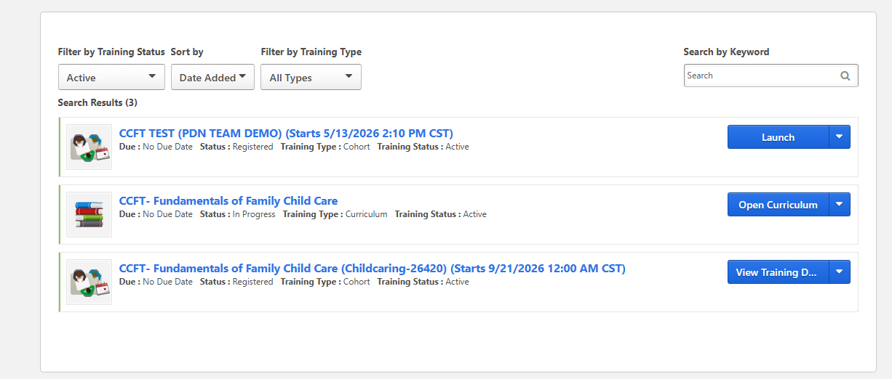
WAITING TO LAUNCH/TRAINING IN THE FUTURE
READY TO GO
You will click launch when the training is ready to begin, bringing you here, which is the “community” your “cohort” will live in.
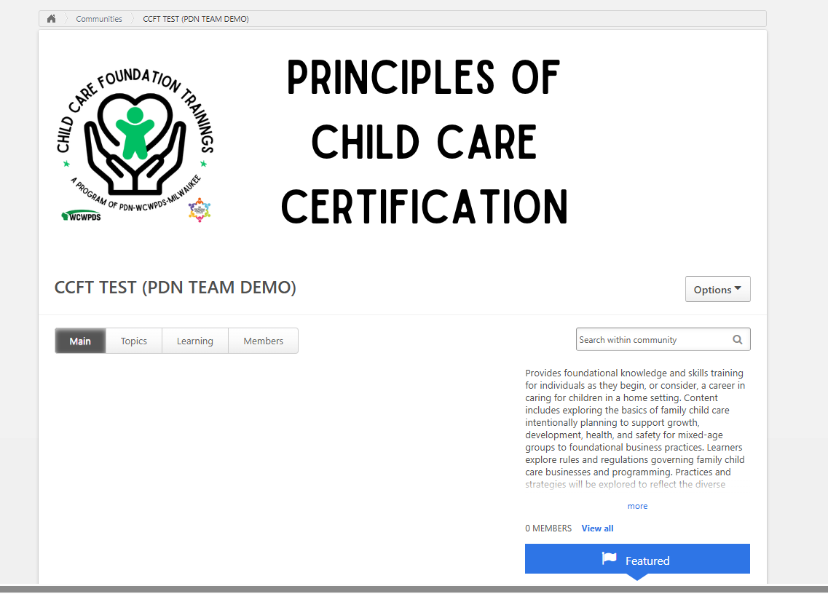
The main page is customizable, where your trainer can highlight materials, discussions, introductions, etc.
The topics page is also customizable, where your trainer will build out folders based on resources you have, assignments, etc.
The learning page is where your learning progress is displayed: 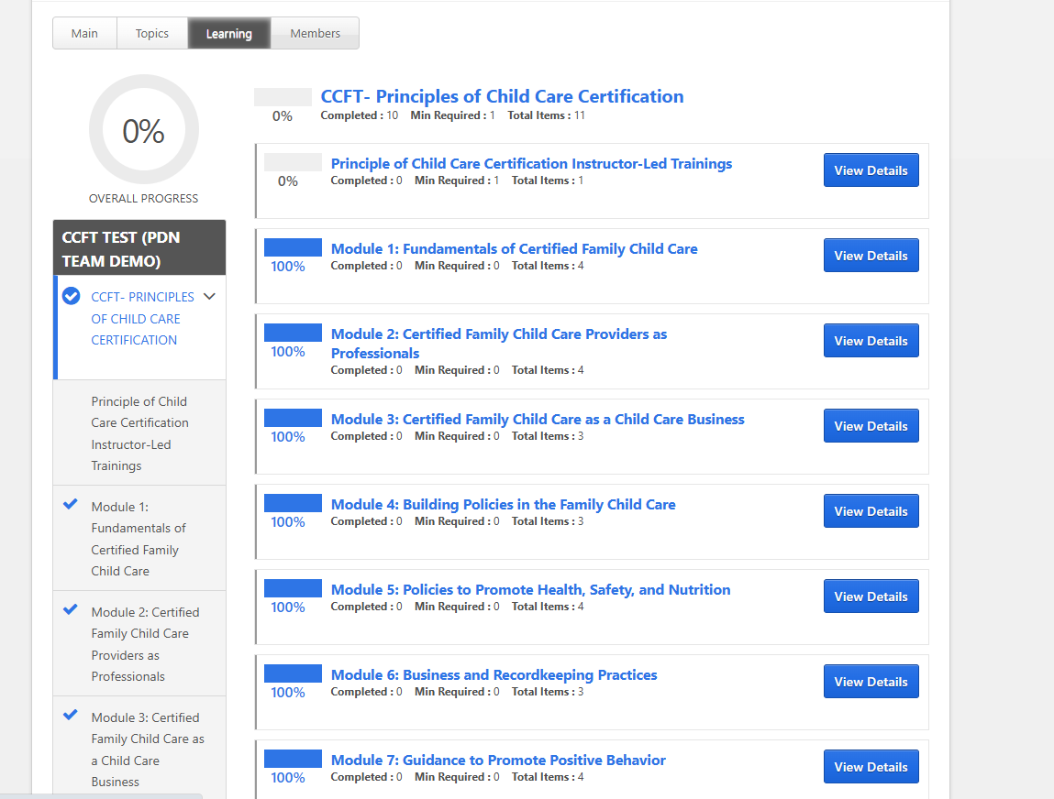
Each TSO and instructor will setup their course differently based on what online modules and elements they will use and what they will train face-to-face, so views may vary, but options include:
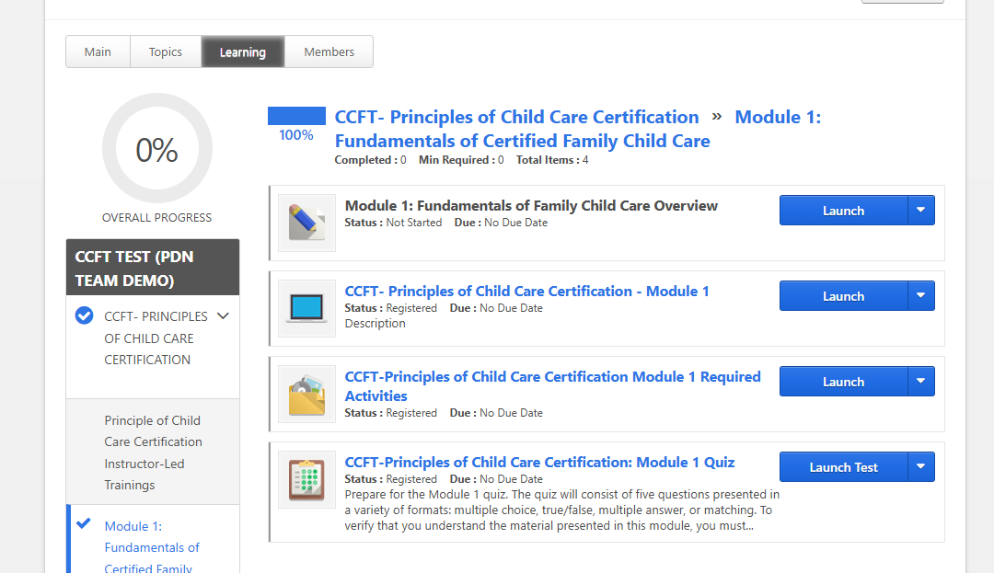
You may see a section overview:
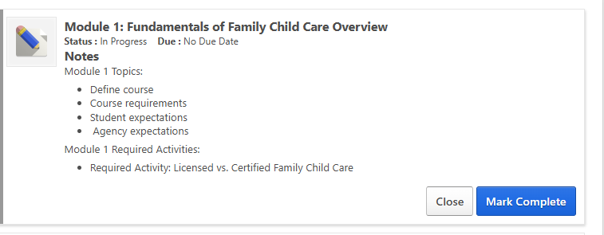
You may launch the asynchronous module (opens in a new page):
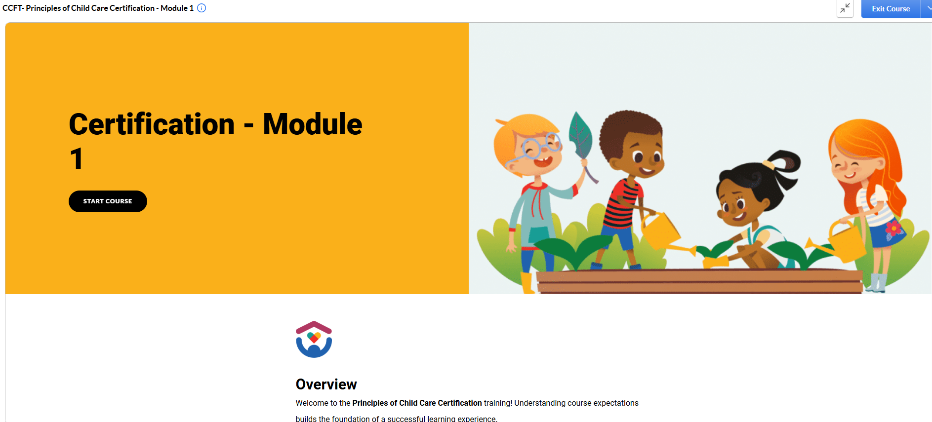

You may launch the materials packet (in a separate window PDF):
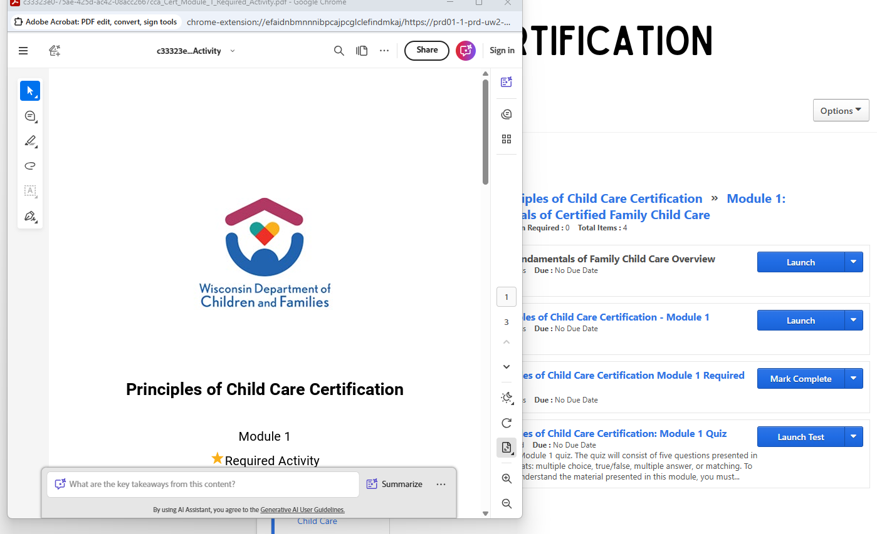

And you may launch and take the quiz. Your trainer will guide you what is and is not included in their instance of the training, and completion of the training will be based on attendance at the face-to-face (required) portions of the training, and completion of all required assignments, quizzes, and instruction set forth by the trainer.

