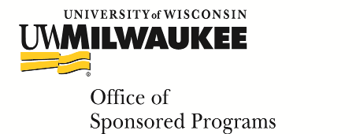 | National Science Foundation FastLane Registration Form  created 6 July 2016

Please use this form only to request a new FastLane account. If you had a previous FastLane account with another institution, please contact your Pre-Award Specialist in the Office of Sponsored Programs to discuss updating your affiliation to UWM.

An NSF ID will be generated for all new users when registration is complete. You will need to use both your NSF ID and your password in order to access FastLane.

Please return the completed form to your Pre-Award Specialist in order to complete your FastLane registration.

*First Name:

*Middle Initial:

*Last Name:

*Department:

*Ten Digit Phone Number:

*E-mail:

*Highest Degree Obtained:

*Degree Year:

16 Digit ORCID Identifier:

*Denotes Required Field

