Home Visiting & Bed Bugs

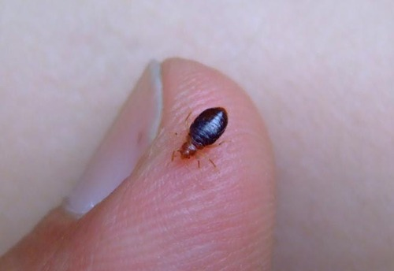

While this outline specifically mentions bed bugs, it may also apply to other types of insects or pests.
Remember : On-person infestations are uncommon

If you visit homes where bed bug infestations are known and present, the following guidelines will be helpful when conducting a home visit:
- Avoid placing any items on upholstered furniture or bedding. This is the most common way to transfer bed bugs from one place to another.
- Do not sit on cloth-covered furniture or bedding. Pay attention to cracks and crevices of wooden or hard surface chairs as it is possible that bed bugs are hiding in these cracks and crevices.
- The safest place to sit would be in the kitchen on a non-upholstered chair; this is the place where you are least likely to encounter bed bugs.
- Bring only items necessary for the visit into the home. A plastic or metal clipboard can be used to hold paperwork.
- Store personal items securely in your car prior to arriving at the home.
- Have a separate pair of shoes in your car which you wear into homes with bed bug infestations and then store in a sealed plastic bag when not in use.

If bed bugs are suspected; upon completion of the visit:
- Perform a self- inspection. Pay attention to inside and outside of shoes, lace holes, socks, leg area and around hands and arms.

IF you find a bed bug, use wet wipes to contain or crush the insect. Wipe the surrounding areas with another wet wipe.
Notify your supervisor and return home and follow these guidelines:
- When you arrive home, remove your clothing (either in an attached garage or just inside the entry door).
- Place clothes in a plastic bag that can be tightly closed via a knot or twist tie.
- Wash clothing in hot, soapy water and dry in a dryer using the highest heat setting that the fabric can safely withstand.
- Any clothing that cannot be washed or dry cleaned should be placed in a dryer on medium high for at least 30 minutes.
- If items are taken to the dry cleaner, inform the cleaner of the possibility of bed bugs.

The following items may be useful to keep in your car:
Plastic grocery or garbage bags
Wet Wipes
Change of clothing/shoes

These guidelines are based on those created by the Central Ohio Bed Bug Taskforce. Additional information provided by University of Minnesota Entomology and Minnesota Department of Agriculture

