Using Maps to Learn Puerto Rico’s History
Grade Level: 6-8
Courses: Social Studies
Topics: Puerto Rico, Map Analysis, Colonization of the Caribbean

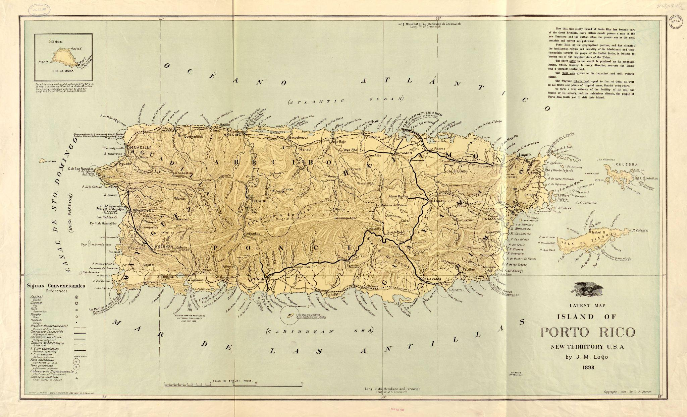

Lago, J. M. Latest Map of Island of Porto[Sic] Rico, New Territory U.S.A. / by J. M. Lago ; Drawn and Printed by Colton, Ohman & Co. ; Copyright by C.F. Storer. 1898, https://collections.lib.uwm.edu/digital/collection/agdm/id/5392/rec/59. University of Wisconsin-Milwaukee Libraries, American Geographical Society Library Digital Map Collection.

Objectives
➤ Students will think critically about and engage with maps as a primary source.
➤ Students will form a basic understanding of Puerto Rico’s history by analyzing a chronological timeline of maps. These maps will be used as a springboard for classroom/group discussion.

From the University of Wisconsin-Milwaukee's Center for Latin American and Caribbean Studies

This lesson plan was developed by undergraduate student Boston Peters in summer 2025
under a Support for Undergraduate Research Fellows (SURF) grant through the UWM
Office of Undergraduate Research (OUR), supervised by the UWM Center for Latin
American and Caribbean Studies (CLACS) Associate Director, Monica VanBladel.
This, and more teaching resources developed under the research grant, can be found on https://uwm.edu/clacs/public-engagement/teaching-resources/k-12-lesson-plans-surf-2025-26/.
Please note that the UWM CLACS website will be redesigned in 2026, resulting in a change of the website’s stable URL. When this occurs, the link provided above will no longer be functional. The new website will prominently feature available educator resources, including this one.

The University of Wisconsin-Milwaukee’s Center for Latin American and Caribbean
Studies is a member institution of the national Consortium of Latin American Studies
Programs (CLASP). CLASP also develops and shares a wide variety of K-12 educator
resources on its website: https://claspprograms.org/k-12-educators/.

The following lesson may include state standards and/or “I can” statements related to the
lesson content. These standards/statements were initially added as an educational
framework for lesson design and may not be exhaustive.

This document may include hyperlinks. A page at the end of the document has been added
to provide the URL included in each hyperlink, as well as other information about where
the hyperlink leads. This information is intended to assist in finding the linked webpage if
the hyperlink no longer functions.

Introduction

Begin with a student discussion to gauge their prior knowledge of Puerto Rico. You could offer students this list of questions to use as the basis for a partner or small group conversation:
- Have you heard of Puerto Rico?
- Do you know anyone from there? Friends or family? Celebrities or artists?
  - Have you ever traveled there or know someone who has traveled there?
- What languages are spoken in Puerto Rico?
- What food is eaten there?
- What is the weather like?
- Where is Puerto Rico located? Is it near the United States? Is it north of the U.S. (closer to the poles) or south of the U.S. (closer to the equator)?
  - If you have a world map in your classroom, you could ask students to try identifying Puerto Rico on the world map.
- Is it an independent nation (self-governing), or part of another country?
  - If not an independent nation, how did that come about?

Tell students: “Today we're going to practice working with a specific primary source—maps—to learn more about this U.S. territory and its history."

Lesson: Day 1

Wisconsin Standards for Social Studies (PDF)
Standard SS.Hist4: Wisconsin students will evaluate a variety of primary and secondary sources to interpret the
historical context, intended audience, purpose, or author’s point of view (Historical Methodology).
SS.Hist4.a.m Explain how the historical context (situation) influences a primary or secondary source.
SS.Hist4.b.m Explain the significance of the intended audience of a primary or secondary source.
SS.Hist4.c.m Explain the significance of the intended purpose of a specific primary or secondary source.
SS.Hist4.d.m Explain how the POV of the author can influence the meaning of a primary or secondary
source.
URL: https://dpi.wi.gov/sites/default/files/imce/standards/New%20pdfs/2018_WI_Social_Studies_Standards.pdf

Images of the maps that will be utilized for this lesson are included towards the end of this document. For the best image resolution, it may be helpful to visit the original webpages that the maps are from.

Have students read through Meet the Map!, a resource created by Georgia Brown, Public Services Librarian at the American Geographical Society Library at UW-Milwaukee. This resource helps to explain the process of map analysis for students. It also includes a “Test Your Skills” section that can help students prepare to analyze a map.

- Break students into four different groups, one group for each map.
- Each group will begin analyzing their assigned map using the questions provided on the Meet the Map! Worksheet (included further on in this document, past the “Links and Citations” section). Have students answer the worksheet questions in the “Meet the Map! — Singular Map” section first and wait before moving on.
  - You are welcome to edit/omit some parts of the worksheet if it is a bit long for the allotted class time.
- Next, pair two groups and have them work together to answer the worksheet questions in the section “Meet the Map! — Compare Two Maps”.
- If time permits, repeat this process with groups analyzing the maps they have not yet seen.
Students may need access to the information in “Map Links and Citations” (or to the original databases where the maps are hosted) in order to determine some map information, such as author and date created. However, encourage students to make an educated guess on what language the map is in before they reference the database information.

Lesson: Day 2

Wisconsin Standards for Social Studies (PDF)
Standard SS.Hist1: Wisconsin students will use historical evidence for determining cause and effect.
SS.Hist1.a.m Use multiple perspectives to analyze and explain the causes of issues or events within and
across time periods, events, or cultures.
SS.Hist1.b.m Use multiple perspectives to analyze and explain effects of issues or events within and
across time periods, events, or cultures
URL: https://dpi.wi.gov/sites/default/files/imce/standards/New%20pdfs/2018_WI_Social_Studies_Standards.pdf

Today, students will utilize the maps from the prior day/lesson in order to build a mini-timeline of Puerto Rico’s history.
Students should work together in groups to identify which parts of the timeline match with each map. Groups should be made up of students who each worked on different maps so that knowledge of each map is represented in each group.
When preparing students for this activity, emphasize that the maps don’t necessarily portray the specific historical moments listed. Rather, they represent either a broader time period where the listed events were taking place OR the results of the listed events.
Students should be prepared to explain WHY they made the matches they did.

Once students have had some time to make the matches within their assigned groups, have each group pair with another group to discuss their matches. Ask students to share the reasoning behind their decisions with the other group.
Students can utilize this model if they need assistance giving feedback:
- I agree that Map #_ matches with Time Period #_ because of Reason X and Reason Y.
- I don’t agree that Map #_ matches with Time Period #_ because of Reason X and Reason Y. I think that Map #_ matches with Time Period #_ because of Reason X and Reason Y.

If some groups complete the matching task earlier than others, have students consider and discuss the following questions:
Discussion Questions for Recognition
- Do you recognize the names Boriquén, Saint-Domingue, and/or Puerto Rico?
- Did you know France also had colonies in the Caribbean?
- Have you heard of the Spanish-American war?
Discussion Questions for Critical Thinking
- How would it feel for people living on an island to have different countries fighting for leadership of that island?
- How might a person’s day-to-day life be affected if there is a change in who (which country) is controlling/governing the land where they live?
- How do each of the listed events lead to the next? How are they related?
A matching worksheet is included further down in this document, following the full-size map images. Note that on the worksheet the time period descriptions are no longer in chronological order (though the maps themselves are). The matching list below provides the answers to this worksheet.

Era & Events Matching List:
[Map A] #3. 1493: Christopher Columbus lands on Boriquén
Columbus lands on Boriquén November 19th, 1493. Spain’s colonization of Boriquén follows, leading to the genocide of the Taino people—Boriquén’s indigenous population.
[Map B] #4. 18th century (1700s) scramble for colonial control
Hispaniola—the island west of Puerto Rico—is initially controlled by Spain in its entirety. The western portion becomes a French colony named Saint-Domingue, which later becomes Haiti. The eastern portion remains controlled by Spain and later becomes the Dominican Republic. Meanwhile, in 1797, England (at war with France and Spain) attempts to seize Puerto Rico. This invasion fails, meaning Spain retains possession of Puerto Rico.
[Map C] #1. 1898: Spanish-American War
While Cubans are fighting for independence from Spain, an explosion sinks a U.S. ship anchored in a Cuban harbor (February 15th, 1898.) U.S. journalism frames Spain as the culprit, contributing to the United States’ eventual decision to wage war against Spain. This Spanish-American War ends with multiple of Spain’s Caribbean territories being ceded to the United States, including Puerto Rico.
[Map D] #2. Late 20th century (1900s) tourism
After a century as a U.S. territory, tourism has become a key element of Puerto Rico’s economy, acting as an important source of tax revenue and economic activity. The island has adapted to accommodate both increased tourists and foreign residents, many of them coming from the mainland U.S.

Bigger Picture Discussion: Day 2 cont’d.

Teacher Preparation: Read through About Memoria Decolonial to gain more context about the map being presented.

Have the class come together for a moment to introduce them to a new map: Cartographies of Memory: Map of (de)colonial monuments in Puerto Rico.
Explain that this map was created by Puerto Ricans as a way for them to catalog and assess how colonization has impacted Puerto Rico.

Have students group for a final discussion.
For baseline and additional questions, have students revisit the Meet the Map! worksheet. Questions #9-10, #12 (in the “Singular Map” section), and #5 (in the Comparison section) could be omitted for this discussion.
The following are unique/new questions to be used in this discussion:
- What differences stand out to you between the previous maps and this new map?
- Who created each of the maps? Why does the creator of the map matter when comparing the previous maps to this new map?
- How does a map creator’s experience of a place change what they highlight on a map?
- How does Puerto Rico’s history of external control influence what mapmakers believe is worth highlighting?
- How has technology influenced who has the ability to create a map?
- How does creating a map like this give people a voice?

Key Takeaway: This new map (“Cartographies of Memory: Map of (de)colonial monuments in Puerto Rico”) was created by Puerto Ricans themselves as a way to recognize and criticize the presence of external control (colonization) on their island. This contrasts the older maps that were created from a colonial perspective in order to document and lay claim to the island of Puerto Rico from the outside.

Links and Citations

“Meet the Map!” by Georgia Brown (Public Services Librarian at the American Geographical Society Library at UW-Milwaukee) on ArcGIS StoryMaps, https://storymaps.arcgis.com/stories/92427ccde5d743bcb38b38a8ebdcabc1.

“About Memoria Decolonial” on MEMORIA (DE)COLONIAL (2025), https://memoriadecolonial.com/en/about.

“Cartographies of Memory: Map of (de)colonial monuments in Puerto Rico.” created by MEMORIA (DE)COLONIAL (8 August 2023, Updated 16 August 2025) on uMap (https://umap.openstreetmap.fr/en/), https://umap.openstreetmap.fr/en/map/memoria-decolonial-mapa-de-monumentos-decoloniales_489674#9/18.1772/-66.6623.

Below are additional resources that were referenced while producing this lesson plan.

“Spanish-American War” (2 August 2025) on Encyclopedia Britannica, https://www.britannica.com/event/Spanish-American-War.

“Important Dates in Puerto Rican History” (7 July 2020) by Teaching for Change, https://www.teachingforchange.org/important-dates-puerto-rican-history.

“Haiti (Saint-Domingue)” created through collaboration of the United Nations Educational, Scientific and Cultural Organization’s (UNESCO) Slave Route Project and The Colonial Williamsburg Foundation, hosted on Slavery and Remembrance (https://slaveryandremembrance.org/), https://slaveryandremembrance.org/articles/article/?id=A0111.

“Puerto Rico” (Updated 28 May 2025) on History.com, https://www.history.com/articles/puerto-rico-history.

“Today in History - February 15: Remember the Maine!” on the Library of Congress website, https://www.loc.gov/item/today-in-history/february-15/.

“The Untold History of Puerto Rico” by Vanessa Ramos (Updated 4 February 2025) on Travel Lemming, https://travellemming.com/perspectives/puerto-rico-history-you-should-know/.

MAP A. A higher-resolution version of this map can be found here: https://digitalcommons.unf.edu/alcfh-maps/4/
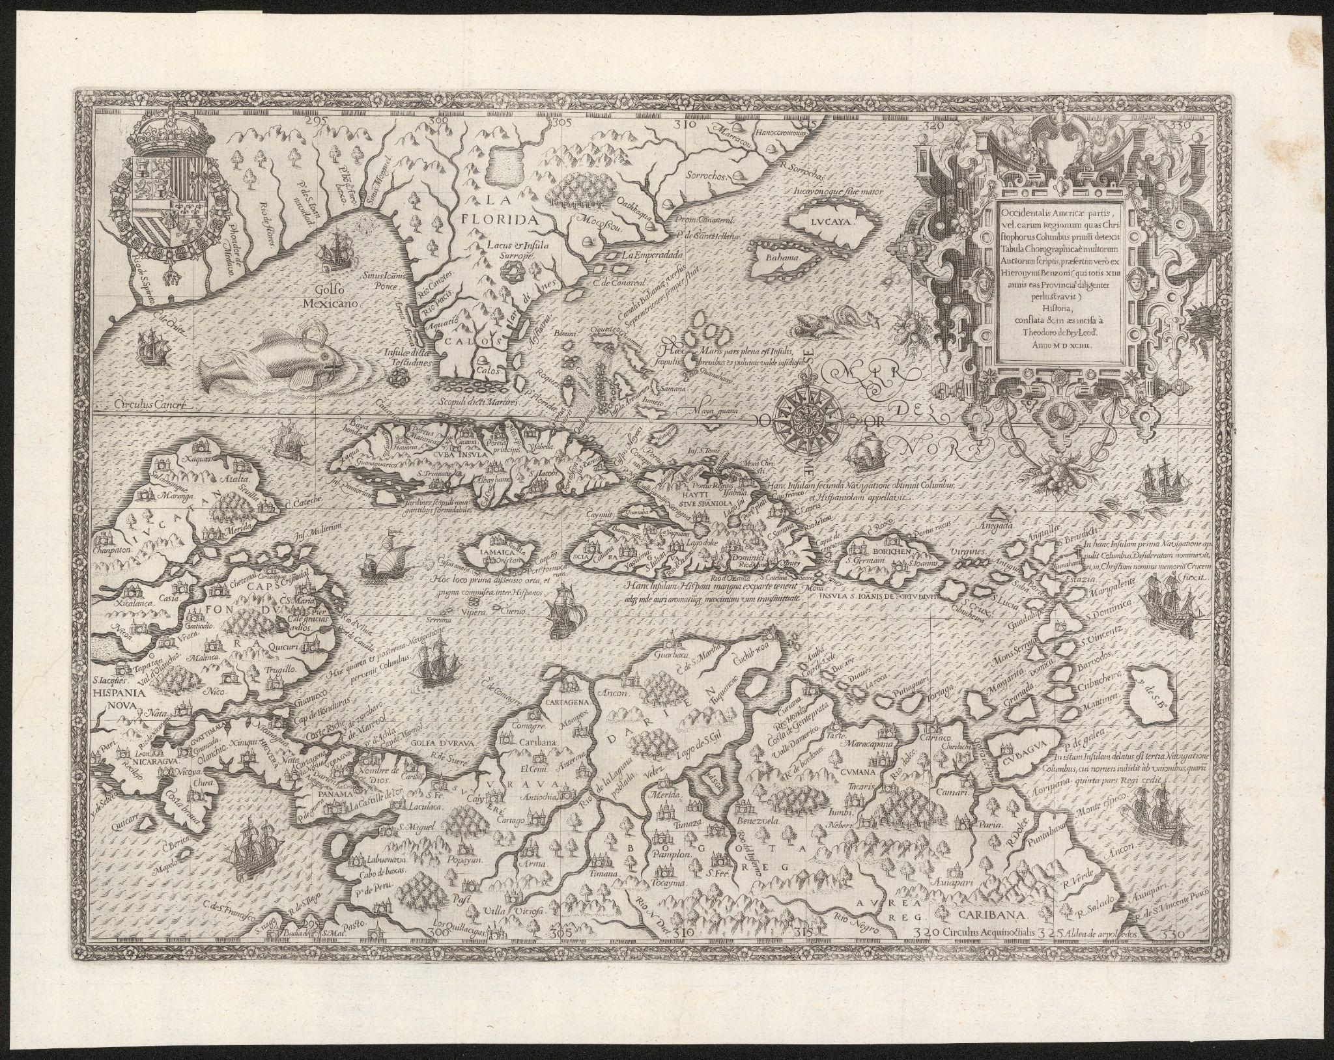
MAP B. A higher-resolution version of this map can be found here: https://upr.contentdm.oclc.org/digital/collection/MapasRaros/id/21/rec/1
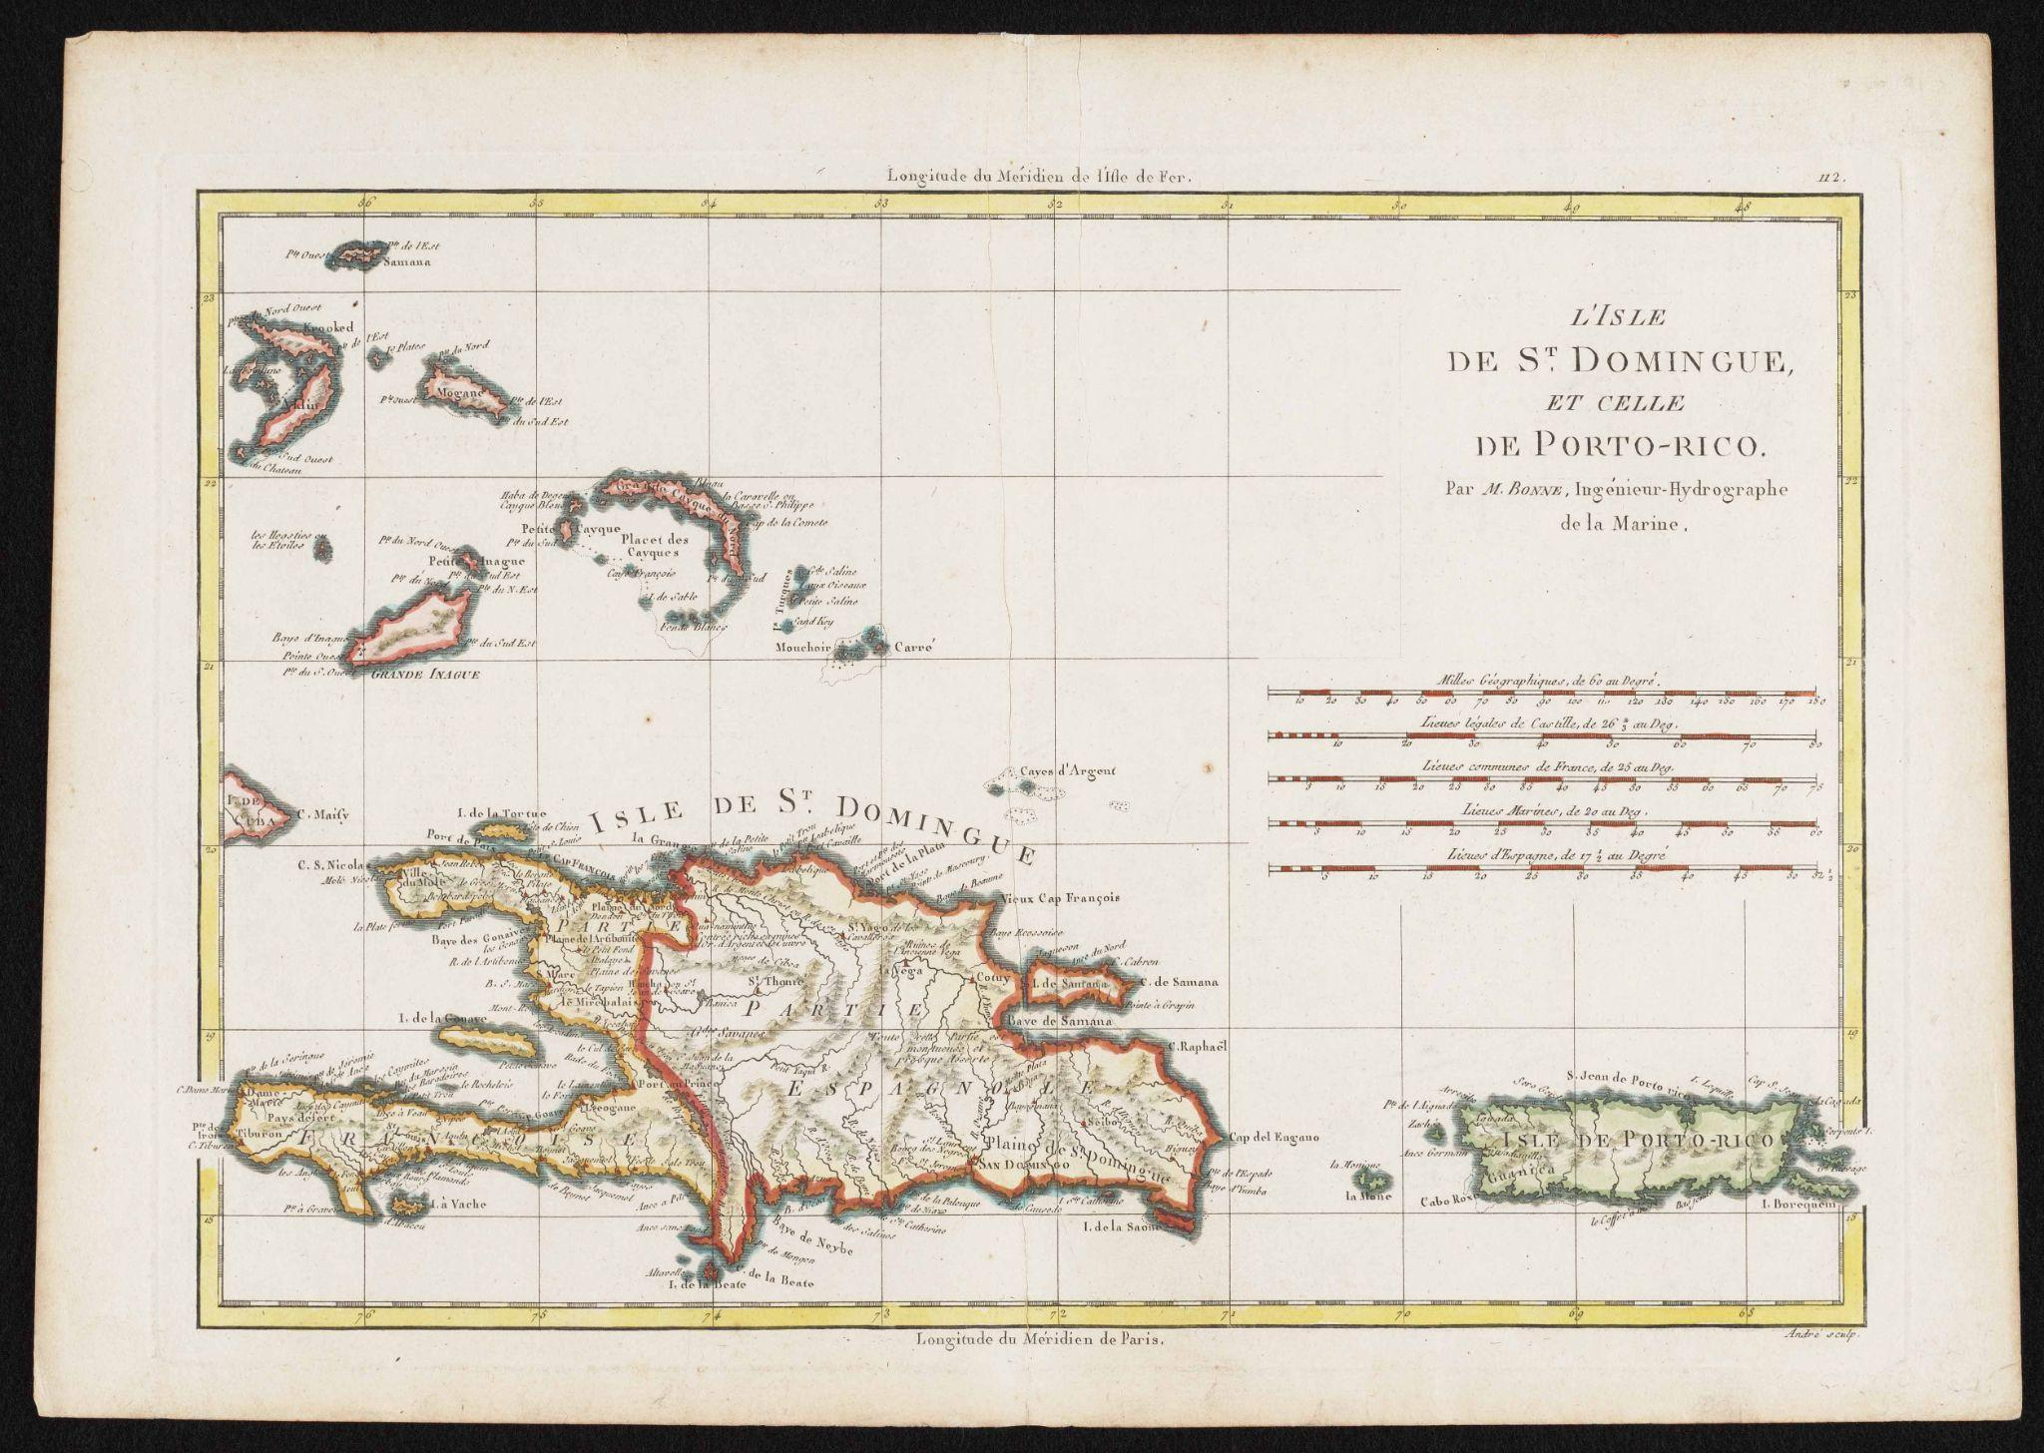
MAP C. A higher-resolution version of this map can be found here: https://collections.lib.uwm.edu/digital/collection/agdm/id/5392/rec/59

MAP D. A higher-resolution version of this map can be found here: https://collections.lib.uwm.edu/digital/collection/agdm/id/35883/rec/3
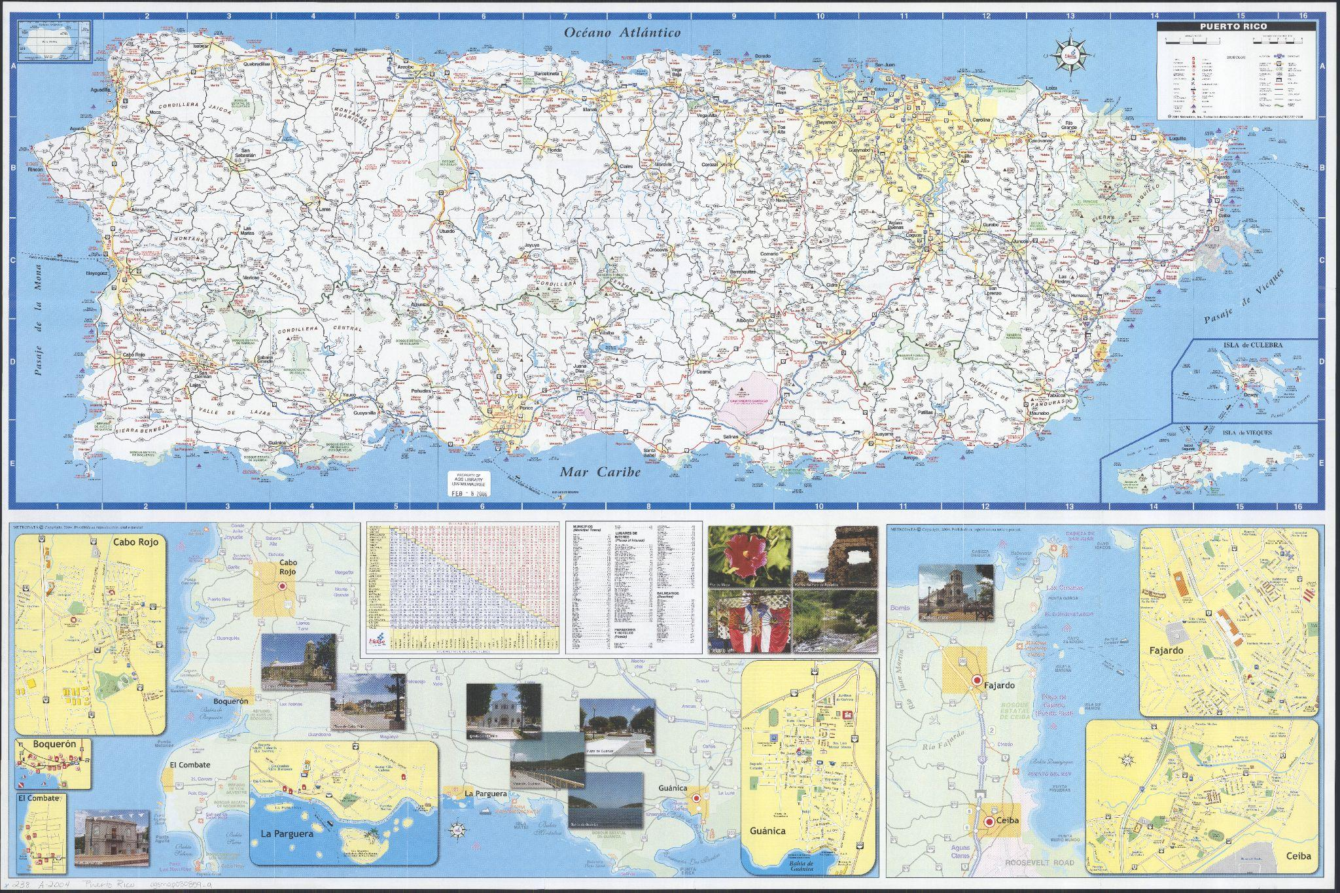

Map Links and Citations

Map A - Page 1

Basic Info
Author: Theodor de Bry (1528-1598)
Created: 1594
Language: Latin

Rights Statement
NO COPYRIGHT - UNITED STATES
http://rightsstatements.org/vocab/NoC-US/1.0/

Citation
Bry, 1528-1598, Theodor de. "Occidentalis Americae partis : vel earum regionum quas Christophorus Columbus primũ detexit tabula chorographicaè multorum auctorum scriptis, praesertim verò ex Hieronymi Benzoni (quitotis XIIII annis eas provincias diligenter perlustravit)." Francofurti ad Moenvm : Typis Ioannis Feyrabend, 1594. Allen Lastinger Center for Florida History. Thomas G. Carpenter Library, University of North Florida. UNF Digital Commons, https://digitalcommons.unf.edu/alcfh-maps/4

Map B - Page 2

Basic Info
Author: Rigobert Bonne
Created: 1700s
Language: French

Rights Statement
Article L123-1 of the French Intellectual Property Code states the proprietary rights generally end 70 years after the author’s death.

Citation
Bonne, Rigobert. L’Isle de St. Dominique et celle de Porto-Rico. Paris : s.n., 17--?, https://upr.contentdm.oclc.org/digital/collection/MapasRaros/id/21/rec/1. Biblioteca Digital Puertorriqueña, Mapas Raros.

Map C - Page 3

Basic Info
Author: J. M. Lago
Created: 1898
Language: English

Rights Statement
About Copyright and the UWM Libraries’ Digital Collections
https://uwm.edu/libraries/digital-collections/copyright-digcoll/

Citation
Lago, J. M. Latest Map of Island of Porto[Sic] Rico, New Territory U.S.A. / by J. M. Lago ; Drawn and Printed by Colton, Ohman & Co. ; Copyright by C.F. Storer. 1898, https://collections.lib.uwm.edu/digital/collection/agdm/id/5392/rec/59. University of Wisconsin-Milwaukee Libraries, American Geographical Society Library Digital Map Collection.

Map D - Page 4

Basic Info
Author: Metrodata, Inc.
Created: 2004
Language: Spanish

Rights Statement
Fair use of copyrighted material for educational purposes.

Citation
Metrodata, Inc. Mapa Vial y Turistico Puerto Rico / Metro Data. San Juan : Metro DATA, 2004, https://collections.lib.uwm.edu/digital/collection/agdm/id/35883/rec/3. University of Wisconsin-Milwaukee Libraries, American Geographical Society Library Digital Map Collection.

Meet the Map! — Singular Map

Observe its parts.

1. What are the first three things you notice about your map?

2. What is the title?

3. What place or places are shown?

4. When is it from? (Most American Geographical Society Library maps show the date in the call number on the lower left corner.)

5. Who made it? What language is it in?

6. How might the creator / mapmaker impact the content of the material / map?

Try to make sense of it.

7. Do you trust this map? Why or why not?

8. Why was it created? List the evidence from the map, knowledge about the mapmaker, or knowledge of what was happening in history that leads you to your conclusion.

9. How would you remake a map of the same place?

10. What would a good research question be for your map?

Use it as historical evidence.

11. What narrative does this map provide? Who is the intended audience?

12. What other documents or historical evidence could you use to help you understand this event or topic?

13. What did you find out from this map that you might not learn anywhere else?

Meet the Map! — Compare Two Maps

1. What place or places are shown?

2. Do these maps depict the same place(s)? How far apart in years were the maps made?

3. What are three differences between the two maps?

4. Can you tell why the two maps were created?

5. What research questions could you ask of the two maps?

Utilizing Maps to Learn Puerto Rico’s History: Matching Worksheet

While Cubans are fighting for independence from Spain, an explosion sinks a U.S. ship anchored in a Cuban harbor (February 15th, 1898.) U.S. journalism frames Spain as the culprit, contributing to the United States’ eventual decision to wage war against Spain. This Spanish-American War ends with multiple of Spain’s Caribbean territories being ceded to the United States, including Puerto Rico. | #1 | Map A
After a century as a U.S. territory, tourism has become a key element of Puerto Rico’s economy, acting as an important source of tax revenue and economic activity. The island has adapted to accommodate both increased tourists and foreign residents, many of them coming from the mainland U.S. | #2 | Map B
Columbus lands on Boriquén November 19th, 1493. Spain’s colonization of Boriquén follows, leading to the genocide of the Taino people—Boriquén’s indigenous population. | #3 | Map C
Hispaniola—the island west of Puerto Rico—is initially controlled by Spain in its entirety. The western portion becomes a French colony named Saint-Domingue, which later becomes Haiti. The eastern portion remains controlled by Spain and later becomes the Dominican Republic. Meanwhile, in 1797, England (at war with France and Spain) attempts to seize Puerto Rico. This invasion fails, meaning Spain retains possession of Puerto Rico. | #4 | Map D

