Portrait of Tenochtitlan: Analyzing a Pre-Columbian City
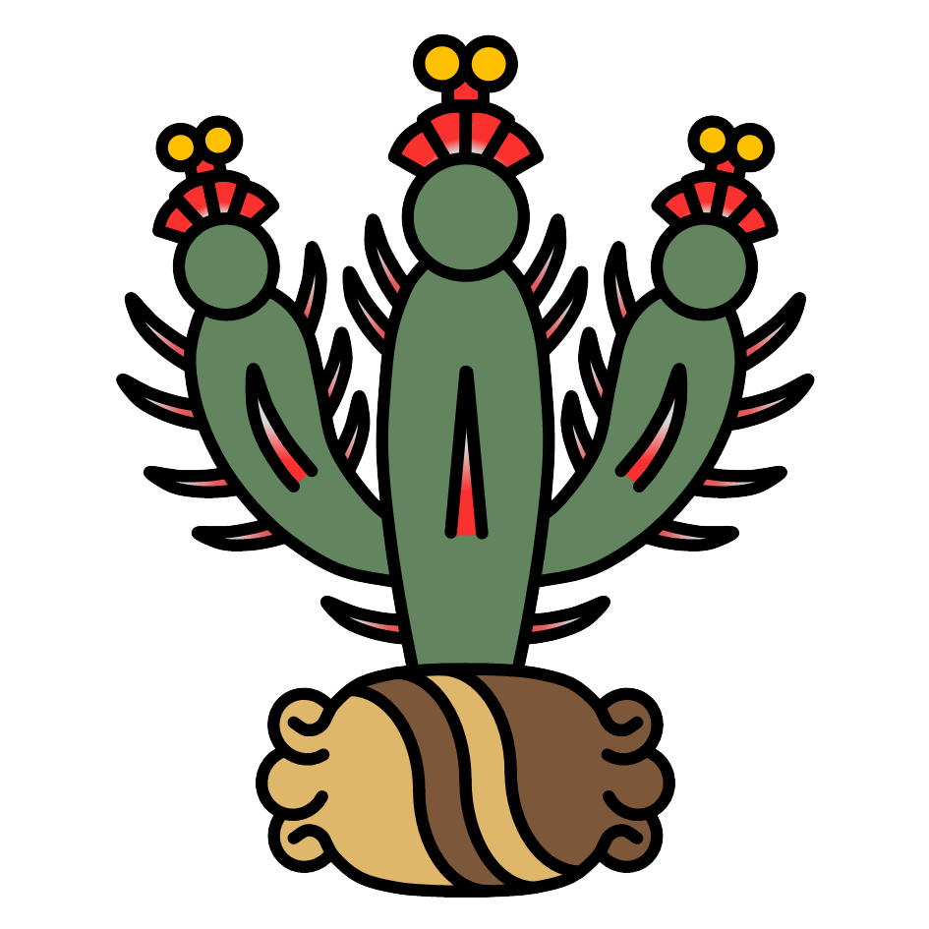
Grade Level: 6-8
Courses: Social Studies, Ancient Civilizations, Urban Studies, History of Mexico
Topics: Pre-Colonial Mexico, City of Tenochtitlan, Mexico City, Comparison of Past vs. Present, Social Uses of Space, Urban Relationship to Natural Environment

Objectives
➤ Students will study a 3D reconstruction of the pre-Columbian Mesoamerican city Tenochtitlan alongside short text selections. They will then analyze and draw conclusions about this important civilization that preceded Spanish rule in the Valley of Mexico.
➤ Students will learn about the complexity of Tenochtitlan, including its location, principal structures, social organization, and primary language.
➤ Students will practice making comparisons between past (Tenochtitlan/Lake Texcoco) and present (Mexico City).

Main Resource: Thomas Kole’s “A Portrait of Tenochtitlan”

“File:Tenochtitlan.png” (above, right) by User:AztecEmpireEmbassy is licensed under CC BY-SA 4.0.

From the University of Wisconsin-Milwaukee's Center for Latin American and Caribbean Studies

This lesson plan was developed by undergraduate student Boston Peters in summer 2025
under a Support for Undergraduate Research Fellows (SURF) grant through the UWM
Office of Undergraduate Research (OUR), supervised by the UWM Center for Latin
American and Caribbean Studies (CLACS) Associate Director, Monica VanBladel.
This, and more teaching resources developed under the research grant, can be found on https://uwm.edu/clacs/public-engagement/teaching-resources/k-12-lesson-plans-surf-2025-26/.
Please note that the UWM CLACS website will be redesigned in 2026, resulting in a change of the website’s stable URL. When this occurs, the link provided above will no longer be functional. The new website will prominently feature available educator resources, including this one.

The University of Wisconsin-Milwaukee’s Center for Latin American and Caribbean
Studies is a member institution of the national Consortium of Latin American Studies
Programs (CLASP). CLASP also develops and shares a wide variety of K-12 educator
resources on its website: https://claspprograms.org/k-12-educators/.

The following lesson may include state standards and/or “I can” statements related to the
lesson content. These standards/statements were initially added as an educational
framework for lesson design and may not be exhaustive.

This document may include hyperlinks. A page at the end of the document has been added
to provide the URL included in each hyperlink, as well as other information about where
the hyperlink leads. This information is intended to assist in finding the linked webpage if
the hyperlink no longer functions.

Introduction

Ask students…
- Do you know anybody from Mexico? Anybody who has traveled to Mexico? Have you ever been to Mexico?
- Are you familiar with Mexico City? Do you know where in Mexico it is located?
- Can you point out Mexico on a world map? What about Mexico City on a map of Mexico? (feel free to have students try!)

Display Thomas Kole’s image recreations of Tenochtitlan for students to view. Ask students what they notice.
Now, surprise students by sharing that these are not real contemporary photographs, but rather digital reconstructions of an old civilization.
Introduce the topic of the day: Tenochtitlan, the capital city of the Aztec/Mexica empire.

Pronunciation primer:
Tenochtitlan = “Teh-noach-TEET-tlan”
Mexica = “Meh-SHEE-ca”
Nahuatl = “NAH-wat”
Texcoco = “Tesh-COH-coh”
Have students repeat the pronunciations after you say them.
- If you would like to gain a more in-depth understanding of Nahuatl pronunciation, you may visit Basic Nahuatl Pronunciation | Tlacatecco. Note that this guide is a bit too advanced to go through with students.

Explain that Nahautl is still spoken by millions of people today, and was the dominant language of the Aztec/Mexica empire that existed 600 years ago. Tenochtitlan was the capital of that empire, and was located where modern-day Mexico City (Ciudad de Mexico) now is.
Ask students…
- Do you know of any other languages spoken in Mexico City?

Allow students time to explore the site, “A Portrait of Tenochtitlan”.
As students read through the site, encourage them to write down any words they do not recognize. As they read the site, students can also complete the handout below.

The site also includes an interactive 3D viewer students can use to explore Thomas Kole’s recreation! This is not necessary for the lesson plan, but is a fun feature nonetheless.

Discussion: Inferences from the Text

Students can work in small groups or individually to make inferences on the following questions. Some questions are not directly answered on the website! Sample answers to some of the following questions are provided in purple.

Making Inferences
- On either side of the introductory paragraph, there are two stylized maps. What do each of these maps show us? How are they significant to the topic?
  - The left map shows North America, with a dot placed roughly where Lake Texcoco/Tenochtitlan was located. The surrounding land, highlighted in orange, may represent the reach of the Aztec empire. The right map shows Lake Texcoco, the lake on which Tenochtitlan was built.
- What is Nahuatl?
  - Nahuatl is the dominant language of the Aztec empire, which once controlled what is now Central Mexico. It is still widely spoken today.
- What mode of transportation might have been most popular in Tenochtitlan? Why?
  - Travel by canoe was very popular in Tenochtitlan because the city was filled with canals designed for this use.
- What is colonization? What do you know about it? Do you have any background knowledge about Spain’s colonies or other European colonies?
- The Spanish conquest is referenced a few times on the website. What might this event have been? What did it mean for Tenochtitlan?
  - This event involved Spanish explorers, or conquistadors, colonizing (taking control over) the land in Mexico. This eventually led to the fall of Tenochtitlan.

A printable handout of these questions can be found on the next page.

Portrait of Tenochtitlan: Discussion Handout

On either side of the introductory paragraph, there are two stylized maps. What do each of these maps show us? How are they significant to the topic?

What is Nahuatl?

What mode of transportation might have been most popular in Tenochtitlan? Why?

What is colonization? What do you know about it? Do you have any background knowledge about Spain’s colonies or other European colonies?

The Spanish conquest is referenced a few times on the website. What might this event have been? What did it mean for Tenochtitlan?

Discussion: Comparisons

Part 1
Break students into groups to answer the following questions, still utilizing “A Portrait of Tenochtitlan” as the information source. These questions are more in-depth and detail-oriented, painting a “portrait of the past” for students:
- What places/sections were present in each of the city’s neighborhoods?
- What were the two main public buildings of Tenochtitlan?
- Name two ways the natural geography of the city influenced what the people built.
- What was Tenochtitlan’s neighboring city? How come they were “combined”?

Part 2
Ask students to compare modern-day Mexico City to Thomas Kole’s recreation of Tenochtitlan (using the image sliders in the “Past and Present” section.)

When answering the following questions, keep structures and terrain in mind!
- What are the biggest differences you notice?
- What has stayed the same or is similar?

This video “The Shrinking of Lake Texcoco” provides a long-term visual of how Lake Texcoco was gradually drained. If you choose to show this video, you may want to speed it up (click on ‘Settings’ icon, then ‘Playback Speed’), as it does move a bit slowly.

Other Resources

“Mexico City Then and Now” overlays Aztec Causeways, Tenochtitlan Streets, and the water of Lake Texcoco over a current map of Mexico. Provided is a link to the project overview. The website, ArcGIS, may require you to log in to view the map.

“Map of the Aztec Empire, c. 1427–1521: The Rise and Fall of Mesoamerica’s Warrior Kings” demonstrates “...the origins and territorial expansion of the Aztec Empire in Mesoamerica between the 14th and 16th centuries.” Other potentially relevant maps can be found in the “Related Images” section below the linked illustration.

Links and Citations

“A Portrait of Tenochtitlan” by Thomas Kole (2023-2025), https://tenochtitlan.thomaskole.nl/.

“File:Tenochtitlan.png” by User: AztecEmpireEmbassy (1 August 2021) on Wikipedia, https://commons.wikimedia.org/wiki/File:Tenochtitlan.png.

“Basic Nahuatl Pronunciation” by Cehualli (15 January 2009) on Tlacatecco: Mesoamerican Culture, History, and Religion (WordPress), https://tlacatecco.com/2009/01/15/basic-nahuatl-pronunciation/.

“The Shrinking of Lake Texcoco” by User: TDH (The Dragon Historian) (25 November 2024) on YouTube, https://www.youtube.com/watch?v=WI0sfXFIISI.

“Mexico City Then and Now_WG_NPS” by User: gchribar_norfolkps (8 August 2016) on ArcGIS, https://www.arcgis.com/home/item.html?id=a7665b9660f24f0fbcc83e1255bf0fdf#overview.

“Map of the Aztec Empire, c. 1427–1521” by Simeon Netchev (3 June 2021) on World History Encyclopedia, https://www.worldhistory.org/image/14181/map-of-the-aztec-empire-c-1427-1521/.

