Lenguas indígenas de México [Indigenous Languages of Mexico]
ACTFL Level: Intermediate, Speaking & Listening
Courses: Spanish Language Acquisition
Topics: Indigenous Languages, Prepositions, Geography of Mexico, Mexican States

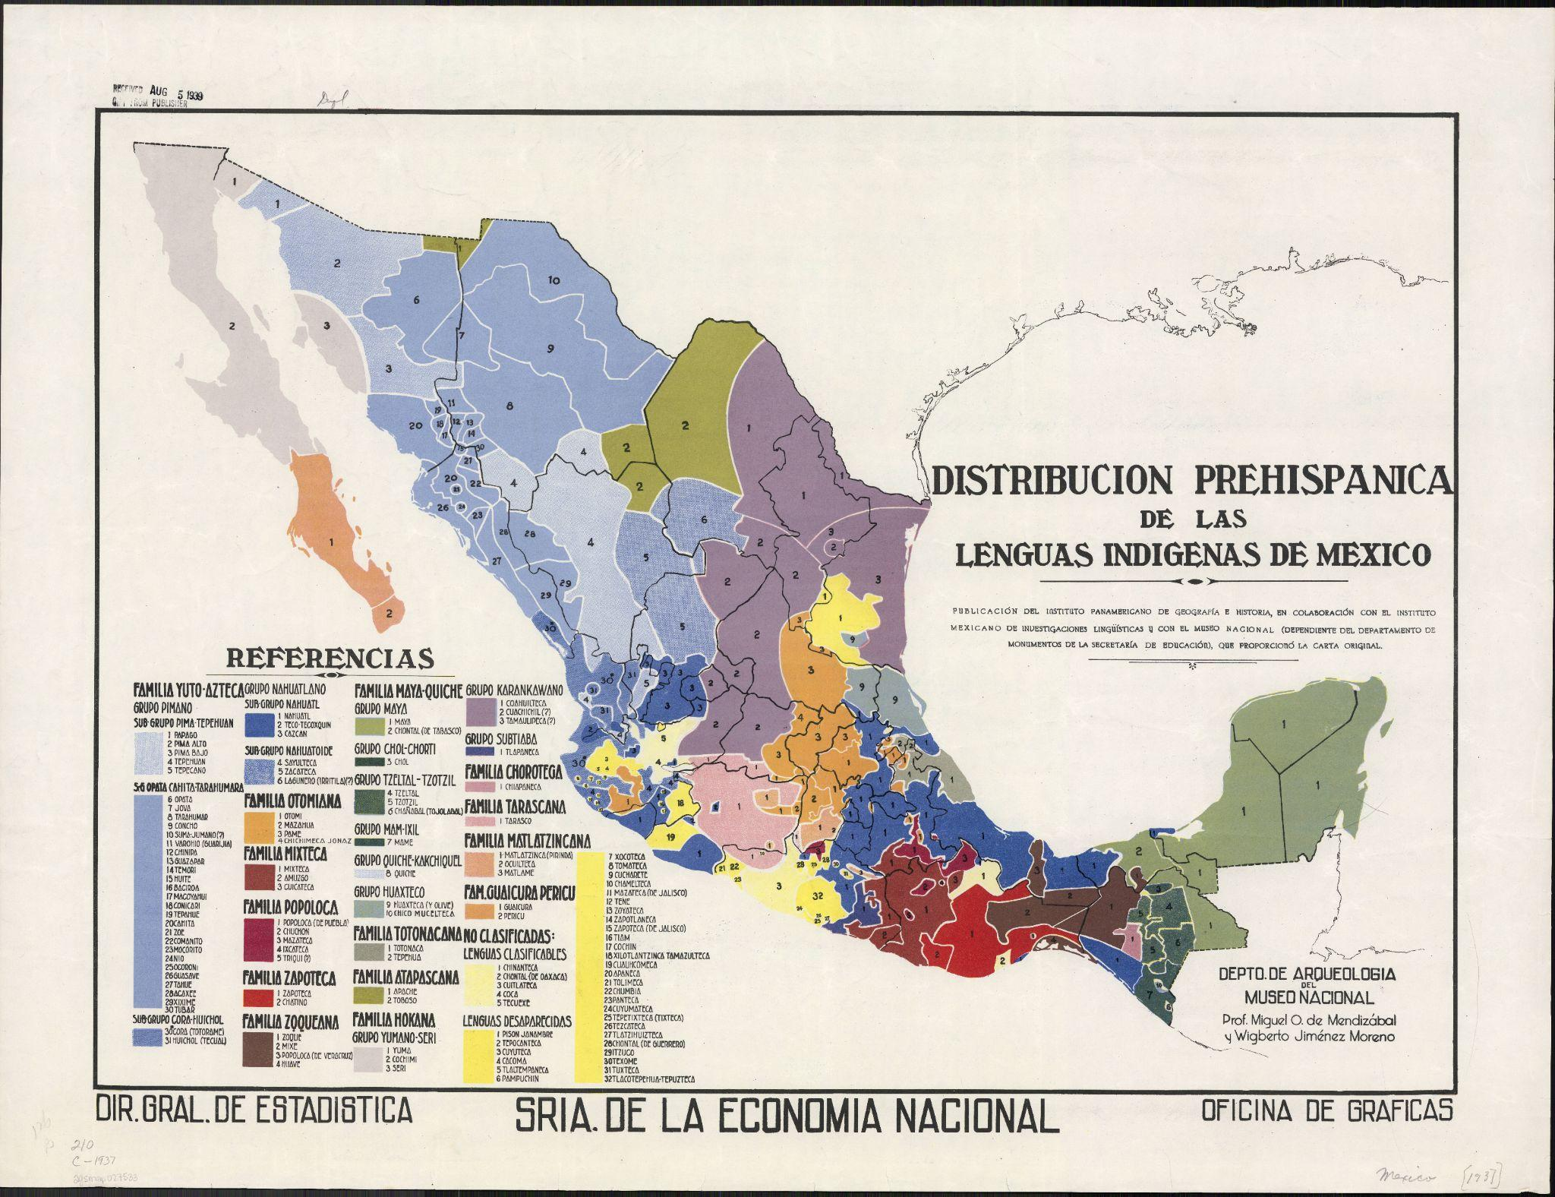
Mendizábal, Miguel Othón de. Distribucíon prehispanica de las lenguas indigenas de México… (Shortened Title). Dir. Gral. Estadistica, Sria. de la Economia Nacional, Oficina de Graficas, 1937, https://collections.lib.uwm.edu/digital/collection/agdm/id/27190/rec/3. University of Wisconsin-Milwaukee Libraries, American Geographical Society Library Digital Map Collection. Cropped from original.

Objetivos
➤ Students will practice describing and comparing several different maps of linguistic distribution in Mexico. Students will formulate and share their own opinions and interpretations of these maps, utilizing circumlocution when they are uncertain of vocabulary.
➤ Students will draw upon background knowledge to discuss and analyze the distribution of indigenous languages present in Mexico.
➤ Students review the use of prepositions by analyzing and describing the content portrayed within two different maps.

From the University of Wisconsin-Milwaukee's Center for Latin American and Caribbean Studies

This lesson plan was developed by undergraduate student Boston Peters in summer 2025
under a Support for Undergraduate Research Fellows (SURF) grant through the UWM
Office of Undergraduate Research (OUR), supervised by the UWM Center for Latin
American and Caribbean Studies (CLACS) Associate Director, Monica VanBladel.
This, and more teaching resources developed under the research grant, can be found on https://uwm.edu/clacs/public-engagement/teaching-resources/k-12-lesson-plans-surf-2025-26/.
Please note that the UWM CLACS website will be redesigned in 2026, resulting in a change of the website’s stable URL. When this occurs, the link provided above will no longer be functional. The new website will prominently feature available educator resources, including this one.

The University of Wisconsin-Milwaukee’s Center for Latin American and Caribbean
Studies is a member institution of the national Consortium of Latin American Studies
Programs (CLASP). CLASP also develops and shares a wide variety of K-12 educator
resources on its website: https://claspprograms.org/k-12-educators/.

The following lesson may include state standards and/or “I can” statements related to the
lesson content. These standards/statements were initially added as an educational
framework for lesson design and may not be exhaustive.

This document may include hyperlinks. A page at the end of the document has been added
to provide the URL included in each hyperlink, as well as other information about where
the hyperlink leads. This information is intended to assist in finding the linked webpage if
the hyperlink no longer functions.

Standards & Guidelines

ACTFL Proficiency Guidelines 2024
Table 5. Modes of Communication and Parameters of Performance in Speaking—Intermediate Level
Expresses self and participates in conversations on familiar topics using sentences and series of sentences.
Handles short social interactions in everyday situations by asking and answering a variety of questions. Can
communicate about self, others, and everyday life.
Language Control: Can produce straightforward language that contains mostly familiar structures. Can
ask and answer a variety of questions. Can control language structures and articulation/stress/intonation
patterns sufficiently to ensure clarity in many situations, though some miscommunication may occur.
Vocabulary: Can produce high-frequency vocabulary on a variety of everyday topics, topics of personal
interest, and topics that are familiar or have been rehearsed.
Table 5. Modes of Communication and Parameters of Performance in Listening—Advanced Level
Understands main ideas and some supporting details on familiar topics from a variety of straightforward oral
message types.
Can recognize when clarification is needed or miscommunication occurs. May use some or all of the
following strategies:
• Using visual support and background knowledge
• Predicting meaning based on context, prior knowledge, and/or experience
• Using context clues
• Recognizing word family roots, prefixes, and suffixes
• Making comparisons with other known languages
URL: https://www.actfl.org/proficiency-guidelines-overview

WCRS "I Can" and "We Will" Statements (Google Sheets) on Wisconsin Career Readiness Standards
WCRS.LIF.3: Global competence — Understand one’s impact on the world and develop the ability to interact with people from other backgrounds, nations, and cultures.
WCRS.LIF.3.A: Acquire and use intercultural and global knowledge and skills, including proficiency in
languages of our local and global communities.
WCRS.LIF.2.B: Communicate and collaborate with others, using various modes of communication,
across languages, cultures, and contexts.
URL (Statements): https://docs.google.com/spreadsheets/d/e/2PACX-1vQ6Przd8CkGd_bqt2wq5MNTCGxJ05oyEKqsIL_LL5WMh05SwgRj_-MNdHQwXhFvwbTfbuPmIm8vwSi1/pubhtml#
URL (Standards): https://dpi.wi.gov/cte/resources/common-career

Discusión antes de la presentación de los mapas

- Según entiendes, ¿cuántos distintos grupos indígenas existían en México antes de la llegada de los europeos? Usa tu conocimiento anterior; puede ser útil nombrar los grupos que conozcas.
  - [According to your understanding, how many different indigenous groups were there in Mexico before Europeans arrived? Use your prior knowledge; it may be useful to name indigenous groups that you are familiar with.]
- ¿Saben de algunas lenguas indígenas? ¿Algunas de Mesoamérica o de otra parte del mundo? ¿Dónde se hablaban/hablan?
  - [Do you know of any indigenous languages? Any from Mesoamerica or from another part of the world? Where were/are they spoken?]

Stage 1 — Warm-Up, Review of Preposition Vocabulary

The goal of this stage is to provide a grammatical review of the use of prepositions while warming up students for a more detailed comparison and analysis, drawing on potential prior knowledge. Encourage students to utilize circumlocution throughout the upcoming discussion activities.
Images of and links to the maps referenced are provided later in this document.

Present the first map (Map 1: “Distribucíon prehispanica de las lenguas indigenas de México”) to students.
Utilize this map as a means to strengthen the first target skill: use of prepositions. The following are example questions which could be used to practice this target skill:
- ¿Cuál comunidad lingüística existe al lado de la comunidad mixteca?
- ¿Cuál lengua indígena se habla en las montañas de _____?
You may pre-prepare additional questions in advance if desired. Alternatively, you could provide students with time to work individually on developing a list of 10 questions incorporating prepositions. Once students have prepared their questions they can be paired up to ask and answer one another's questions.
A vocabulary bank for prepositions is provided below. Additionally, Las preposiciones de lugar provides a useful graphic for understanding the prepositions.

It may also be useful to include a group review of the Spanish phonetic system to help students pronounce any unfamiliar names they may encounter. If needed, emphasize respect and not making a joke out of unfamiliar words. The Spanish Alphabet - Spanish411 and Spanish Alphabet Pronunciation | SpanishDictionary.com are two resources that you may find useful.
As an extension activity for pairs that work more quickly, you could have students write a list of 5 descriptive sentences based on their Q&A conversations.
The map of Mexican states (Map 3, provided towards the end of this document) can be referenced by students to provide some landmark areas for description.
You may also challenge students to reference the vocabulary list of geographical terms (see below) and utilize these words in their descriptive sentences. Mexico Map and Satellite Image is an additional map that students could reference to incorporate these terms, as the other maps do not label many geographical features.

The following are additional discussion questions, also potentially useful for students who may finish more quickly than others:
- ¿De cuál época/año es este mapa? ¿Cómo saben?
- En tu opinión, ¿son muchas o pocas las lenguas indígenas representadas? ¿Por qué?

Ask pairs to finish their discussions and request that students share some of their work with the full group. This will help to conclude the initial activity as well as correct any misunderstandings before the class proceeds to part two.

A practicar la descripción geográfica y las preposiciones

Usen los mapas para describir la distribución de las lenguas indígenas e incorporen las preposiciones en sus descripciones. Pueden consultar el mapa de estados mexicanos y usen los estados como puntos de referencia para describir.

Las preposiciones
cerca de | near | sobre | above
lejos de | far from | detrás de | behind
al lado de | next to | delante de | in front of, before
a la izquierda de | to the left of | enfrente de | in front of, opposite
a la derecha de | to the right of | frente a | in front of, opposite
en | in, on | alrededor de | surrounding
entre | between | desde | from
dentro de | inside of | hacia | towards
fuera de | outside of | por | through
debajo de | below | hasta | until
encima de | above

La geografía
norte | north | el océano | ocean
este | east | el/la mar | sea
sur | south | la costa | coast
oeste | west | el golfo | gulf
al norte/este/sur/  oeste de… | to the north/east/  south/west of… | la bahía | bay
el mapa | map | la playa | beach
el país | country | la península | peninsula
Norteamérica, América del Norte | North America | la isla | island
Estados Unidos (EE.UU.) | United States  (U.S.) | Guatemala | Guatemala
México | Mexico | Belice | Belize

Stage 2 - Describe and Compare
Introduce the second map (Map 2: “Distribución geografica de las lenguas Indigenas de Mexico : conforme al Censo de 1930 (por municipios)”).

The following questions could be used to introduce this second stage. They could be answered as a class-wide discussion or between paired students.
- Consideren los títulos y las leyendas de los dos mapas y discutan: ¿Para quién serán estos mapas? ¿Qué público? ¿Para qué?
  - [Consider the titles and legends of the two maps and discuss: Who are these maps for? What audience? For what purpose?]
- Examinen el mapa de los estados mexicanos modernos. En el año 1930, ¿donde se hablaba la mayoría de las lenguas sobrevivientes?
  - [Examine the map of modern Mexican states. Where were the majority of the surviving languages spoken in 1930?]
- Al comparar los mapas, ¿cuáles lenguas han desaparecido por completo?
  - [When comparing the maps, which languages have disappeared completely?

Next, have students work in their pairs to Compare and Contrast the first map with the second map.
- Describe - If you find it useful, first have students provide descriptions for Map 2 (without yet comparing it to Map 1). Students should continue to incorporate prepositions while also referencing the positioning of modern Mexican states (see the labeled map provided later on in this document). Additionally, have them draw upon previous knowledge or reference a word list to utilize relevant geographical vocabulary.
  - For example, students could utilize all of these different terms/skills to describe where linguistic communities are situated in relation to modern-day Mexican states. Which communities correspond with which states?
- Compare - Now have students generate a list of the seven most notable differences or similarities that they observe between the two maps. As always, encourage the use of circumlocution if students are unsure of a word or phrase.
  - This article—CLACS & the AGSL—has a slider which allows for easier comparison between the first two maps.
  - A potential formula for students expressing comparisons: “En mapa 1, [descripción], mientras en mapa 2, [descripción]”

Included later on in this document there is a worksheet titled “Meet the Map!”. This worksheet is in English, but provides extremely valuable questions for analyzing (and comparing!) maps. You are encouraged to take a look at it and potentially adapt it for use in the Spanish classroom!
- The Meet the Map! worksheet questions were created by Georgia Brown, Public Services Librarian at the American Geographical Society Library at UW-Milwaukee.

Preguntas de análisis e interpretación
These discussion questions challenge students to expand upon their observations by hypothesizing about the meaning of the maps. Some remain map-specific while others gesture to a broader context.
- ¿Por qué se disminuyó la distribución de las lenguas indígenas?
  - [Why did the distribution of indigenous languages reduce?]
- ¿En su opinión, es importante la diversidad lingüística? ¿Cuáles son las ventajas y desventajas?
  - [In your opinion, is linguistic diversity important? What are its advantages and disadvantages?]
- ¿Qué preguntas tienen después de leer estos mapas? Identifiquen al menos tres puntos que quieren investigar más. (Por ejemplo: la historia de la zona, las comunidades, las distintas regiones geográficas, etc.)
  - [What questions do you have after reading these maps? Identify at least three items that you would like to investigate further. (For example: the region’’s history, the various communities, the different geographic regions, etc.)]

BONUS: Lectura relacionada
Lee este artículo en español:
El enigma de la supervivencia de las lenguas indígenas en México

Para buscar mientras leen:
- Tiempos gramaticales que no reconoces.
  - [Grammatical tenses that you don’t recognize.]
Preguntas para responder después:
- ¿Cuáles factores impactan en si una lengua es transmitida a la siguiente generación?
  - [What factors impact if a language is transmitted to the next generation?]

Links and Citations

“Las preposiciones de lugar” by Elena de Astorza (2012-2025) on La página del español, https://paginadelespanol.com/las-preposiciones-de-lugar/.

“The Spanish Alphabet” on Spanish411.net, https://spanish411.net/Spanish-Alphabet.asp.

“Spanish Alphabet Pronunciation” on SpanishDictionary.com, https://www.spanishdict.com/guide/spanish-alphabet-pronunciation.

“Mexico Map and Satellite Image” on Geology.com, https://geology.com/world/mexico-satellite-image.shtml.

“CLACS & the AGSL” by Georgia Brown (Public Services Librarian at the American Geographical Society Library at UW-Milwaukee) (16 December 2021) on ArcGIS StoryMaps, https://storymaps.arcgis.com/stories/c329eaa1f4ba4a2aaf598f66ec911fc6.
“El enigma de la supervivencia de las lenguas indígenas en México” by Panu Pelkonen and Diego De la Fuente Stevens (3 August 2021) on The Conversation (theconversation.com), https://theconversation.com/el-enigma-de-la-supervivencia-de-las-lenguas-indigenas-en-mexico-209943.

Below are additional resources that were referenced while producing this lesson plan.

“Preposiciones de lugar: para ubicar y de movimiento” by Elena Prieto on Tu escuela de español (https://www.tuescueladeespanol.es/), https://www.tuescueladeespanol.es/blogs/preposiciones-de-lugar-ubicacion/.

“Geography | 60 Spanish Vocabulary Words” on Live Lingua, https://www.livelingua.com/vocabulary/geography#.

Map Links and Citations

View the referenced maps on the following page of this document.

Map 1
Mendizábal, Miguel Othón de. Distribucíon prehispanica de las lenguas indigenas de México / Publicación del Instituto panamericano de geografía e historia, en colaboración con el Instituto mexicano de investigaciones lingüísticas y con el Museo nacional ... Depto. de arqueología del Museo nacional, prof. Miguel O. de Mendizábal y Wigberto Jiménez Moreno. Dir. Gral. Estadistica, Sria. de la Economia Nacional, Oficina de Graficas, 1937, https://collections.lib.uwm.edu/digital/collection/agdm/id/27190/rec/3. University of Wisconsin-Milwaukee Libraries, American Geographical Society Library Digital Map Collection.
Rights Statement: Fair use of copyrighted material for educational purposes.

Map 2
Mendizábal, Miguel Othón de. Distribución geografica de las lenguas Indigenas de Mexico : conforme al Censo de 1930 (por municipios) / publicación ... por el Instituto Panamericano de Geografía de Historia, en colaboración con el Instituto Mexicana de Investigaciones Lingüísticas ; carta formada por Miguel O. De Mendizabal. Mexico, D.F. : Pan American Institute of Geography and History, 1937, https://collections.lib.uwm.edu/digital/collection/agdm/id/27191/rec/4. University of Wisconsin-Milwaukee Libraries, American Geographical Society Library Digital Map Collection.
Rights Statement: Fair use of copyrighted material for educational purposes.

Map 3
“Map of Mexico States” available to customize on ultimaps (ultimaps.com), https://ultimaps.com/vector-maps/america/mexico/.
Rights Statement: Attribution required.

Map 1. A higher-resolution version of this map can be found here: https://collections.lib.uwm.edu/digital/collection/agdm/id/27190/rec/3
Map 2. A higher-resolution version of this map can be found here: https://collections.lib.uwm.edu/digital/collection/agdm/id/27191/rec/4
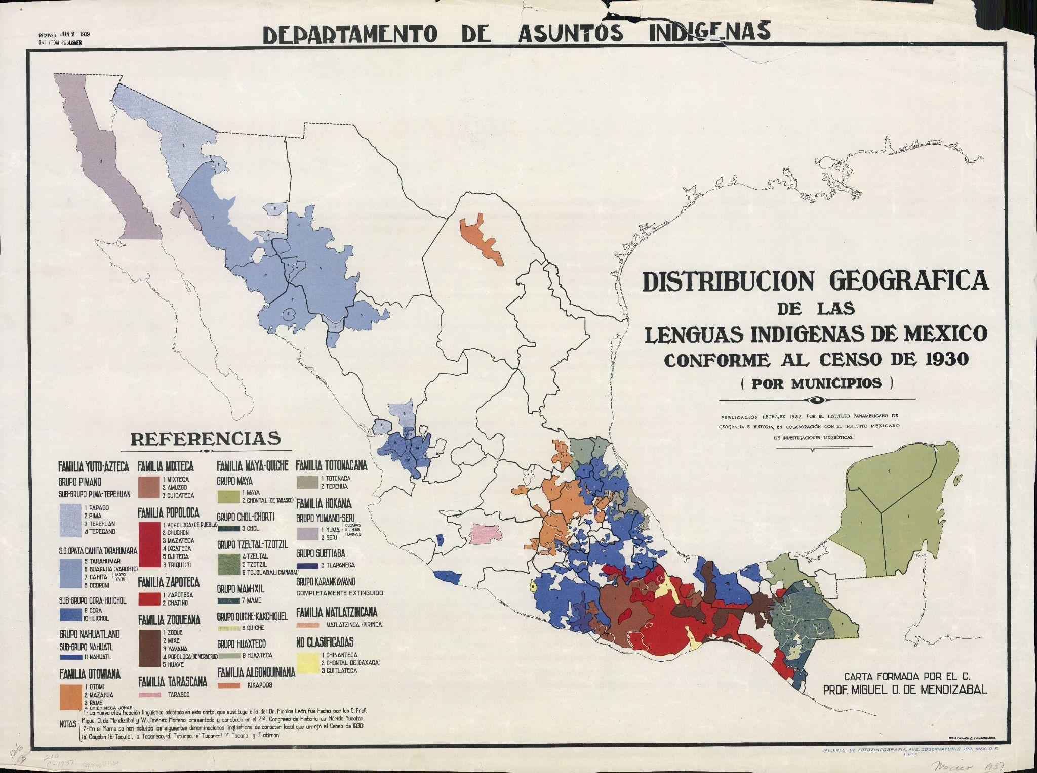
Map 3. A higher-resolution version of this map can be found and customized here: https://ultimaps.com/vector-maps/america/mexico/
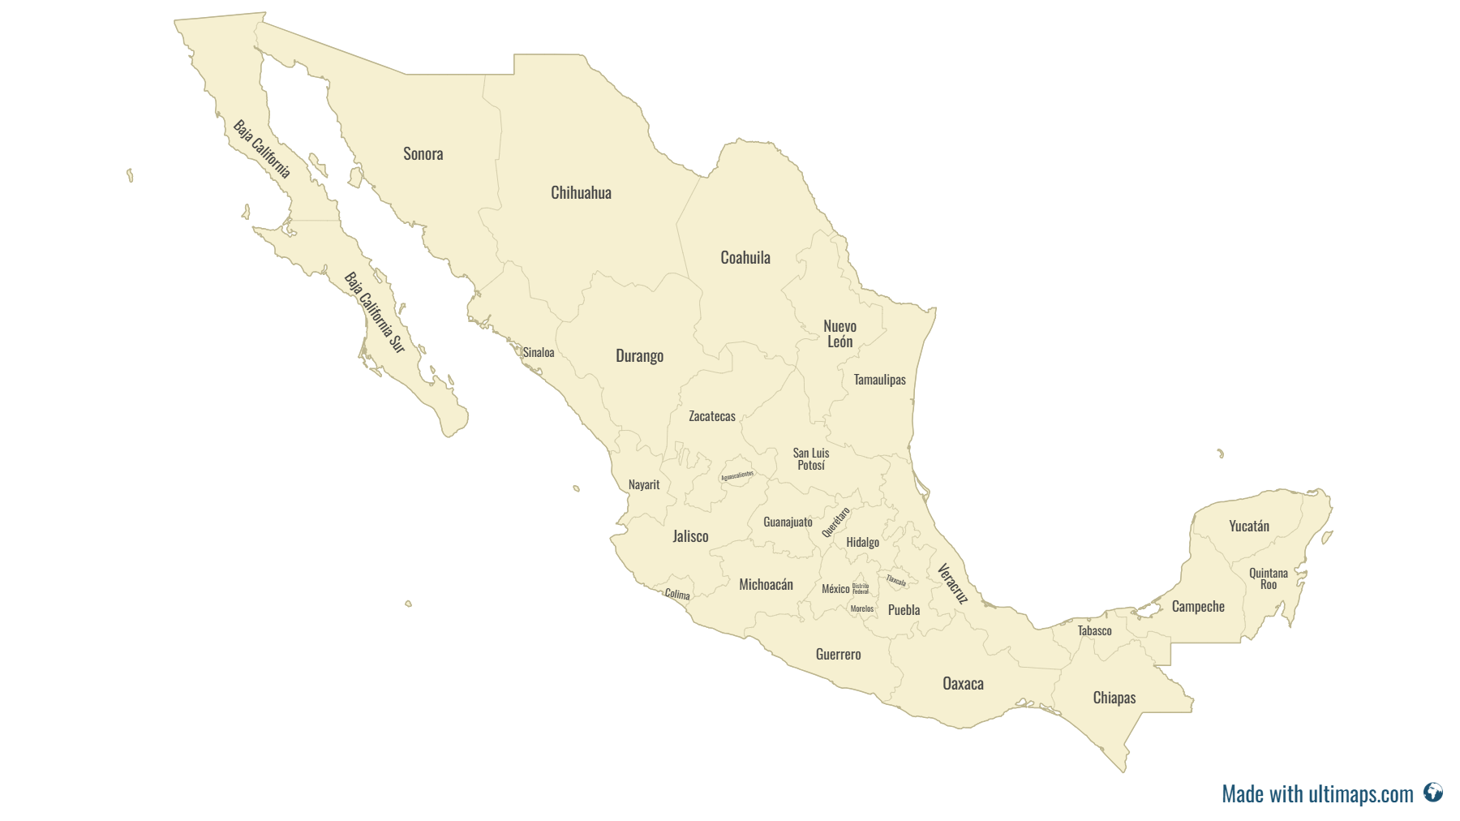

Meet the Map! — Singular Map

Observe its parts.

1. What are the first three things you notice about your map?

2. What is the title?

3. What place or places are shown?

4. When is it from? (Most American Geographical Society Library maps show the date in the call number on the lower left corner.)

5. Who made it? What language is it in?

6. How might the creator / mapmaker impact the content of the material / map?

Try to make sense of it.

7. Do you trust this map? Why or why not?

8. Why was it created? List the evidence from the map, knowledge about the mapmaker, or knowledge of what was happening in history that leads you to your conclusion.

9. How would you remake a map of the same place?

10. What would a good research question be for your map?

Use it as historical evidence.

11. What narrative does this map provide? Who is the intended audience?

12. What other documents or historical evidence could you use to help you understand this event or topic?

13. What did you find out from this map that you might not learn anywhere else?

Meet the Map! — Compare Two Maps

1. What place or places are shown?

2. Do these maps depict the same place(s)? How far apart in years were the maps made?

3. What are three differences between the two maps?

4. Can you tell why the two maps were created?

5. What research questions could you ask of the two maps?

