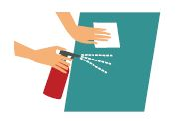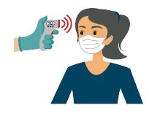**What We Will Do**

The staff at the University of Wisconsin-Milwaukeetake safety very seriously. This is why we are taking extra steps to ensure that when you come for a research visit, all necessary precautions have been taken to reduce the risk of COVID-19 infection. We will do our part to prevent infection, but we also ask you to do your part as well.

**Caring for You During Your Research Visit**

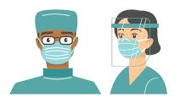

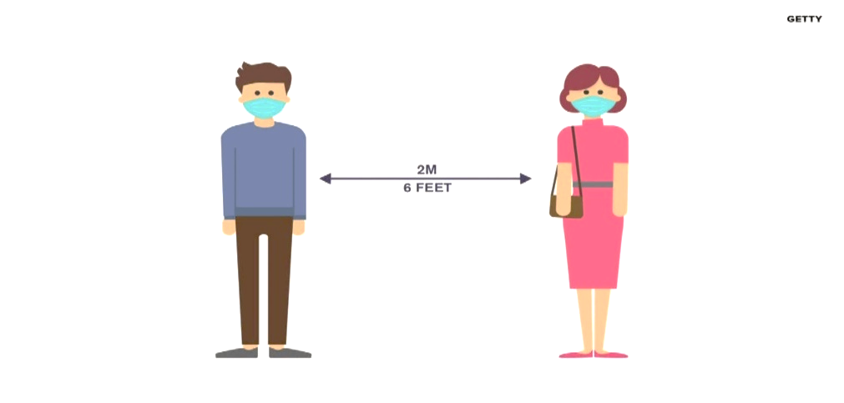

* Screen our staff for symptoms of COVID-19 prior to coming to work.
* Wear masks and appropriate personal protective equipment as needed throughout your visit.
* Sanitize all rooms before and after each visit.
* Clean public areas frequently.



* Limit the number of research participants to allow for social distancing.
* Take you to our own private room if available
* Structure visits in a manner that will reduce the amount of time you are present.
* Conduct as much of the study visit as possible remotely via videoconference or phone.

* When possible, we will maintain a distance of 6 ft.

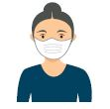**What We Will Ask You to Do When You Visit**

* Please wear a face mask throughout the visit. If you don’t have one, we will provide one to you.
* Be responsible and take care to socially distance during your visit when possible.
* After your visit, notify staff if you experience symptoms or test positive for COVID19.

**If you have concerns about your research visit, please reach out to [Name of Center] staff member.**

**Please let the staff member know what we can do to help you feel more comfortable with completing your research visit.**

Staff Member Name:

Phone Number:

* Prior to coming for your visit or upon arrival, a staff member will call you to screen you for COVID-19 symptoms.
* The staff member will ask if you have been exposed to COVID-19 or have been tested for the virus.
* Upon your arrival, you may have your temperature taken at the entrance of the building.

*Credit to the Center for Cognitive Medicine at Vanderbilt University Medical Center and the University of Arizona.*