Toxins in Use
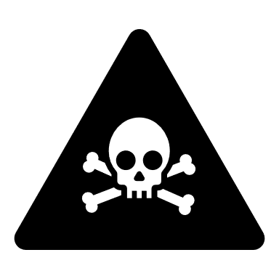
Authorized Personnel Only

Entry/ Exit Procedures:

