Intent to apply form

Interdisciplinary Scholars Partnering for Action and Research with Communities
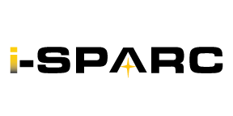

Name:
Degree:
Program:
Department:
College:
Advisor/Committee Chair:
Year in Program:
Current cGPA:

My qualifications for and interest in applying to be on an i-SPARC project team this year include (please check any of the following that apply to you):

- Lived experience: Geographic
- Lived experience: Demographic (experience with visual disability)
- Work/professional experience related to one of the i-SPARC projects for this year
- Skills and/or degree that aligns with one of the i-SPARC projects for this year
- Career interest related to one of the i-SPARC projects for this year
- Ability to meet the time commitment of 4-6 hours per week for 2 semesters
- Commitment to working with a team (full contribution as a team member)

Required for confirmation of intent to apply (due by August 7, 2026 for priority consideration):

- I affirm that I have received verbal or electronic approval/support from my academic advisor or committee chair to apply to be a UWM Graduate School i-SPARC Scholar for 2026-27.

- I affirm my intent to apply to be a UWM Graduate School i-SPARC Scholar for 2026-27

- Signature:

Submit to: i-sparc@uwm.edu using “i-SPARC Intent to Apply” in the subject line.

