Application Instructions

Interdisciplinary Scholars Partnering for Action and Research with Communities
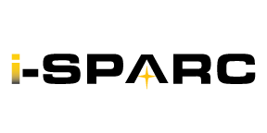
Applications due August 21, 2026

Eligibility criteria:
- Second year graduate student or later
- Good academic standing (3.0 cGPA or higher) for graduate career
- Availability for the full 2026-27 academic year (Fall and Spring semesters)
- Ability to manage active participation in a program requiring 4-6 hours/week for AY ‘26-27
- Advisor/Committee chair support
- Application submitted by deadline

Selection criteria:
- Scholars will be selected for fit to each project and interdisciplinary project team
- 12 scholars total, with 6 scholars per interdisciplinary team (i.e., each team will have only 1 student from a given discipline/program)

Applying to become a 2026-27 i-SPARC Scholar

Application checklist.

- Read the 2026-27 i-SPARC Project Information Sheet to identify your interest in a project.

- Talk with your advisor/committee chair to assure that your participation in this community scholars project will not adversely impact your timely degree progression. Note that an advisor/committee chair approval form is required with your application.

- Submit the Intent to Apply form to i-sparc@uwm.edu no later than August 7 , 2026.

- Prepare your application, prior to August 21, 2026.

Application components include:
- Updated CV or Resume
- Completed application
- Advisor/Committee Chair Approval Form
- Copy of your current transcript.

- Submit all application materials to i-sparc@uwm.edu by August 21, 2026, 5PM cst.
All application materials should be sent in ONE email.

