TITLE OF THE DISSERTATION IN ALL CAPS AND DOUBLE SPACED

by

[Full Name]

A Dissertation Submitted in
Partial Fulfillment of the
Requirements for the Degree of

Doctor of Philosophy
in [official degree program name]

at

The University of Wisconsin-Milwaukee
Month year

ABSTRACT

DISSERTATION TITLE IN ALL CAPS AND SINGLE SPACED

by

[Full Name]

The University of Wisconsin-Milwaukee, 20[2x]
Under the Supervision of Professor [name of major professor]

Abstract text goes here: double spaced and left-justified. Above, make sure that the text lines, “The University of Wisconsin-Milwaukee, 20[2x]” and “Under the Supervision of Professor [name of major professor]” are single spaced with no extra space between the lines.

© Copyright by Full Name, 202x
All Rights Reserved

Dedication (Optional)

TABLE OF CONTENTS

LIST OF FIGURES vi
LIST OF TABLES vii
LIST OF ABBREVIATIONS viii
ACKNOWLEDGEMENTS ix
Chapter One Add Title Here 1
Section Heading One 1
Sub Heading One 5
Sub Heading Two 5
Sub Heading Three 5
Section Heading Two 5
Sub Heading One 5
Sub Heading Two 5
Sub Heading Three 5
Section Heading Three 6
Sub Heading One 6
Sub Heading Two 6
Sub Heading Three 6
Section Heading Four 6
Sub Heading One 7
Sub Heading Two 7
Sub Heading Three 7
Section Heading Five 7
Sub Heading One 7
Sub Heading Two 7
Sub Heading Three 7
Bibliography/Works Cited/References 8
Appendix A: Title for the First Appendix 9
Appendix B: Title for the Second Appendix 10
Appendix C: Title for the Third Appendix 11

LIST OF FIGURES (if required)

Figure # | Figure title | Page #
Figure 1 | Graduate School Logo | 2
Figure 2 | Milwaukee Skyline | 4

LIST OF TABLES (if required)

Table # | Table title | Page #
Table 1 | A Sample | 2

LIST OF ABBREVIATIONS (if required)

ABC | Explanation

ACKNOWLEDGEMENTS

Text here: double spaced and left-justified.

(Optional Frontispiece/Epigraph. Delete this entire page if not using.)

Chapter One Add Title Here

Section Heading One
Delete this text. Use or delete the section headings and subsection headings as you need to. The formatting of the headings determines at what level or sub-level they appear in the table of contents; when you change the text, be sure to keep the formatting. When you have added your chapter text, click inside the Table of Contents text block, and select “Update Table” from the Table of Content drop down menu. When prompted, select “Update entire table” populate the Table of Contents with your chapter titles, heading titles, and page numbers. Do not update the Table of Contents manually.
All figures, tables, and graphs should maintain the 1” margins of this document. Keep figures, tables, and graphs together with their caption on the same page. If a figure, table, or graph needs to be full page, insert it with landscape orientation so that the top of the figure would appear at the bound edge of the paper (left margin). For landscape-oriented figures, the page number must remain in the same position as all other pages. Embedded in the text, a figure would appear as follows:
Figure 1: UWM Logo. Do not forget to add this table or figure to the list of tables or figures on page viii or ix. This caption must be single spaced, left justified, and no smaller than a 9-point font.

Tables can appear within the text or as full pages oriented to be landscape or portrait. If a table appears within the text, keep the caption with it on the same page, and don’t forget to add the table to the List of Tables on page ix. Here is a table within the text:
Table 1: A Sample
 | Label | Label | Label
Label
Label
Label

If you need to insert full page figures or tables, you can make them portrait or landscape as appropriate. Keep the page numbering consistent: the page with the full-page figure should be numbered in sequence with the rest of the text. In addition, keep the page number in the same place on all pages.
To insert a full landscape-oriented figure or table, follow these instructions. First, create sections. On the last page of your portrait pages, click after the end of the content, go to the’ Page Layout’ menu and choose the ‘breaks’ tab, select to add a section break ‘next page’.
· On the last page of your landscape pages, click after the end of the content, go to the’ Page Layout’ menu and choose the ‘breaks’ tab, select to add a section break ‘next page’.
This will make your portrait pages section 1, landscape pages section 2, and the next portrait pages section 3. You can continue doing this for as many sections as you need if you continue to have alternating portrait and landscape pages.
Double click into both the header and footer of the first page of each section, in the ‘Header and Footer Design’ and ‘Navigation’ be sure ‘Link to Previous’ is de-selected in both the header and footer.
Then, add the page number to the landscape pages. To add the page number in the portrait sections, click into the footer, in the File menu select the ‘Page Number’ menu and choose ‘bottom of page’ with the plain number, centered.
To add the page number in your landscape pages, click into the footer, in the File menu select the ‘Page Number’ menu, choose ‘page margins’ and ‘large left’, Change the page number to the correct number, size and font, and then in ‘text box tools, format’ menu, change the text direction so that the page number is in the same orientation as the portrait pages as if it was laying in portrait. A landscape page formatted this way follows.

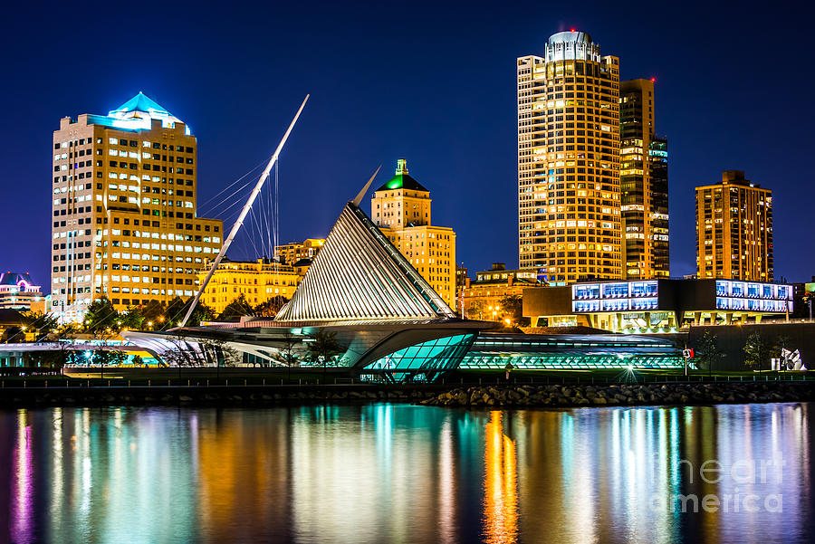
4

Figure 2: Milwaukee Skyline. Note that the page number remains in the same position as all other pages, even on pages with landscape figures.

Sub Heading One

Sub Heading Two

Sub Heading Three

Section Heading Two

Sub Heading One

Sub Heading Two

Sub Heading Three

Section Heading Three

Sub Heading One

Sub Heading Two

Sub Heading Three

Section Heading Four

Sub Heading One

Sub Heading Two

Sub Heading Three

Section Heading Five

Sub Heading One

Sub Heading Two

Sub Heading Three

Bibliography/Works Cited/References

Appendix A: Title for the First Appendix

If you have only one appendix, label it “Appendix,” rather than “Appendix A.”

Appendix B: Title for the Second Appendix

Appendix C: Title for the Third Appendix

