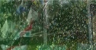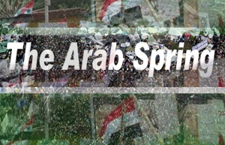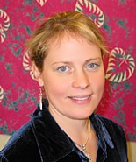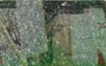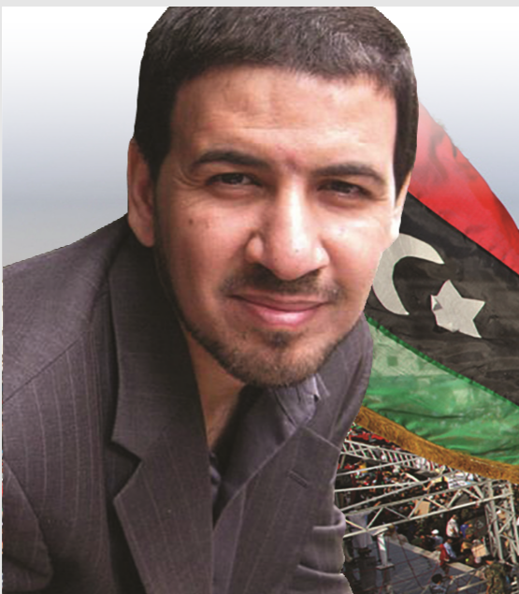

**Dr. Caroline Seymour-Jorn**

**UWM Associate Professor of Comparative Literature and Arabic translation. Author of *Creating Spaces of Hope: Young Artists and the New Imagination in Egypt*. Translations and expertise in Egyptian women writers.**

**Tuesday, Nov. 12, 7 – 9 p.m.**

**UWM Student Union, Fireside Lounge**

**2200 E. Kenwood Blvd. Milwaukee**

**Funded by the UWM Campus Activities Fund, UWM Co-Sponsors:** Trauma Studies Association, Muslim Student Association, Middle East and North African Studies Certificate, and Global and International Studies. **Community Co-Sponsors**: Wisconsin Refugee and Immigrant Mental Health Network, Milwaukee Muslim Women's Coalition. For more information: Deborah Davis, davis73@uwm.edu

**Dr. Omar Reda**

**Libyan-American Psychiatrist, author and public speaker with expertise in refugee trauma, the Libyan revolution and Arab Spring. Founder of “Untangled, a Platform for Love, Hope and Healing.”**

**A Psycho-Social Perspective**