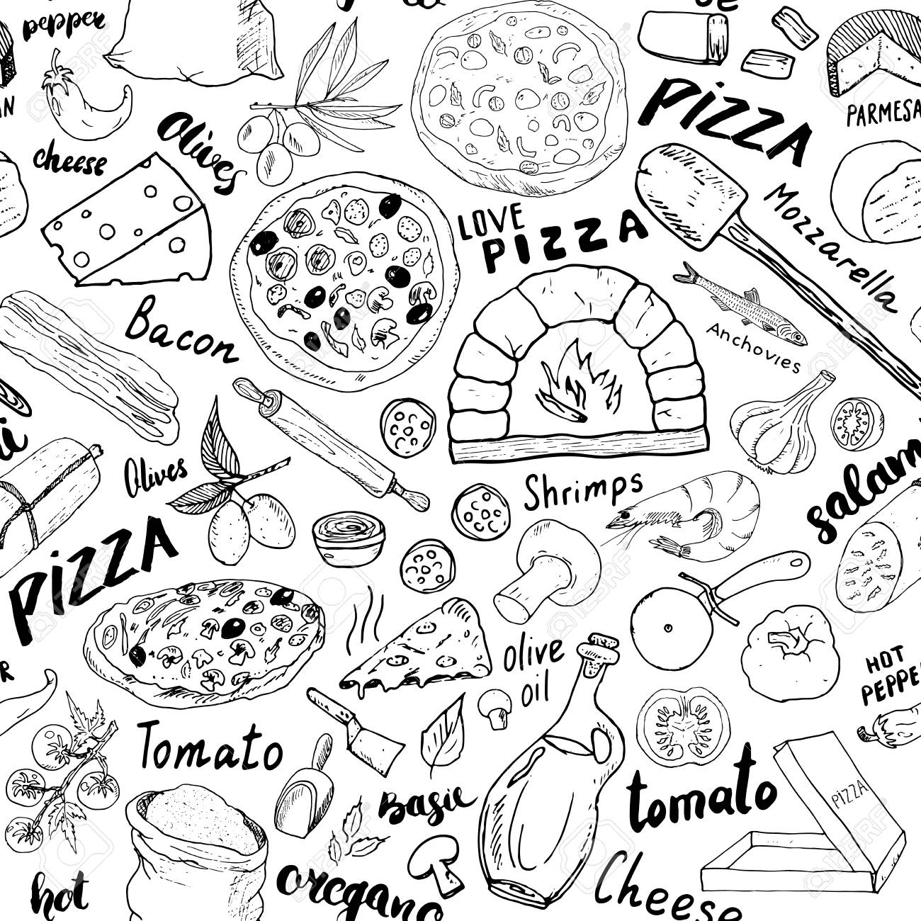

February 19th

5PM

Union 260

Join the Econ Club for our first meeting of the semester.

Meet other students in the department, ask advice about the best classes to take,

and eat free pizza! All majors are welcome.

YOU’RE INVITED TO AN

**Econ Club Pizza Night!**