How to Submit Course Material Adoptions
To submit adoptions for course materials, use this portal: UWM Online Course Materials Adoptions, or go to the website PantherShopUWM and scroll down to the “Online Adoptions” link under the Resources column to access.
- Once you get to the log in page, click on “New? Register Here” below “Forgot Password”. See the circled area in the screenshot below.

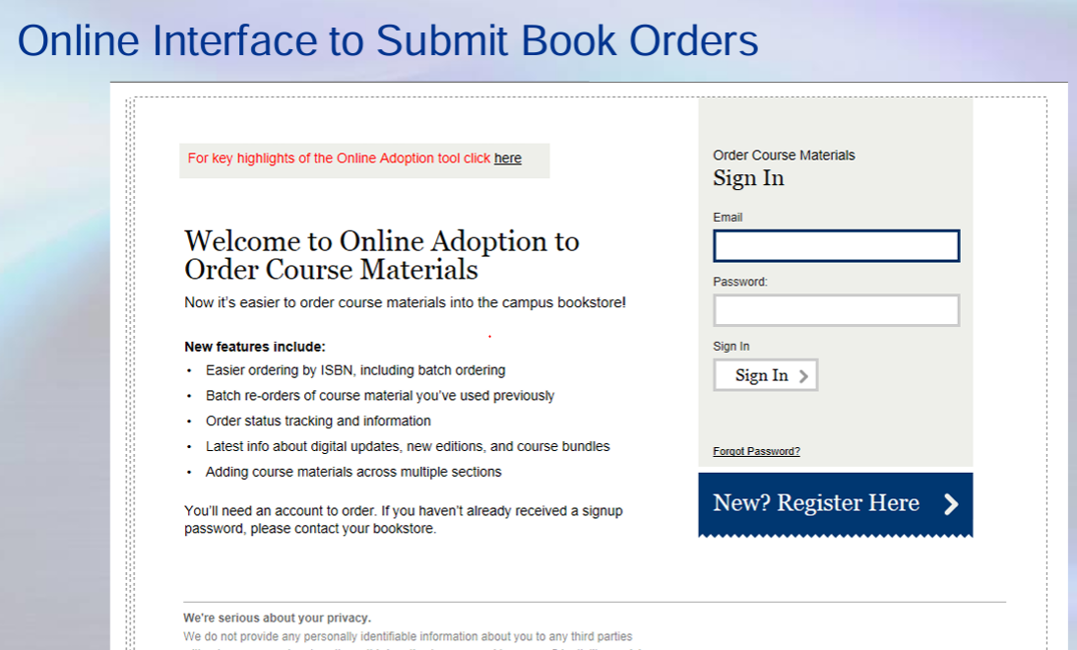

- On the next screen, you will need to create a profile.
In the first box, the bookstore provided password is 2356.
In the fifth box, after last name, the role is “approver.”
See screenshot on next page.

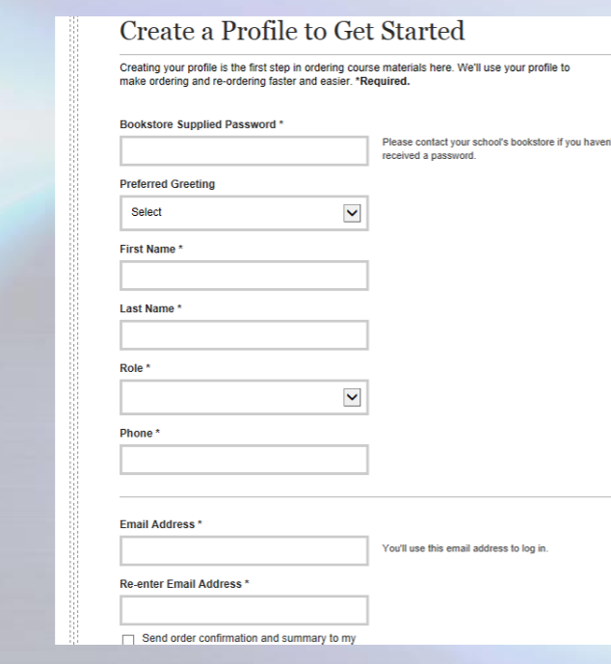

2356

Approver

- On the next screen, click on “Order Course Materials”--EVEN if you are going to note you have no required materials. You will do that later.

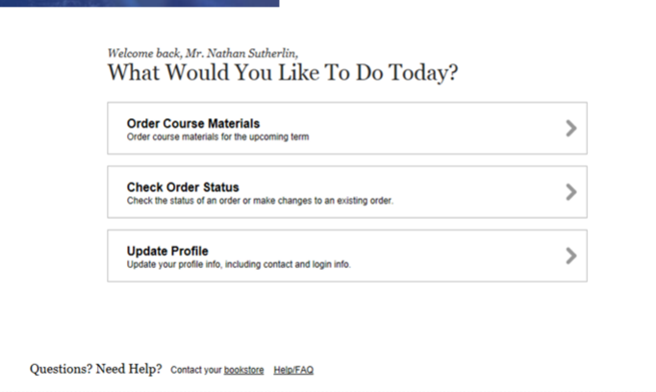

- On the next screen, click on New Order. (EVEN if you have no materials)

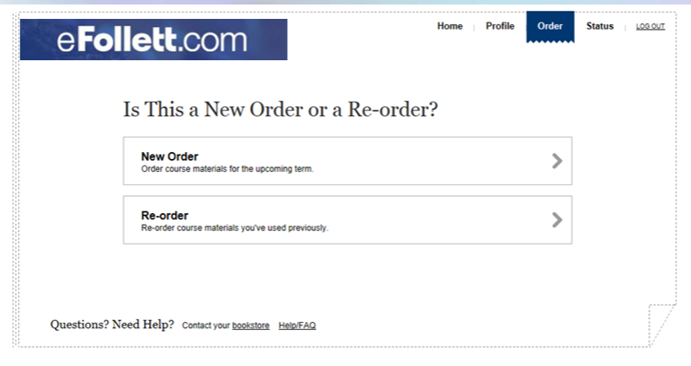
- On the next screen, enter your course information. Under “Program” select Panther Shop. Under “Department” select the course subject (ie: Bus Adm or Busmgmt).
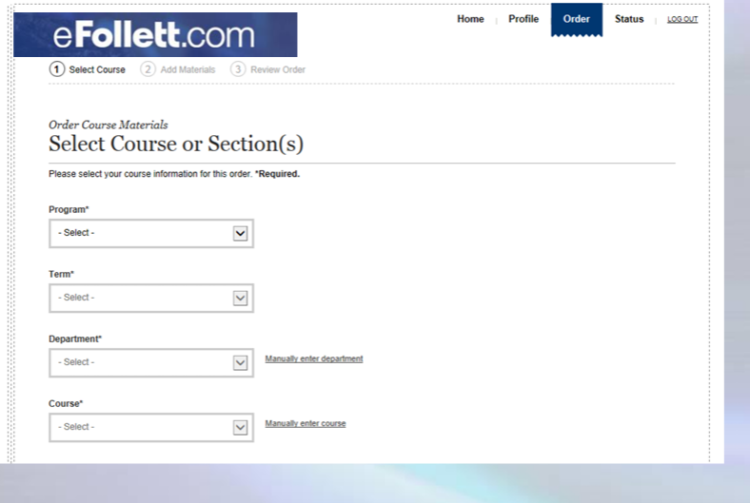
- BELOW your course information, if you have no materials or free open access materials, you can check that box and hit Continue. If you have materials, do not check a box. Click on continue.
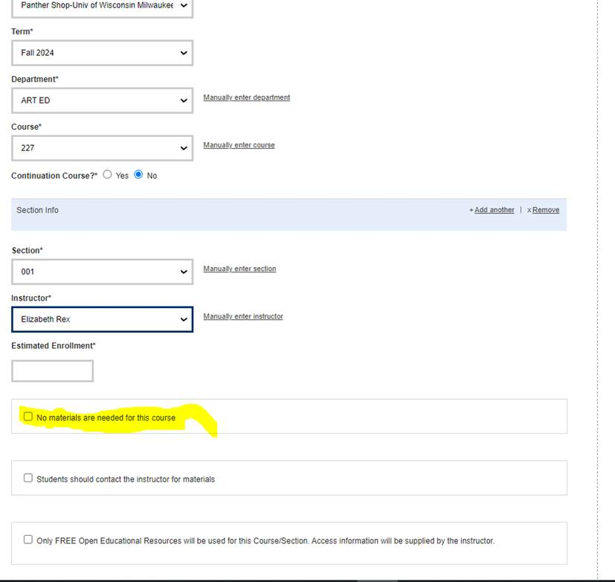

- On the next screen, select how you would like to enter your course material information:
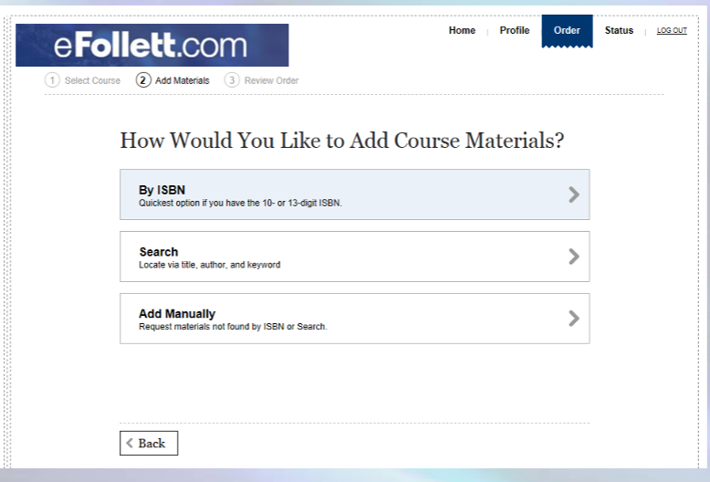

- IF you need to go back at any time, use the “BACK button on the screen—do not use your browser’s back button. After doing a search and locating your course materials or entering them manually, click on “SUBMIT.” 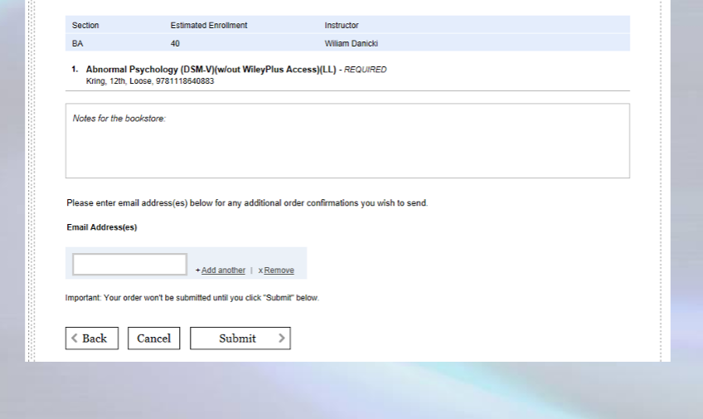
- After you successfully submit the materials, you will see a confirmation page.

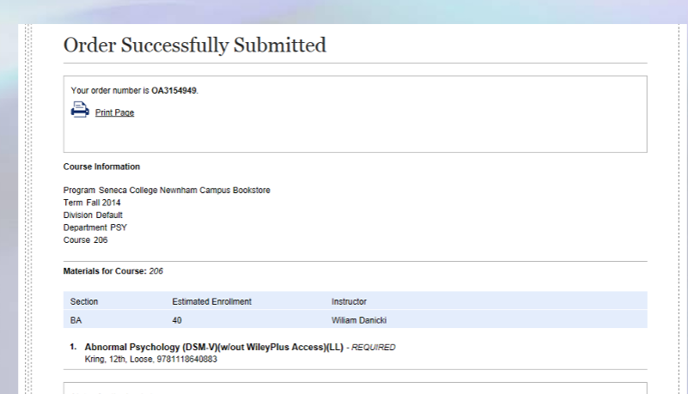
- You will also receive an order confirmation email.

QUESTIONS? Contact the bookstore using their online contact form here.

