Registering and Paying for myClinicalExchange

Dear myClinicalExchange Student,

Welcome to the myClinicalExchange program (mCE). We are making your clinical rotations more organized, efficient, and easy to manage! The directions provided in this letter are divided into three parts: Registration, Log In & Payment, and Navigation Tips.

We wish you a successful year and trust you will find mCE a simple and helpful tool in your academic career!

Sincerely,
mCE Team

Registration
Please navigate to https://www.myclinicalexchange.com/MainPage.aspx by either following this link or copy/pasting it into your web browser.
We recommend using the following internet browsers for the optimal use of myClinicalExchange.
- Google Chrome
- Firefox
- Safari

- In the upper right corner of the homepage, click the Student button, and select Registration from the drop-down menu.
You will be navigated to a page where you can choose from the two options below.
- Click on the New Account (the red box) option. You will be directed to Step 1 of 3.
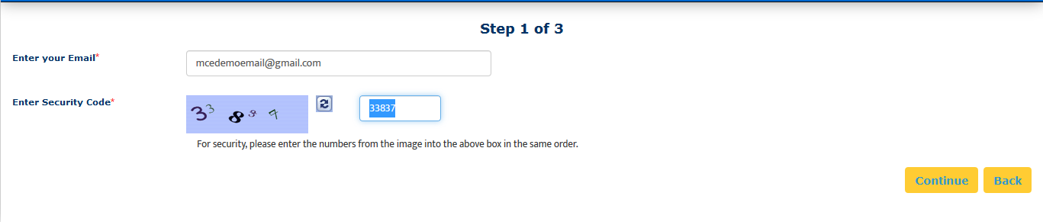
- Enter your school-issued email (the green box above).
  - You must use a proper e-mail address as the system will send you a validation code in the next step. You may use a personal e-mail address if your University does not issue University-based e-mail addresses.
- Enter the security code numbers in the blank box (the orange box above).
  - If you cannot read the security code, click the “refresh” icon to see a new set of numbers. There will be NO letters, just numbers.
- Click Continue, and you will be navigated to Step 2 of 3.
- A validation code with be sent to your email from do-not-reply@myclinicalexchange.com. Please check your inbox for that validation code. If you do not see your validation code in your email, please click on Resend Validation code.
- Enter the validation code (blue box below).
- Enter the security code (yellow box below).
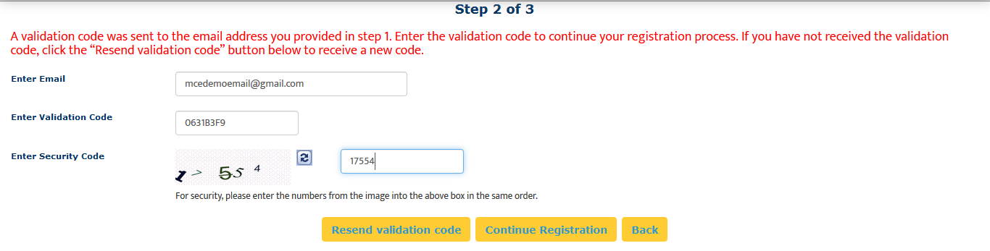
- Click on Continue Registration. You will be directed to Step 3 of 3 where you input your personal information.
Please note that a red asterisk next to a box means that information is required to proceed in mCE.

This next area can be broken down into four sections: Personal Information, School Enrollment Details, Emergency Contact Person, and Login Details.
Personal Information: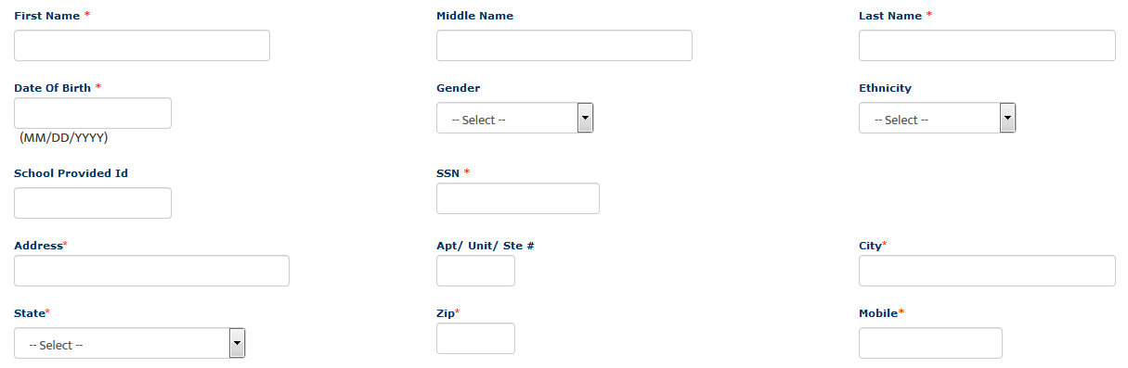
The following information is required on this page:
First Name: Your legal first name.
Last Name: Your legal last name.
Date of Birth: Your date of birth (no one under the age of 13 is allowed to register).
SSN: Your full social security number with no dashes.
Address: Your physical place of residence.
City: The city in which you reside.
State: The state in which you reside.
Zip: Enter the zip code associated to your address.
Mobile: The best contact number you can be reached at.
Please note that myClinicalExchange does not share or sell your information.
School Enrollment Details:
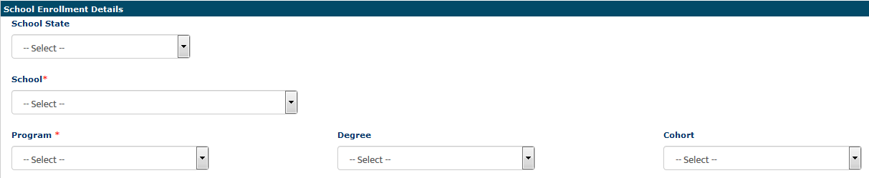
School State: Please select the state your Academic Institution is located in. This is not a required area. H owever, it does assist in the data filtering process.
School: Select the name of your Academic Institution.
Program: Select the program you are enrolled under at your Academic Institution.
Emergency Contact Person:
Name: Enter your Emergency Contact’s first and last name.
Relationship: Enter their relationship to you.
Phone: The best contact number they can be reached at.

Login Details:
Login ID: The email you entered at the beginning of this process will populate in this area.
Password: Enter in your password.
Confirm Password: Re-enter your password.
At the end of these four parts, you will see the image below.
10.) In order to proceed, please check the box to agree to the Privacy and Terms and Web App Usage Terms of Service.
11.) Click on Complete Registration. You will see a confirmation page indicating that your account has been created. Please note that a payment is required to allow you full access to all functions of myClinicalExchange. Continue reading for Login and Payment instructions.
12.) Click Continue to be navigated to the Student Login Page.

Logging into mCE
- You will be redirected to Students login page
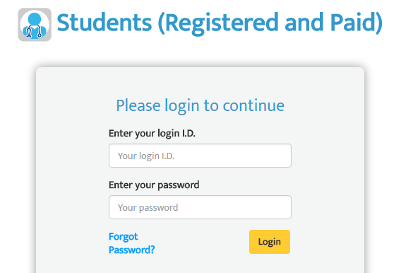
- mCE will prompt you for your login ID which is the e-mail address you were registered with in the previous step.
- Your password was created in the previous step as well and you may enter it here.
- If it’s been awhile since you first registered your account and you do not remember your password, then under the “Log In” area, click on the Forgot Password? link. That will navigate you to a page like this:
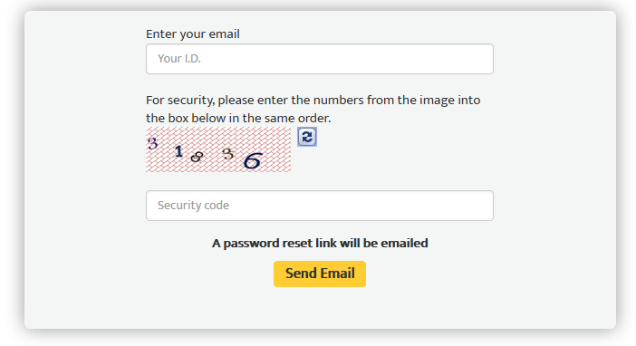
- Look at the numbers in the security code box, then type them into the text box labeled “Security Code”.
  - These will be numbers ONLY, not letters.
  - If you can’t read the numbers, click the refresh button on the right, and mCE will generate a new set of numbers.
- Click Send Email.
- Please check your inbox for an e-mail from donot-reply@myclinicalexchange.com with a link to reset your password.
  - If you do not see an e-mail from this address, please check your junk folder. You will want to designate donot-reply@myclinicalexchange.com as a “Safe Sender” so that further e-mails from myClinicalExchange come directly to your inbox.
  - If you still do not see the e-mail or if you are receiving an error message from the system when you try to get your password, please see the troubleshooting tips on the next page.
- Once you receive your password reset link in your inbox, click the link to be navigated back to mCE.
- You will be prompted to create a brand new password of your own choosing. Your new password MUST include:
  - 8 characters
  - 1 upper case
  - 1 lower case
  - 1 number
  - 1 special character (!, @, #, $, %, ^, &, *)
- Once you reset your password, go back to the main log in page. Enter your email address as the Login ID and your password. Then click the yellow Login button.

Payment
Please check with your School and/or Hospital to see if you need to personally pay for your myClinicalExchange account. In some cases, your School or your rotational Hospital may cover your registration fee.

- At the top left of your homepage, you will see the words, “Account Settings”.

Or at the top right of the homepage
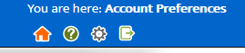
- Click those icons and the platform will navigate you to your profile. On the top right corner, you will this section then click “Make a payment”.

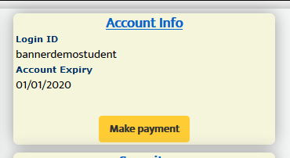

- Double check that all the information on the next page is correct. Please read the instructions before you proceed to Paypal checkout.

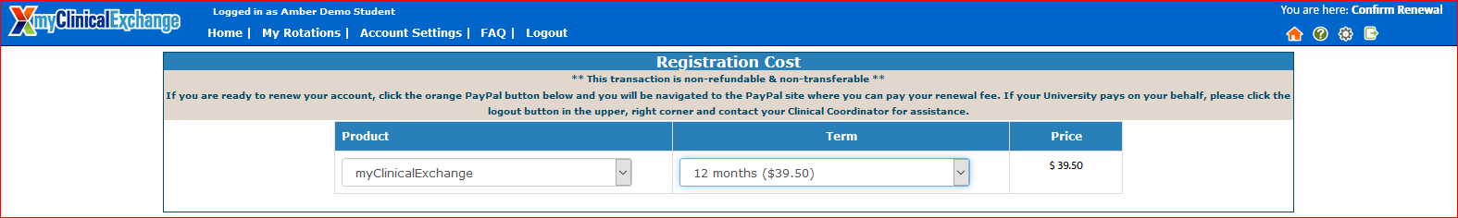
- This will navigate you to a billing page outlining the charges. Click the orange PayPal Checkout button.
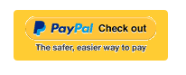
- A new tab will open from PayPal.
  - If you have a PayPal account, you can sign in and pay.
  - If you do not have PayPal account, click Pay with Debit or Credit Card at the bottom to check out as a guest (green outline below).

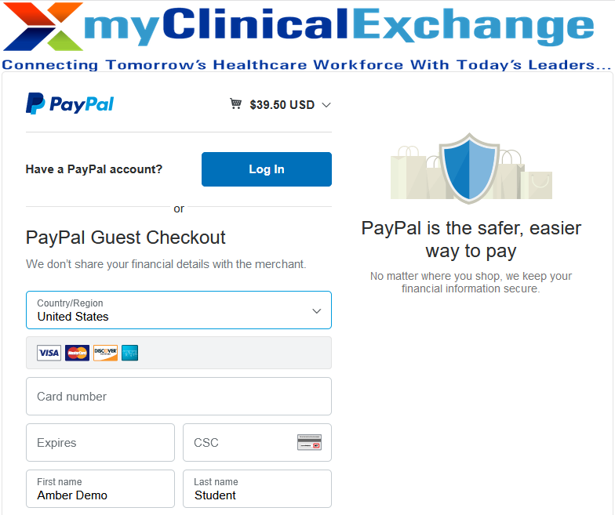
- From this screen, there are two ways to pay for your account.
- If you have an existing PayPal account, you may login and complete payment that way.
- If you do not have an existing PayPal account, click on Pay with Debit or Credit Card (purple box above).
- With either option, you will be prompted to enter in your billing information. Once you’ve entered your information, click on Pay Now.

- You will be sent a receipt from PayPal. Please keep this for your records.

Navigation and Tips
To better understand how to use mCE, please check out our FAQ’s at the top-right of the page or our YouTube channel at https://www.youtube.com/user/myClinicalExchange.
On your homepage, you will see several important things you will need to access and understand.
At the top of the page in a blue header is your Academic Institution’s Compliance Checklist information. Clicking on the words “Campus Compliance Checklist” will navigate you directly to your Campus Checklist.
You will also see four tabs of information under your Campus Compliance Checklist.
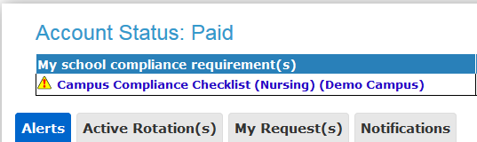
  - Alerts
    - The My Alerts! center lists all the items that are pending completion. If an item is connected to a specific rotation, the Rotation Number is listed first followed by the item pending completion.
  - Active Rotation(s)
    - Any rotations that you have been scheduled for are listed here. If you click the Rotation Number, you will be directed to a more detailed page regarding that specific rotation.
    - If you do not have any Rotations, that means you have not yet been scheduled for a rotation in the mCE system. Please contact your Clinical Coordinator at your school to resolve this issue.
  - My Request(s)
    - Please disregard this tab unless you are an independent or Advanced Practicum student. If you are an independent/advanced practice student AND your Hospital has asked you to submit your own placement request, please contact support@myclinicalexchange.com for more details.
  - Notifications
    - Any messages sent to you from your Academic Institution, Hospital Coordinator, and any auto notifications from mCE will be listed here.

Troubleshooting Tips
- What email should I use?
  - If your Academic Institution issues email addresses, please use the one they gave you. If your Academic Institution did not provide you an email address, a Google, Yahoo, Hotmail, etc. email address is acceptable.

- Why haven’t I received my validation code?
  - It can take up to 15 minutes for the validation code to be sent to your email. If you’ve waited 15 minutes, please check your junk folder, Spam folder, or Clutter Box. The e-mail will be from do-not-reply@myclinicalexchange.com. Please mark e-mails from the domain “myclinicalexchange.com” as a “Safe Sender” so that future correspondence comes immediately to your inbox. If you still have not received the email, verify the email you entered is correct.
- Do I have to use PayPal to pay?
  - Yes, the only way myClinicalExchange accepts payment is through this vendor.
- Why isn’t Internet Explorer loading this website?
  - Are you are using Internet Explorer, v8 or lower? If so, you will either need to update Internet Explorer to v9 or higher. Alternatively, try again in Chrome, Safari or Firefox.
- Why do I have to create Security Questions?
  - When you create your security questions you make recovering your password much easier in the event you forget your password.
- What do I do if I forget my login I.D.?
  - Please reach out to your University Coordinator for this information.
- I forgot my password. How do I login?
  - To retrieve your password, please navigate to the mCE website.
    - Click the Student button.
    - Click Forgot Password?
    - Enter your email address and the Security Code.
    - Click Email Password.
    - Please check your inbox for an e-mail from do-not-reply@myclinicalexchange.com assigning you a password.

If you are still experiencing issues, you can e-mail support@myclinicalexchange.com. Please provide your name, the University you attend, and a brief description of the issue you’re experiencing.

