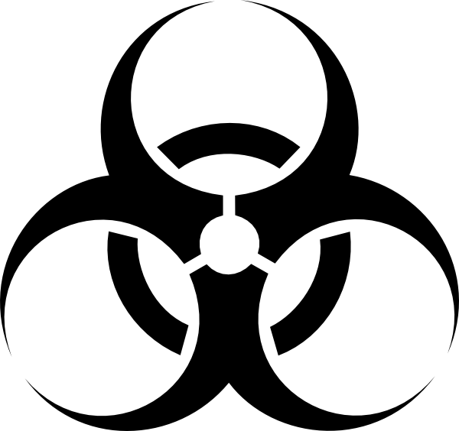

BIOHAZARD
BIOSAFETY LEVEL 2 - RESTRICTED ACCESS
Procedure Required for Entry/ Exit: | Access to the laboratories, support rooms, supplies, chemicals, equipment and technology is limited to those students and staff members that have been authorized access by the University of Wisconsin – Milwaukee, Department of Biomedical Sciences, and/or Laboratory Manager. See uwm.edu/bms-labs/policies-and-procedures/utilization-of-space-and-supplies/ for detailed information.
Special Practices | Personal Protective Equipment required for most tasks. Hand hygiene required before leaving this laboratory.

Notice | Call or See | Building | Room | Phone | E-mail
Laboratory Manager | Brad  De Pons | Enderis Hall | B92 | (414) 229-4499 | bkdepons@uwm.edu
Laboratory Manager | Dr. Elizabeth Liedhegner | Enderis Hall | 439 | (414) 229-5028 | liedhegn@uwm.edu
Biological Safety Officer | Danielle Rintala | Engelmann Hall | 270 | (414) 588-4261 | rintala@uwm.edu

Enderis Hall | Room | Date Posted:

