I-Manager Instructions and Procedures for the Institutional Animal Care and Use Committee
Protocol review and approval in I-Manager will follow the same general process as previously done. Below is the general outline of the I-Manager protocol review process. On the next page, you will find a more detailed flowchart.
- PI/submitter fills out and submits the “IACUC Protocol Review form” in I-Manager

- The office (acp@uwm.edu) receives the submission and can either process it for IACUC review immediately, or return it to the PI to make preliminary revisions before being sent for out IACUC review.

- A link to the study is sent out via email to the entire animal care and use committee to review, make comments/notes on the form, and vote for Designated Meeting Review or Full Committee Review. Committee members will have 5 days to review and vote on the protocol form in I-Manager. **This is the only time at which committee members are able to make comments on the form**

- After the 5-day period, the form will enter the Review Type Confirmation Stage, at which the IACUC office will choose whether the study will be sent for DMR or FCR based on the votes collected. Comments/notes made on the form by committee members will be collected, reviewed (all comments will be made anonymous at this stage – will appear to be made by vet, lab manager, or compliance assistant), and sent to the PI to make revisions. The form will be sent back to the PI to make changes and revisions along with a deadline to return it before the review meeting date.

- For DMR determination: 5 business days prior to the meeting, a link to the protocol will be emailed to the DMR group that will be reviewing the study, along with meeting date and details. This will allow the DMR group to have access to the most up-to-date version of the form before official review.

For FCR determination: 5 business days prior to the meeting, a link to the protocol will be emailed to the full committee with the meeting date and details. This will allow committee members to have access to the most up-to-date version of the form before official review.

- Once the meeting date arrives, the protocol will be reviewed by either the DMR group or the full committee based on the previous determination. All comments that were made on the form will be discussed, including the ones addressed previously by the PI. At the meeting, the outcome determination will be made. The study can be approved at the meeting, approved pending clarifications, forwarded to full committee (for DMR), tabled, or denied (for FCR).

- After the meeting occurs, the office administrator will select the determination made at the meeting in I-Manager.
  - If the protocol is approved, an approval letter will be generated and sent to the PI.
  - If clarifications are requested before approval, the form will be sent to the PI to make the revisions. Once the form is returned, it will be forwarded to the DMR group (for DMR) or a designated number of committee members (for FCR, usually the veterinarian, chair, plus other committee members). The DMR group or selected committee members will review the form and will vote on if the study should be approved.
  - If the study is forwarded to full committee from DMR, it will jump back to step 5 above and follow the FCR process.
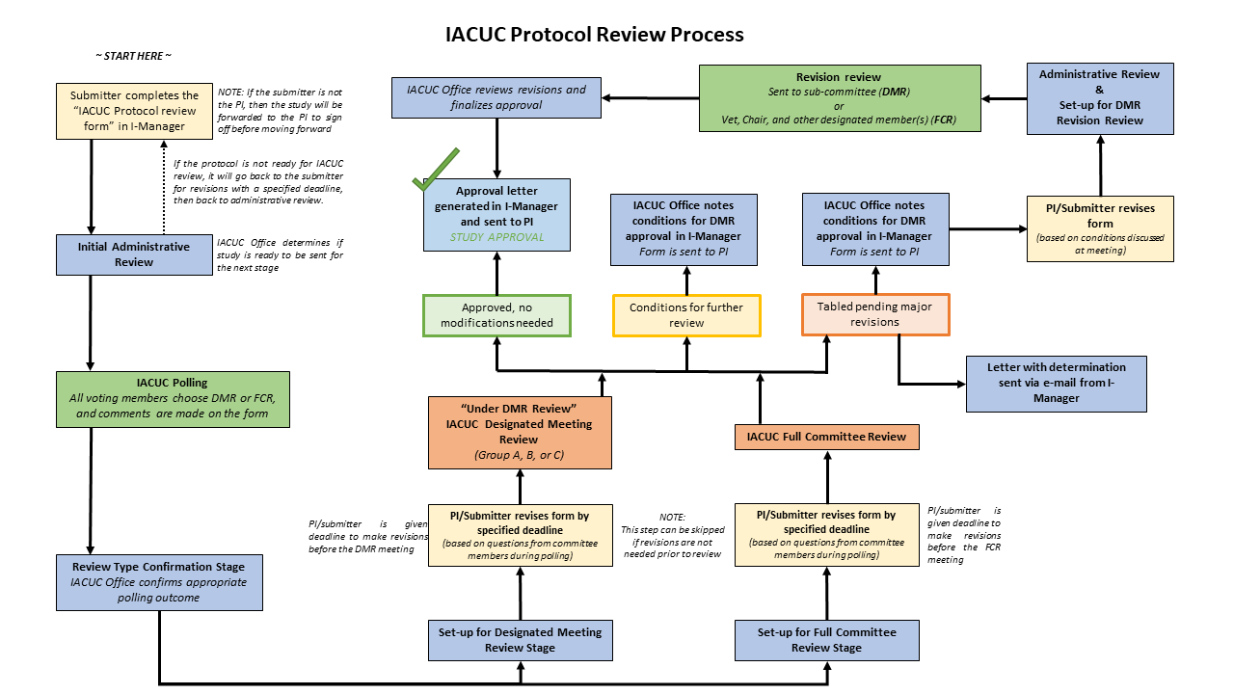

Navigating IManager as an Animal Care and Use Committee Member
Instructions for all tasks that must be completed as a committee member such as polling, making comments on forms, and completing reviews will be sent out via automated email. However, tasks to be completed can also be found within IManager as a committee member.

Accessing Reviews
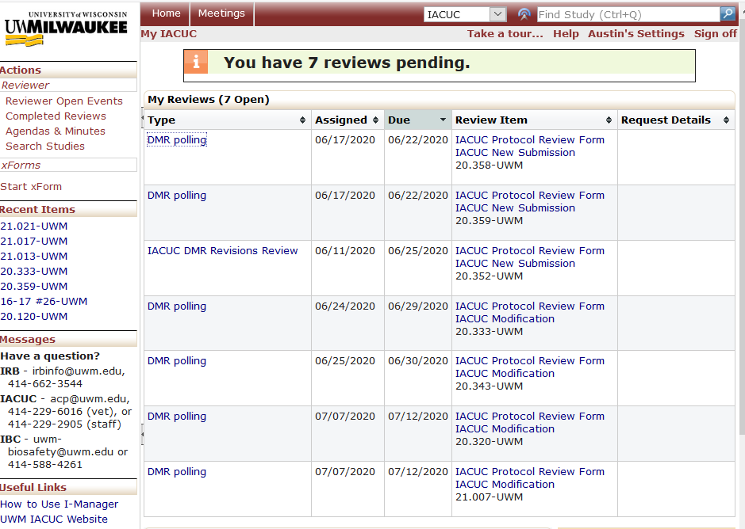
By navigating to your IManager dashboard (click the “Home” tab at the top of the screen), you will see the “My Reviews” section, with all of the pending reviews you have been assigned:

You can click on review in each row of the “Type” column to be brought to the assigned review. Additionally, you can click on the form link in the “Review Item” column to be brought to the study for which the review is assigned (you can also access the form within the review). On the next page, you can find an example of a review.

A typical review will look like this:
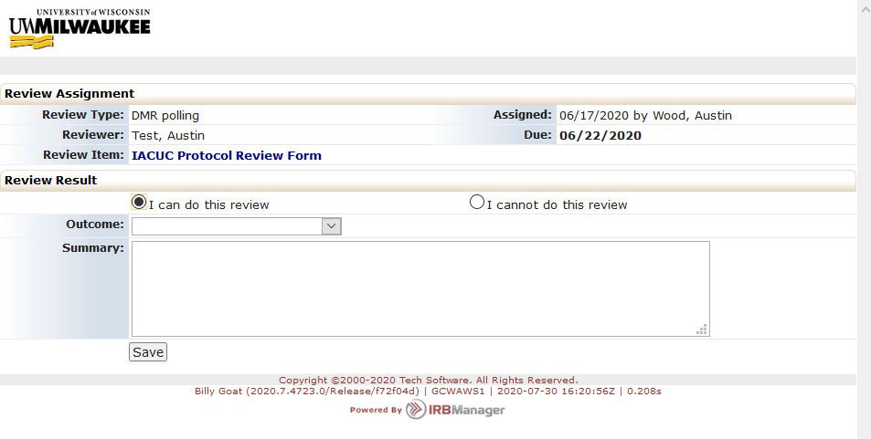
The ‘Outcome’ dropdown list is where you will make your review determination as a committee member. The two most common review types are:
- DMR polling review: the two choices are “Recommend DMR” or “Request full committee review”.
- IACUC DMR Revisions Review: the two choices are “Additional Revisions Requested” or “Revisions Accepted”.
Comments/notes can be made directly on the study form, but you are also given the option to put any comments or summary of comments in the ‘Summary’ text box.
By default, “I can do this review” will be selected. You will likely not need to change this. However, if you are submitting a study and are also a committee member, you should abstain from voting on your own study. In this case, you are asked to select “I cannot do this review” and type “I am involved in this study and must abstain from voting” in the ‘Summary’ text box.

