Submitting an Animal Research Protocol in I-Manager

University of Wisconsin-Milwaukee University Safety & Assurances Animal Care Program
Institutional Animal Care and Use Committee

Table of Contents

Logging into IManager 2
Home Screen / Starting a form 3
IACUC Protocol Review Form 4
Completing the ‘IACUC Annual Renewal Year 1 and 2’ Form 25
Completing the ‘IACUC 3rd Year Progress Report’ Form 29
Modifying /Amending an Existing Study 32

Logging In to IManager

Go to the IManager Page on the Animal Care Program Website.
Access IManager by clicking on the link provided:

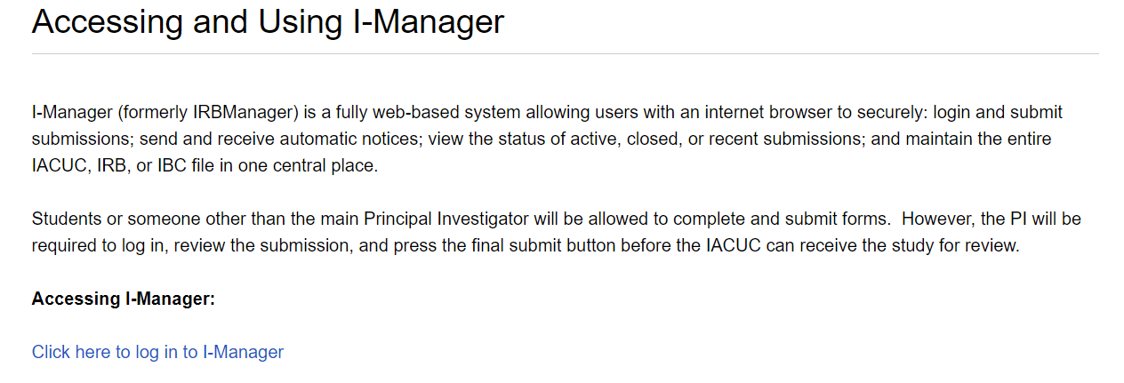

Select your sign-in method. All personnel issued a UWM Panther ID should use the single sign- on option. If you have an account set up with an external e-mail account, select the IRBManager Issued Login. See Figure 2 for the prompt screen.

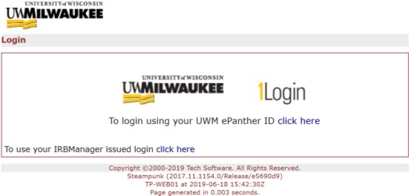

If you are logging in with an issued login and not SSO, make sure the Client ID says “uwm”.

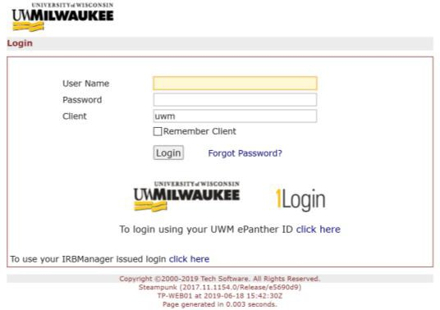

Home Screen

Once you log in, you will be brought to your home screen. On the left-hand side, you will see the prompt “Start xForm”. Click on this to begin a new animal research protocol.
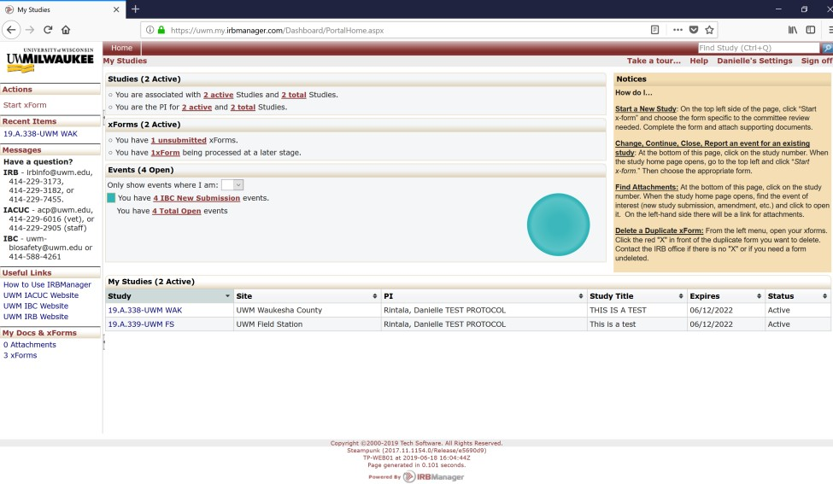

Protocol Form Selection

Select the appropriate form below:
- “IACUC Protocol Review Form” - Full study form that goes through normal IACUC approval and annual review. Approval period on these studies are 36 months.

- “IACUC Protocol for Educational Observational Studies” – Study form that undergoes approval by the veterinarian and IACUC chair. No annual reviews.

- “IACUC Protocol for Field Observational Studies” – Study form that undergoes approval by the veterinarian and IACUC chair. No annual reviews.

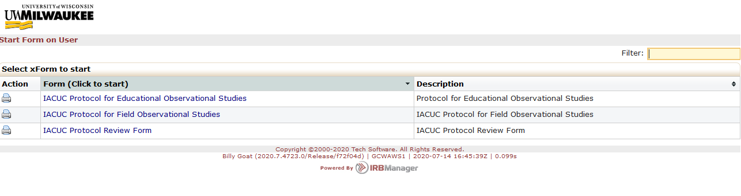

IACUC Protocol Review Form

Protocol Header

The first page is the protocol header. As the submitter your information is already made available on the first page. Enter the information on this page, including PI email and study title. You are also prompted to request closed session for protocol review. Note that all meetings are subject to the State of Wisconsin Open Meetings Law and request for closed session must meet the requirements for closed session, pursuant to Wisconsin State Statute 19.85 (1)(e). If you click yes, you will be required to provide a reason.

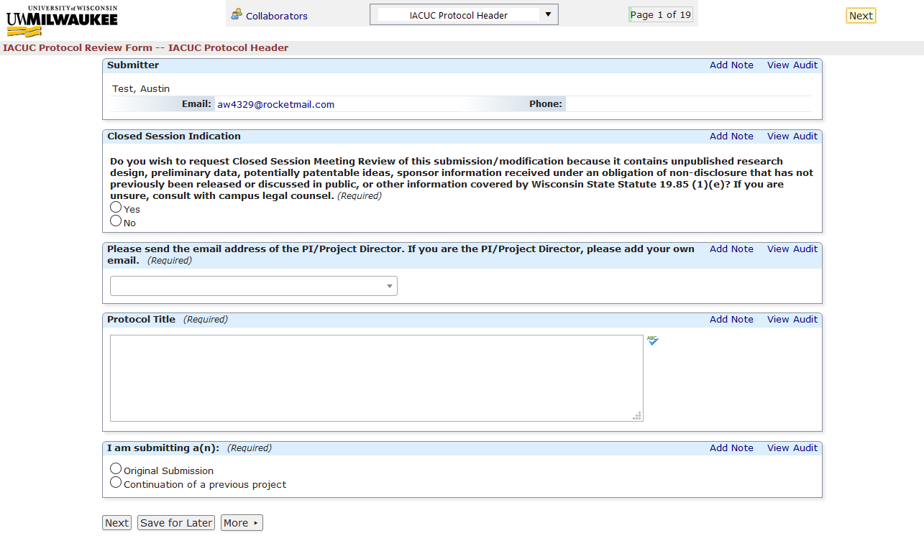

Click “Next” at the bottom of the page to go to the next page.

Pain or Distress Classifications
The next page asks about USDA Pain or Distress Classification numbers. Please provide the numbers and types of animals that fall into each relevant category. Please provide the estimated numbers for each year of the 3-year approval period.

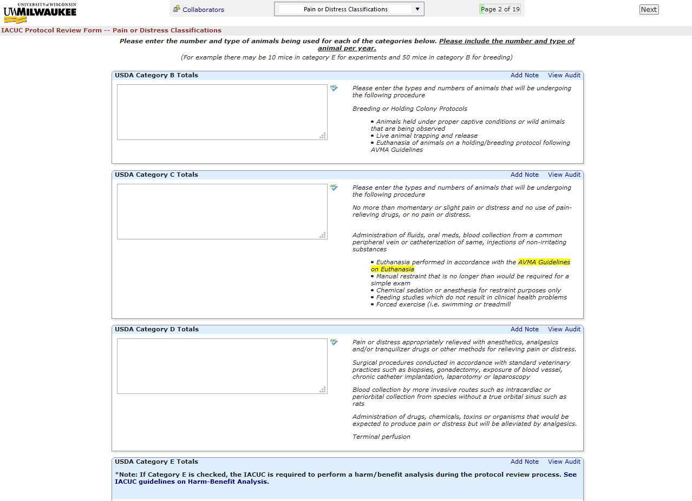
Click “next” at the bottom of the page to go to the next page.

Cover Sheet Details

The cover sheet contains details like collaboration details, funding, project duration, and personnel. Find more information for filling out the personnel tables below.

If your study involves collaboration with another institution, you will be prompted to select the collaboration type. If the animals involved in the study are primarily housed at the other institution, you will be prompted to complete a “Deferred Review Form”.

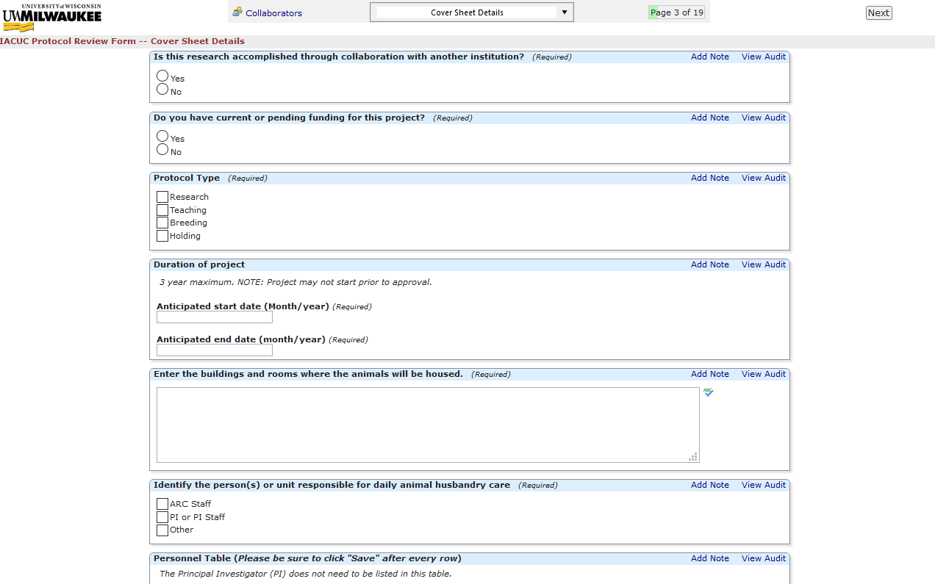

Personnel Tables

The first personnel table is for listing all active members involved in the study. This includes all students, graduate students, volunteers, and any other person interacting with animals in research. Any individual listed here must complete all training required by the IACUC (see this page for more information). The PI does not need to be listed in the first table, as they should have been indicated at the beginning of the form. If a person listed in the table is neither a UWM student or employee, you are asked to list the personnel type in the text box below the table. Make sure to click save after each row in the table, or that row will disappear when you move to the next page.

The second personnel table is for indicating any personnel who are performing procedures involving animals. The PI does need to be listed in this table. All procedures to be included are listed on the page. If a procedure is taking place that is not listed, you are asked to list the procedure in the text box below the table. Make sure to click save after each row in the table, or that row will disappear when you move to the next page.

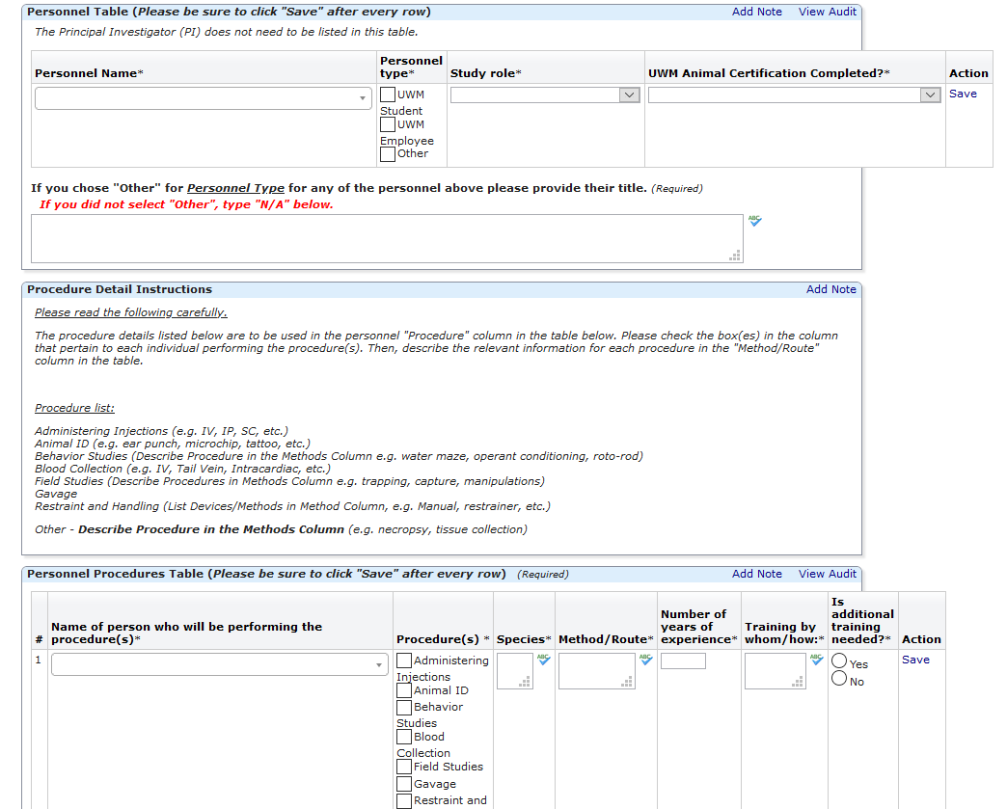

When you have finished this section, click “next” at the bottom of the page.

Protocol Goals and Animal Information

The next page is “Protocol Goals and Animal Information”. On this page, you will input information regarding the study aim and animal information.

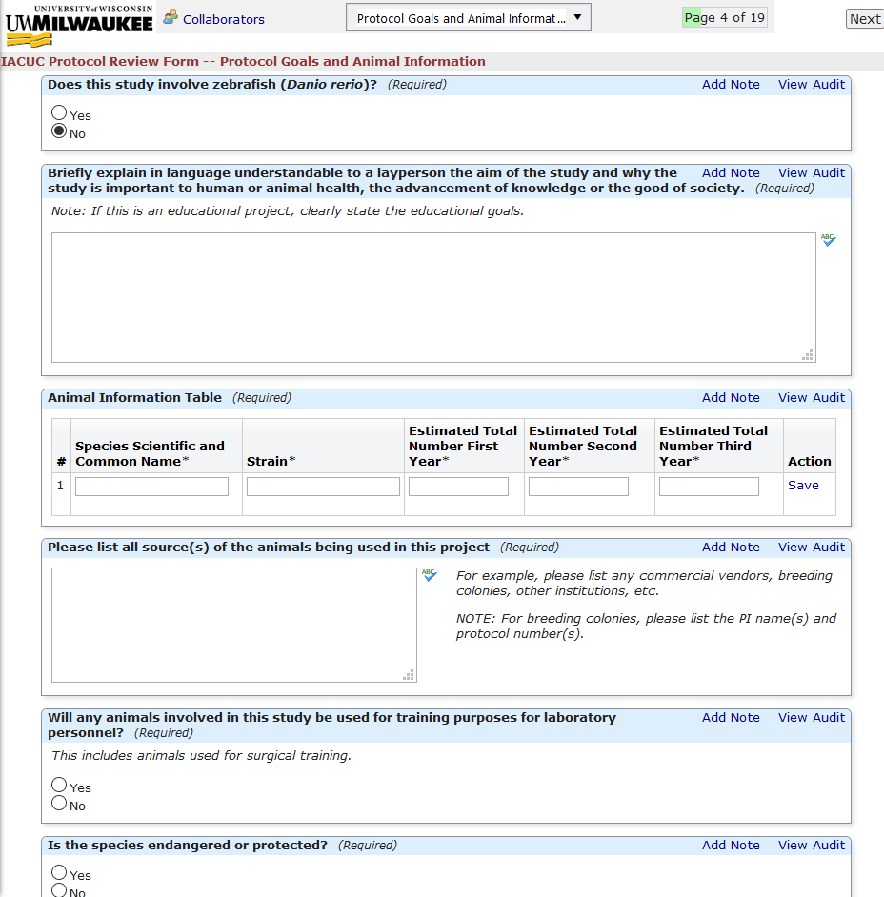

At the beginning of this page, you are asked to specify whether the study involves zebrafish. If zebrafish are involved, you are given three options:
- Zebrafish exclusively under 8 days of age (Study is exempt from full IACUC review)
- Zebrafish under 8 days AND over 8 days of age (Full review occurs)
- Zebrafish exclusively above 8 days of age (Full review occurs)

If you indicate the first option, the study is exempt from further review, and the form becomes a shortened version.

Click “next” when done.

Rationale for Animal Use

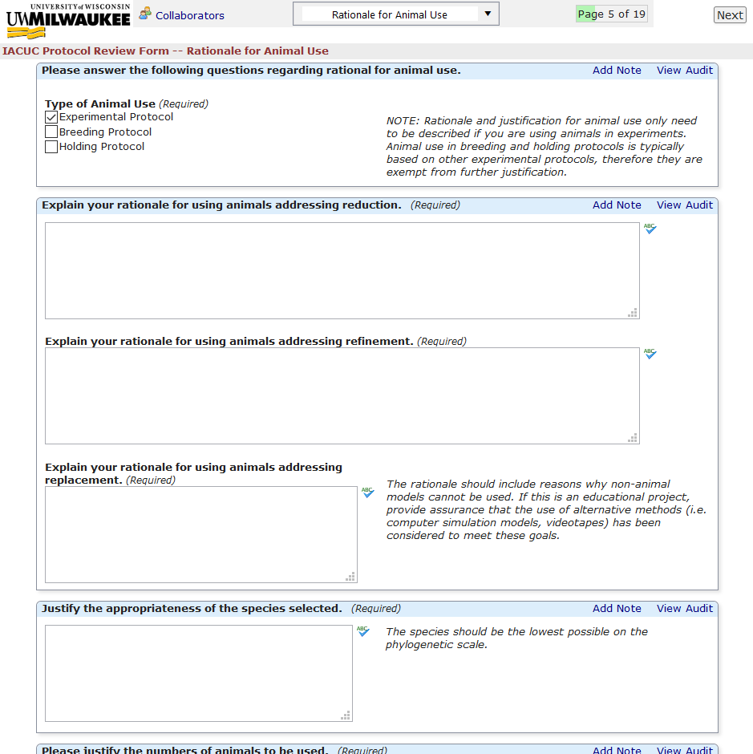
On this page, you are asked to provide a justification for animal use, addressing reduction, refinement, and replacement. If you select only Breeding or Holding, you are exempt from further justification.

Click “next” to continue

Animal Housing

Here, you are asked to provide information regarding animal housing.
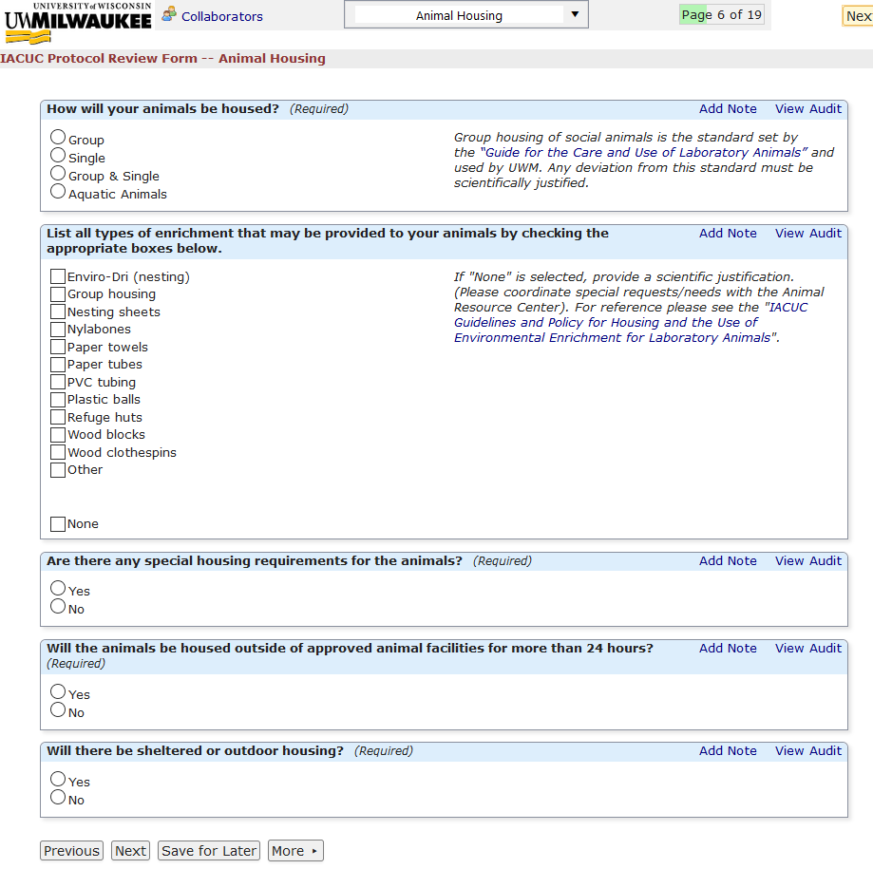

Click “next” to continue

Special Care and Special Diet

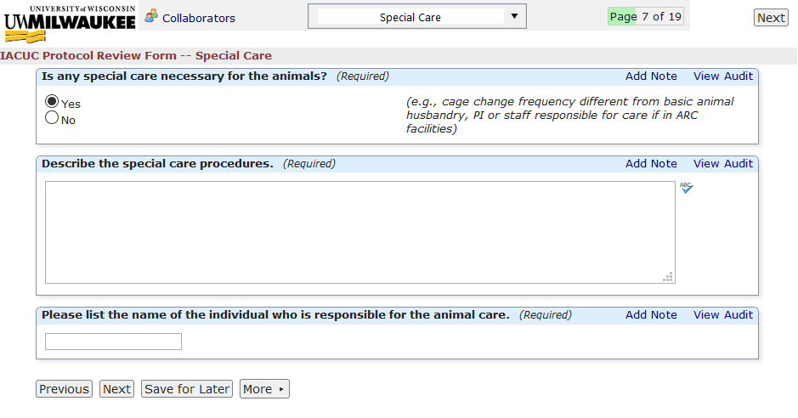
On these pages, you are asked to indicate whether special care and a special diet will be used in the study. If you select yes, you are asked to provide details. Click “next” to continue.

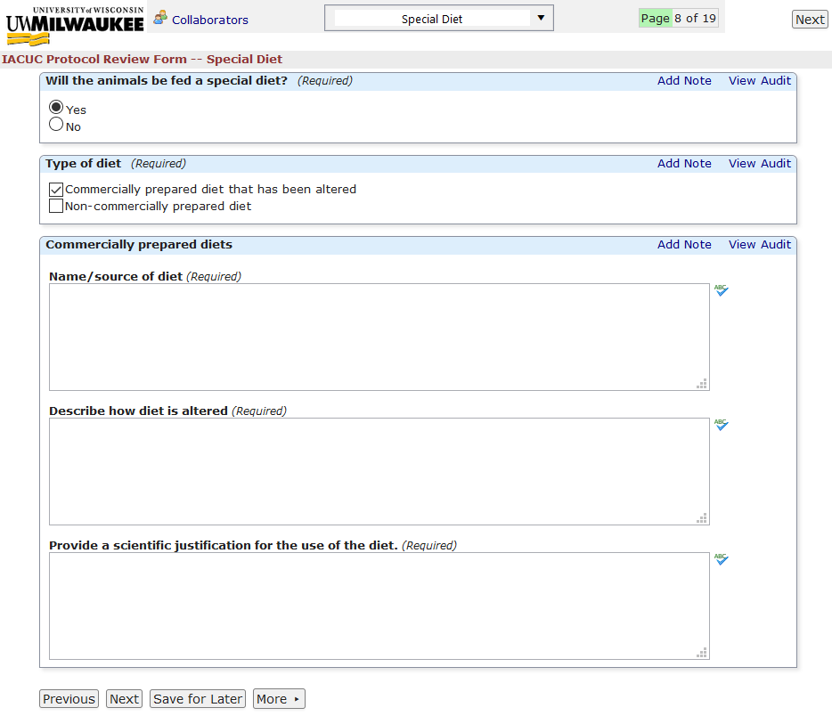

Food/Fluid Restriction

Here, you are asked to indicate whether experimental procedures that require fluid restriction. If so, further questions are revealed asking for more details.
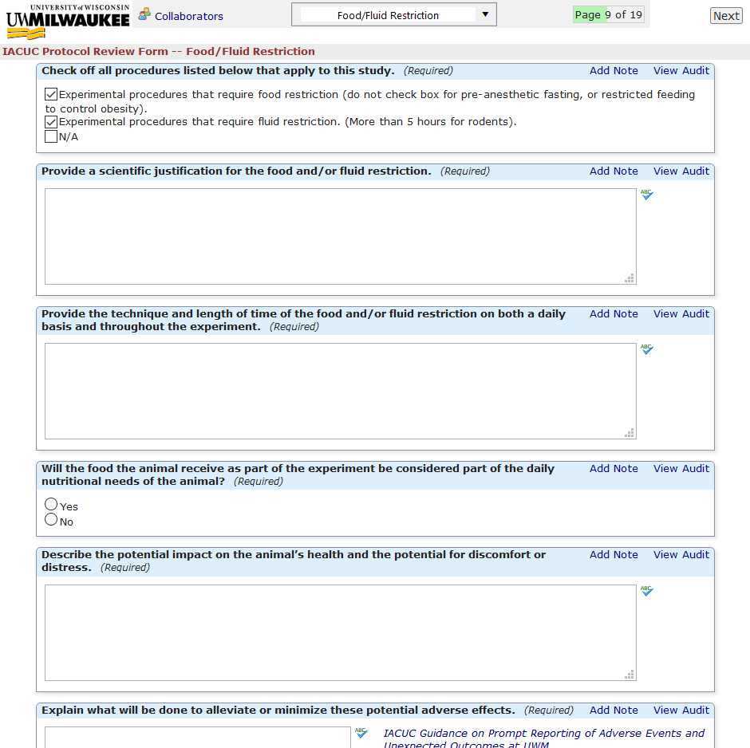

When done, click “next” to go to the next page.

Study Procedures

Further questions regarding study information are asked here.
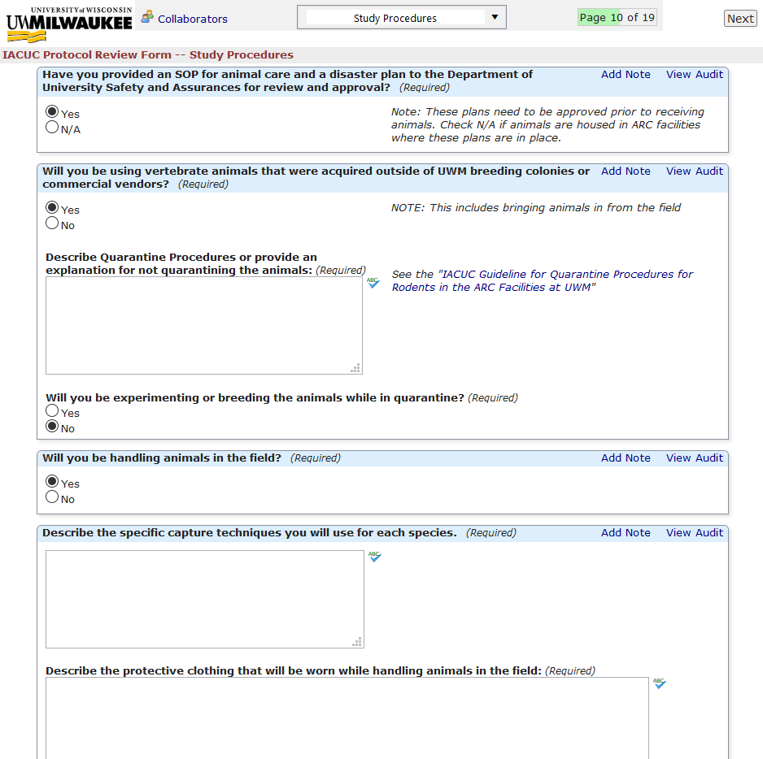

Click “next” to continue.

Transportation Procedures

If transportation is occurring at any time during the study, you are asked to provide details here.

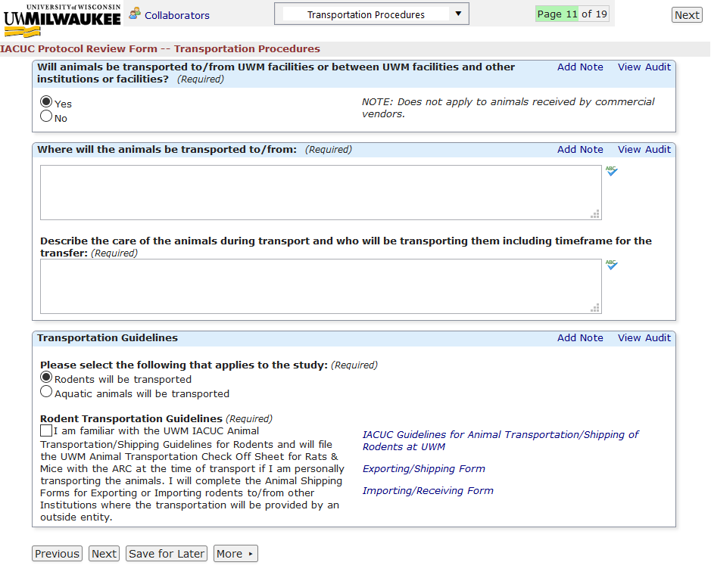

Click “next” to go to the next page.

Animal Project Study Procedures

This page contains the majority of questions regarding the study procedures. You have the ability here to attach any documents or diagrams that may aid in the explanation of your study. It is very highly recommended that you include/attach a diagram or sequence chart that explains the process of your study (like the one below). This will make it much easier for IACUC reviewers to understand the study and will make approval easier.

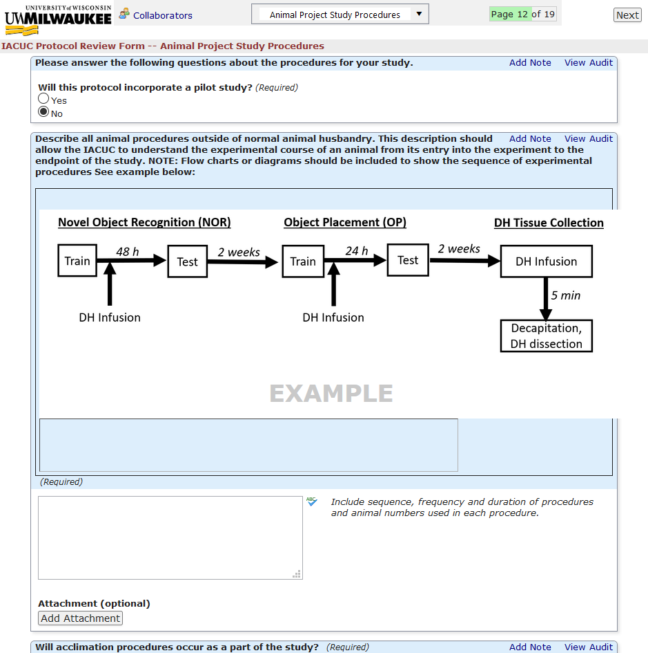

Click “next” to continue.

Anesthesia

If you indicate the use of anesthesia during the study, you are asked to provide details here.

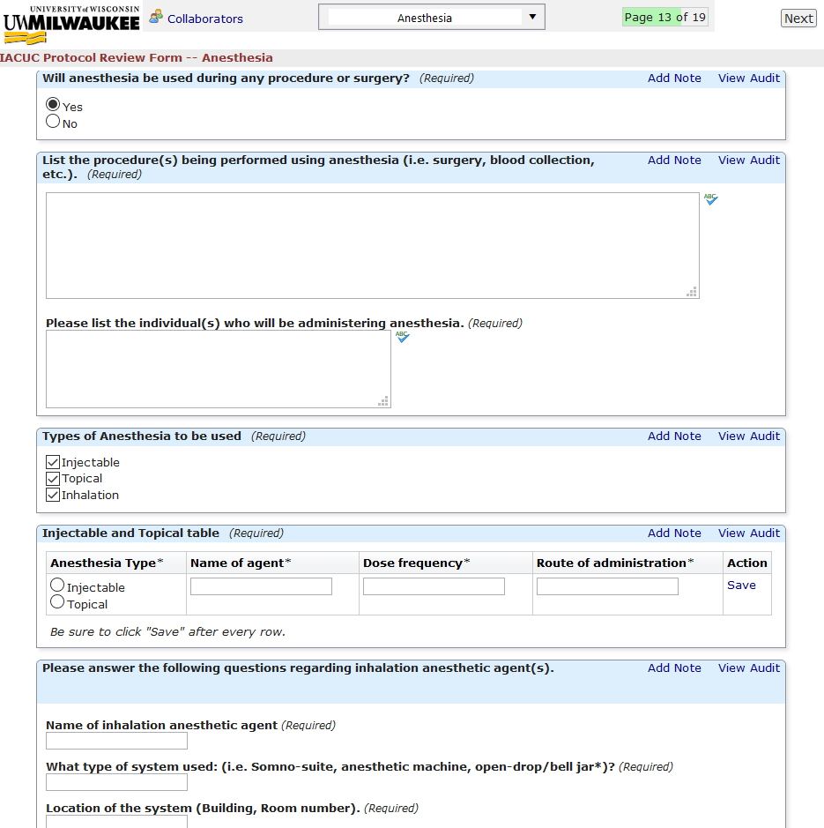

Click “next” to go to the next page.

Surgery

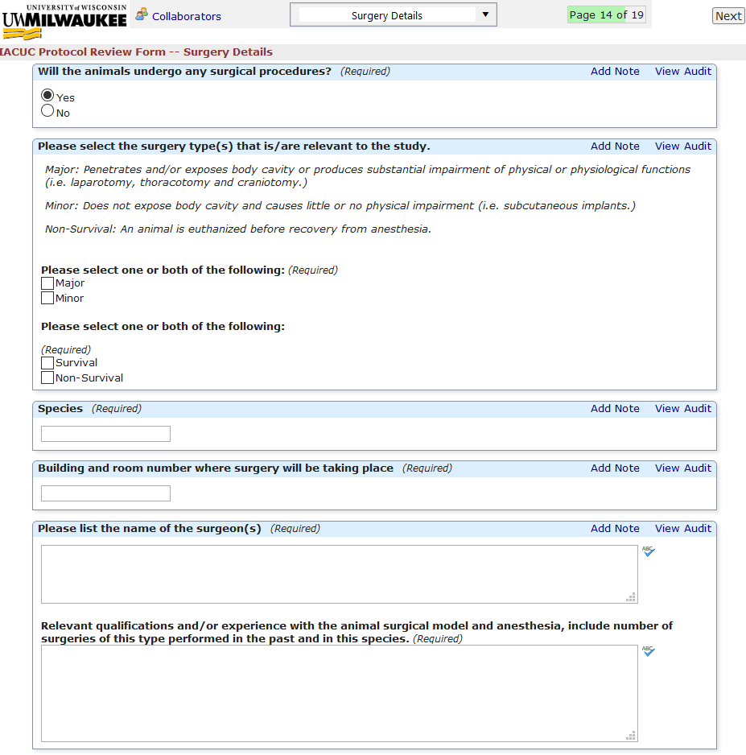
If you indicate surgery as occurring as a part of the study, you are asked to provide details here.

Click “next” to go to the next page.

Euthanasia

If you indicate euthanasia as occurring as a part of the study, you are asked to provide details here.
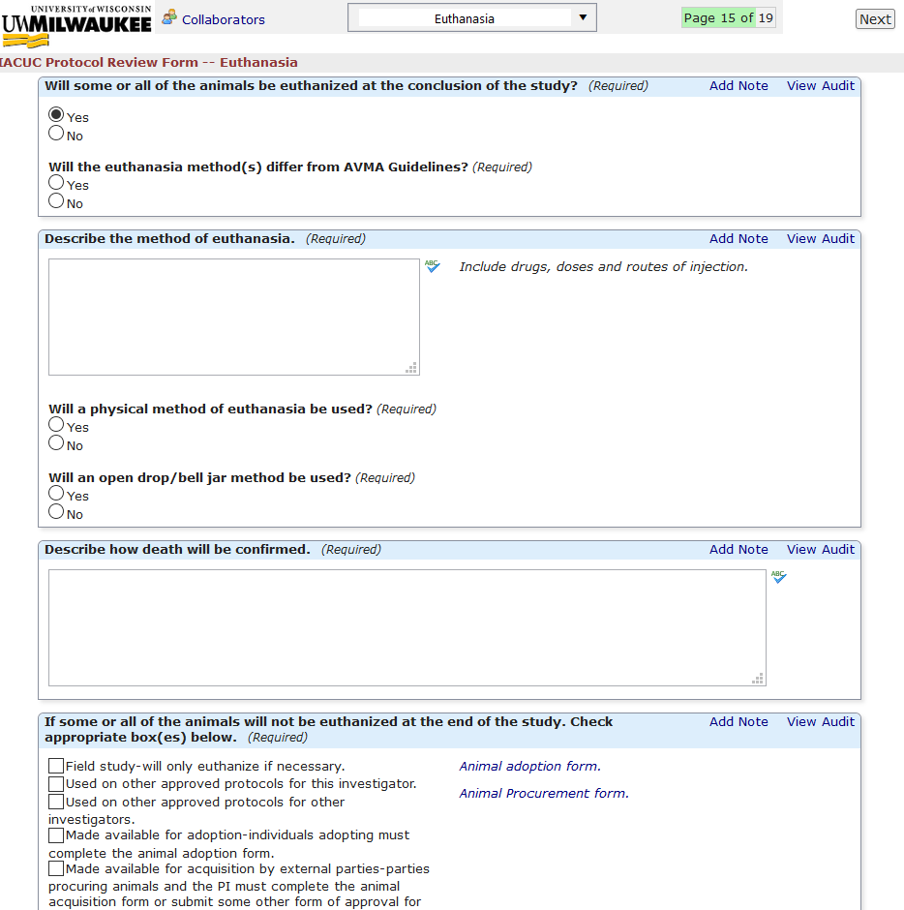

Click “next” to continue.

Hazards

Here, you are asked to indicate the use of any hazards, including hazardous chemicals, biological agents, biological toxins, recombinant DNA, knockouts, transgenics, and radioisotopes. Selecting any of these options will bring up dialogue stating, “You will find questions relating to the above indicated item(s) on the following pages. Please click the "Next" button to proceed to the specific hazard questions.”

Due to the amount and extent of questions regarding each hazard type, it was necessary to place questions on separate pages on the form.

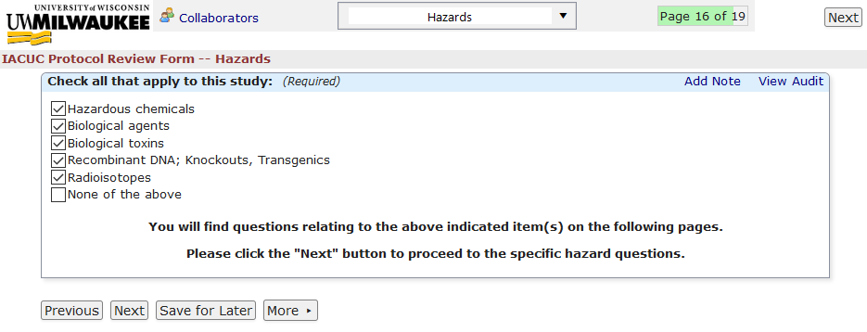

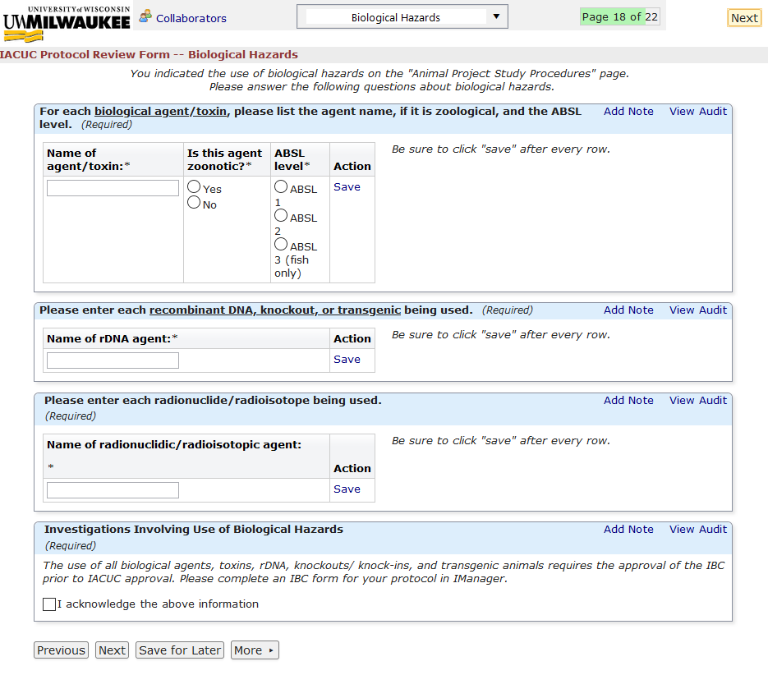
By selecting any of the options and clicking next, you are then prompted to answer specific questions based on the options you selected on the previous page.

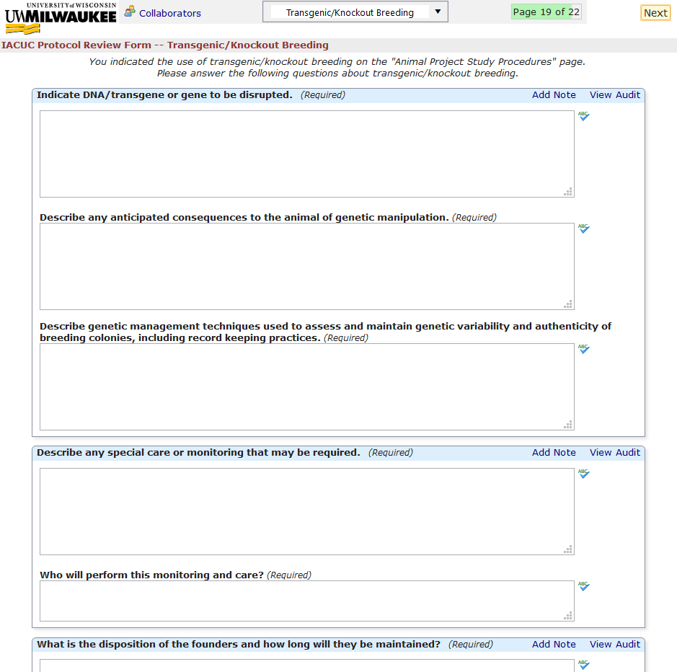

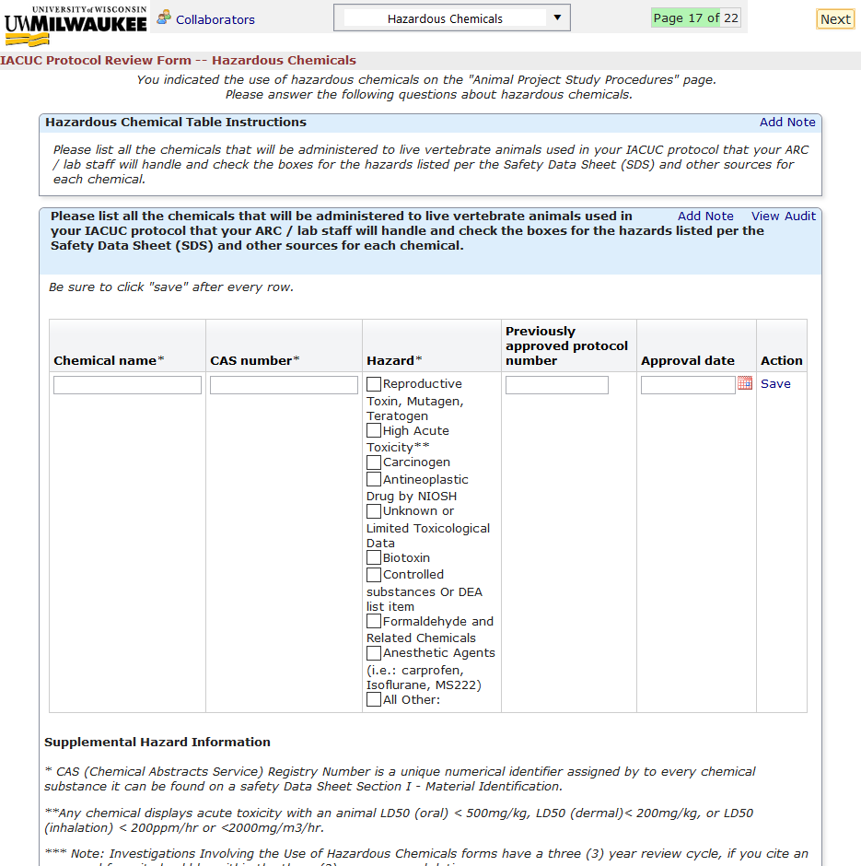

Non-Pharmaceutical Grade Compound Administration

Here, you are asked to indicate the use of non-pharmaceutical grade compounds. If so, further questions must be answered.

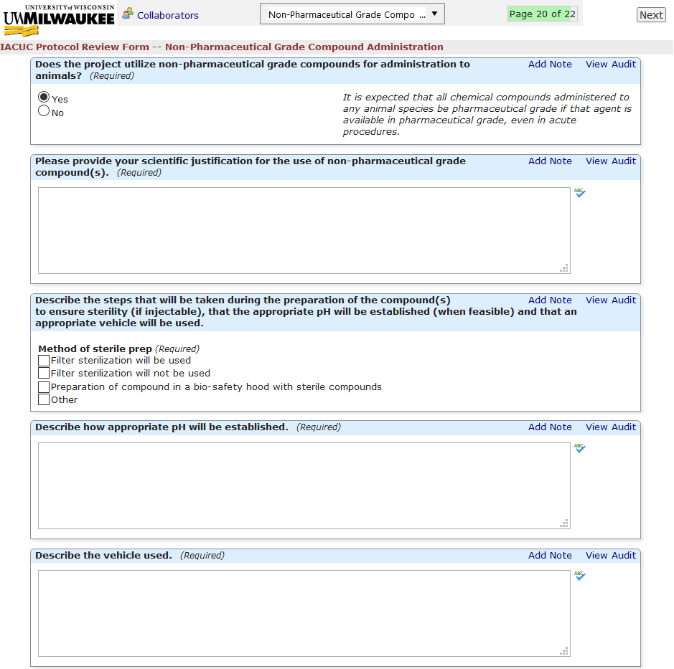

Click “next” to continue.

Monitoring of Animals

Here, you are asked about methods of animal monitoring.

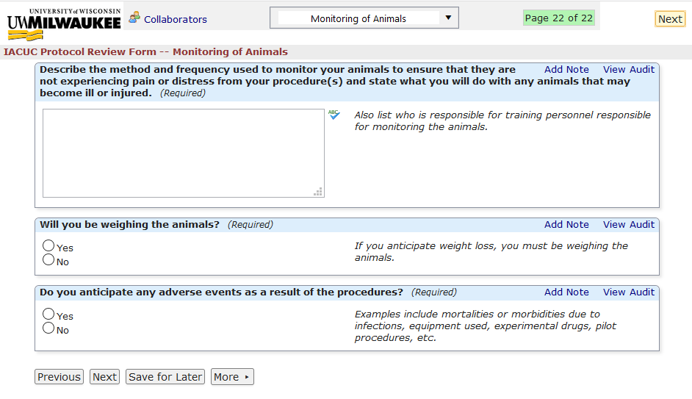

Click “next” to proceed.

PI Signature Stage

If the PI is the submitting user, meaning that the PI is the person filling out this form, then the PI signature stage will be visible at the end of the form. The PI must sign, indicating agreement with the following statement:

UW-Milwaukee has on file with the Public Health Service a written Assurance, which commits UW-Milwaukee to following the standards and regulations established by the Animal Welfare Act and the Health Research Extension Act.
UW-Milwaukee has established the Institutional Animal Care Committee (IACUC) to review and approve proposals for the use of animals in research and teaching. The IACUC will determine if these proposals are consistent with these regulations and requirements. The IACUC is responsible for the welfare of "any live vertebrate animal used or intended for use in research, experimentation, testing, training, or related purpose" if these animals are maintained at UW-Milwaukee or used under funds administered by UW-Milwaukee.
I certify that I have read the above statement and will adhere to all regulations concerning the use of animals in research and teaching, and that I will notify the IACUC in writing of any changes in this Protocol Form before proceeding with any animal experimentation.
I further certify that personnel will not perform any animal procedures until they have been certified by the animal care program personnel.
I will ensure that all personnel are enrolled in the Occupational Health and Safety Program prior to their contact with animals. I will inform all personnel that if their risk status changes (changes to their medical status, job duties, the environment they work in or the species they work with, or changes in hazardous agents that they are exposed to) it is highly recommended that they submit a new risk assessment questionnaire.
I will provide emergency SOPs and after hours contact if needed.

If the PI is NOT the submitting user, meaning that a member of the PI’s lab is filling out the form instead, then submitting the form will send the form to the PI in order to sign.

Once the form is submitted, it will be sent to the IACUC office (acp@uwm.edu) to process for IACUC review. Please contact the office via email with any questions or concerns regarding your form.

If you are looking for a detailed description on the protocol review process after approval, view the “I-Manager Information for the IACUC” document here:

https://uwm.edu/animal-care/accessing-and-using-i-manager/

Completing and Submitting Annual Renewal Forms

Any ‘IACUC Protocol Review Form’ that undergoes designated review or full-committee review and is approved must undergo annual review for Years 1, 2 and 3 based on the date of original approval.

Accessing the ‘IACUC Annual Renewal Year 1 and 2’ Form

The ‘IACUC Annual Renewal Year 1 and 2’ form will need to be completed nearing the end of the first and second years the study is active. Annual progress report forms are only accessible through completed forms. To access the ‘IACUC Annual Renewal Year 1 and 2’ Form:

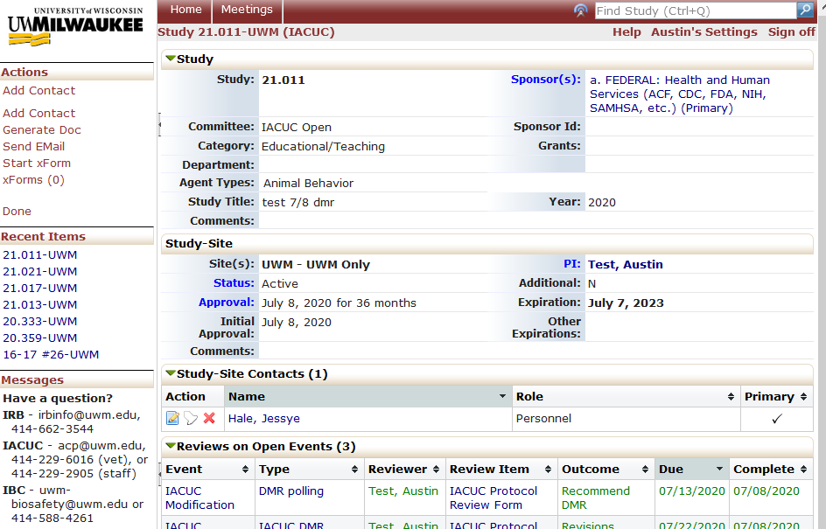
- Navigate to the study for which you are completing the progress report form. Click “Start xForm” in the ‘Actions’ column

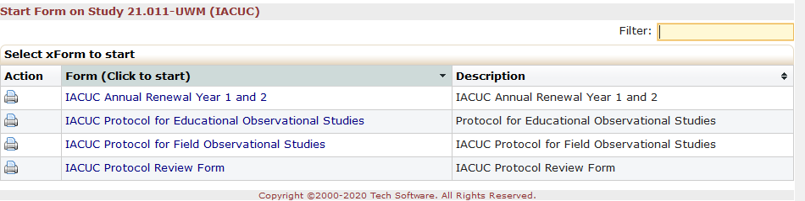
- The page with the list of xForms will come up. Select ‘IACUC Annual Renewal Year 1 and 2’.
Note: If the ‘IACUC Annual Renewal Year 1 and 2’ form does not appear on this list, make sure you are clicking ‘Start xForm’ from the Study page and not the Event page. The study page can be accessed from the event page by clicking the study number near the top of the page.

Completing the ‘IACUC Annual Renewal Year 1 and 2’ Form

Clicking the form link to begin, the study information from the original protocol is carried automatically to this form, including the protocol number, protocol title, PI, and funding information (there is nothing for you to complete in this section).

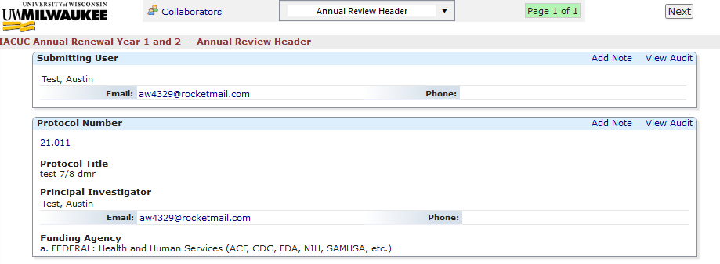

After the header section, complete the progress report section. This section has questions about study procedures during the past year.

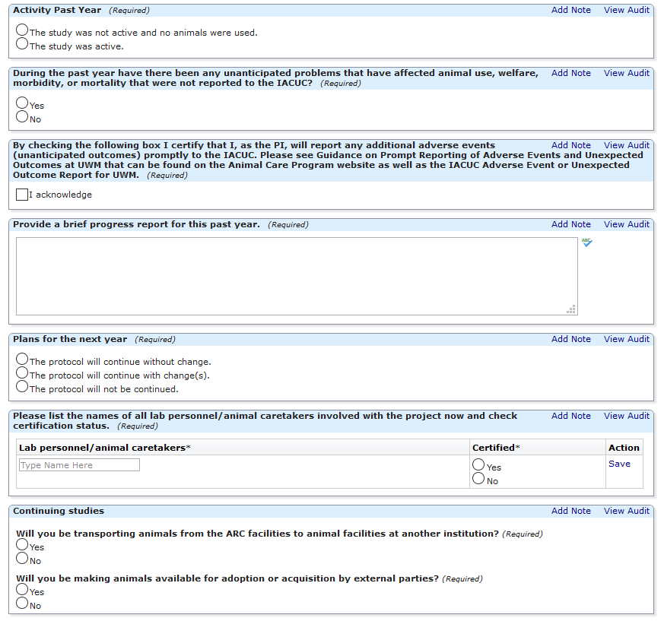

There is a question above titled, “Plans for the next year”. If you are planning on continuing the study into the next year, but are planning for significant changes to the study procedures (second choice), you will be instructed to complete an amendment submission in addition to finishing and submitting the progress report form:
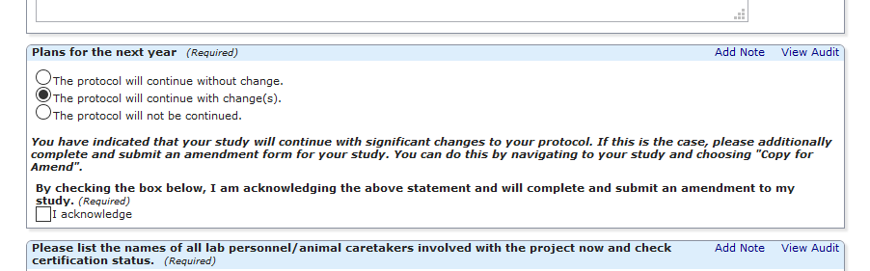

If you wish to close the study before the end of the 3-year approval period, you can do so by choosing, “The protocol will not be continued.” This means you will be unable to continue research under this protocol after the annual expiration date.

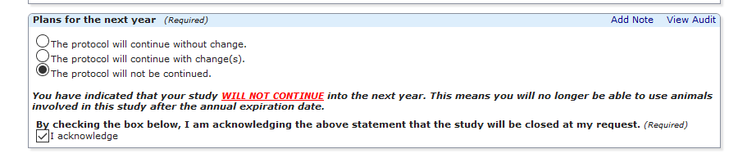

Once submitted, annual progress report submissions will undergo review by the IACUC veterinarian and vice-chair. If there are any issues with the form (e.g. typo in animal numbers), it can be sent back to the PI by the office for revisions. The PI can make revisions/corrections and resubmit for review. After the report is approved, and the annual approval date is reached, (one year from the project start date), the PI will receive an automated email notifying them of the approval, along with the attached approval letter. If the PI indicated that the study will not continue, they will receive an automated email on the annual expiration date indicating closure.

Accessing the ‘IACUC 3rd Year Progress Report’ Form

The ‘IACUC 3rd Year Progress Report’ form will need to be completed nearing the end of the third year the study is active. Annual progress report forms are only accessible through completed forms. To access the ‘IACUC 3rd Year Progress Report’ Form:

- Navigate to the study for which you are completing the progress report form. Click “Start xForm” in the ‘Actions’ column

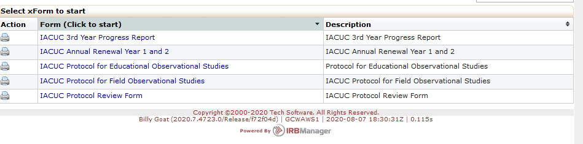
- The page with the list of xForms will come up. Select ‘IACUC 3rd Year Progress Report’.

Note: If the ‘IACUC 3rd Year Progress Report’ form does not appear on this list, make sure you are clicking ‘Start xForm’ from the Study page and not the Event page. The study page can be accessed from the event page by clicking the study number near the top of the page.

Completing the ‘IACUC 3rd Year Progress Report’ Form

Clicking the form link to begin, the study information from the original protocol is carried automatically to this form, including the protocol number, protocol title, PI, and funding information (there is nothing for you to complete in this section).

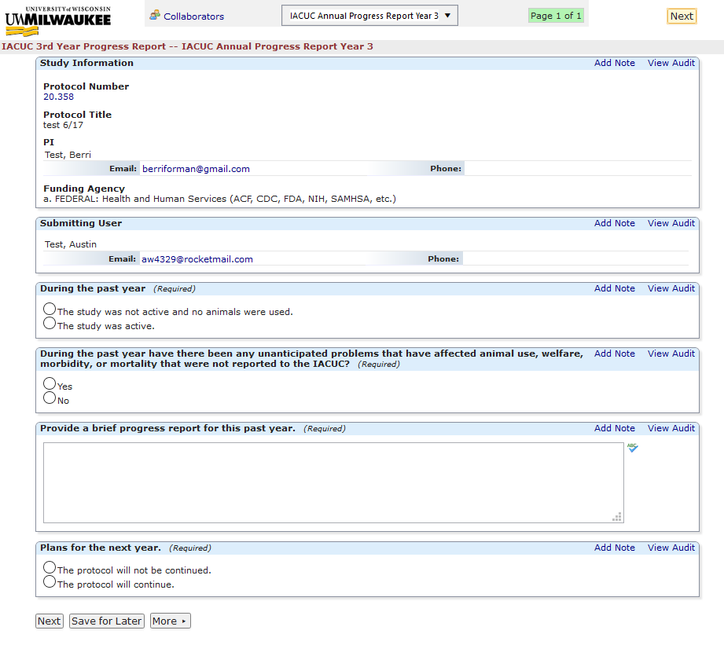

The rest of the form asks basic questions regarding the activities during the past year. If your activities will continue past the 3-year approval period, a new study will need to be submitted in I-Manager. If the protocol will not continue, no further action is needed beyond completing and submitting the progress report form.

If you are continuing your study past the 3-year approval period, a new “IACUC Protocol Review Form” must be submitted in I-Manager. This can be done by navigating to “Start xForm” (see page 3). However, in order to make this process easier, the ‘Copy’ ability has been included with the main protocol form. This allows you to copy most of the form data into a new study form in order to save time. To do this:

- Navigate to “My Docs & xForms” in the left-hand column and click “# xForms”.
- Find the study you wish to copy and click the copy icon.
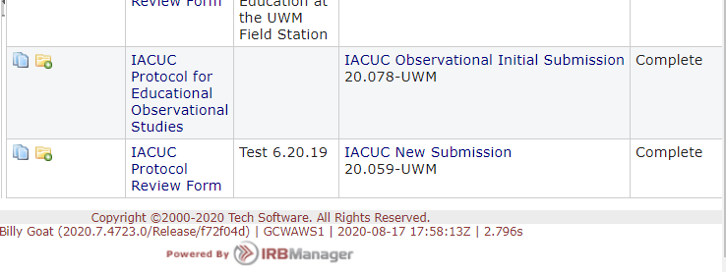
- You will notice that as you navigate through the form, most sections are completed as answers are carried over from the original form. There are a few questions that will not copy, such as questions that address dates.

- Once the form is filled out, it can be submitted for review.

Modifying/Amending an Existing Study

Modifying a Study that was Approved on the Old Protocol Form

Modifications (also called amendments) on existing protocols are still allowed, however there is no way to modify any study approved before September 1st, 202 within I-Manager. This is because all approved studies before September 1st underwent “conversion” into I-Manager from the paper form. The study exists in I-Manager, but no ‘xForm’ exists for these studies.

Therefore, modifications to any protocol approved on the old form should be modified and submitted to acp@uwm.edu on the old form. As we move onto I-Manager, a digital copy (Word, PDF, etc) for all previously-approved studies will be uploaded as an attachment for each protocol. The newest version of each protocol document (including modifications) will be uploaded to the attachments for that study.

As a protocol approved on the old form is approaching its expiration, the study may continue if the “IACUC Protocol Review Form” is filled out and submitted. Then, if a modification is required, the steps below can be followed.

If you have any questions, or need a copy of the old protocol form for your modification, please contact acp@uwm.edu.

Modifying a Study that was Approved within I-Manager

Modifications (amendments) can be completed within I-Manager by following the steps below:

- Navigate to “My Docs & xForms” in the left-hand column and click “# xForms”.
- Find the study you wish to copy and click the “Copy for Amendment” icon.
- This will duplicate the approved version of the form to allow for amendments/changes. You will be required to complete an amendment introduction section including the summary of changes you are making to the study.

- Once the form is filled out, it can be submitted for review.

