My Professional Self-Care Assessment

- Review the list of self-care practices below. For the ones that are important to you, rate how often you are engaging in these practices (feel free to add/share more ideas!)

3 = I do this frequently
2 = I do this occasionally
1 = I barely or rarely do this
0 = I never do this
? = This never occurred to me

____ Take a break during the workday (e.g. lunch, coloring, going to the park, guided meditation)
____ Take time to chat with co-workers
____ Make quiet time to complete tasks
____ Identify and make time for projects or tasks that are exciting and rewarding
____ Set limits with clients
____ Set limits with colleagues
____ Balance my work week (e.g. long visit day followed by day with longer break for lunch)
____ Arrange my work space so it is organized and helps me feel inspired
____ Engage in supervision in a way that feels helpful to me
____ Develop an area of professional interest/expertise
____ Make time to come into office so I don’t have to carry around so much “stuff”
____ Clean my trunk
____Have a self care accountability partner
____Refuel myself while driving (listening to my favorite music or podcast, practicing deep breathing)
____
____
____
____

When you are finished, look for patterns in your responses. Are there items on the list that make you think, "I
can’t make time for that"? Listen to your internal dialogue about self-care and making yourself a priority. Take particular note of anything you would like to include more in your workday.

Adapted from: http://socialwork.buffalo.edu/content/dam/socialwork/home/self-care-kit/self-care-assessment.pdf

- My signs of stress are…

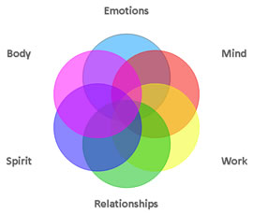

My Self Resiliency Plan (Personal & Professional)

- Some things I can do at and outside of work to manage my stress are…
 | I will continue doing...  How often? (daily, weekly, monthly) | I will start doing...  How often? (daily, weekly, monthly) [ | I will stop doing…
Emotional
Physical
Spiritual
Social
Intellectual

- My barriers to self care are…

- Some solutions for overcoming my barriers are…

